22222
B Employer identification number (EIN)

58-564864X

OMS No. 1545-0008
1 Wages, tips, other compensation
2248.98

2 Federal income tax withheld
449.80

c Employer's name, address, and ZIP code
Bodingles
123 Happy Blvd
Atlanta, GA 30254
d Employee Social Security Number
232-5X-5467

3 Social security wages
2248.98

5 Medicare wages and tips
2248.98

7 Social security tips

9 Advance EIC payment

4 Social security tax withheld
139.44

6 Medicare tax withheld
32.61

8 Allocated tips

10 Dependent care benefits

12a.

e Employee's Name
Seth Bailey
345 Sadness Ln
Douglasville, GA 30350

. 11 Nonqualified plans

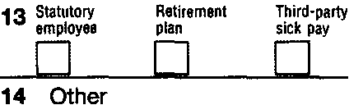

f Employee's address and ZIP code
15 State Employer's state 10 number
GA
5258974X12
Form W-2

16 State wages, tips, etc.
2248.98

17 State income tax
134.94

18 Local wages, tips, etc.

wage and Tax Statement
Copy 1-For State, City, or Local Tax Department

2011
Seth Bailey is an emancipated minor who did not graduate from high school. He works at a fast food chicken restaurant. He cannot be claimed as a dependent on his parents’ tax return and does not want $3 to go to the Presidential Election Campaign.

He does not have a bank account, so Seth cannot have his refund, if there is one, direct deposited.

Complete his Form 1040EZ and his Form 500EZ.

Department of the Treasury-Internal Revenue Service

