Insurance Needs for
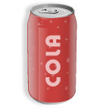
Product Liability
Insurance Company: ____________________
Premium Costs: $ __________ per _____________

Type of Coverage: _____________________________________

Type of Product Covered: _______________________________

Will this type of insurance coverage be enough to insure
against the risk of the product liability involved?
Why or Why not? _____________________________________________________
____________________________________________________________________________________________________________

