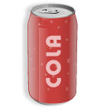
Things in Common

Explain that in each of these cases, as well as countless others, companies were held liable for injury incurred from these products.
Can the class think of any other examples?
What about the E. coli bacteria and Salmonella outbreak that was linked to peanut butter and spinach last year.
What about lead painted toys?
For the examples on the tray:
DentuCreme- contained dangerous levels of zinc.
Silly String- highly flammable; after incidents of children being burned during birthday parties, the manufacturer must now have labeled warnings on the product.
Toyota - Defective gas and brake systems caused numerous accidents; recalled thousands of vehicles

