Thermal Structure and Chemical Composition of the Atmosphere
The Earth is surrounded by a thin layer of gasses which, as you know, is called the atmosphere. The atmosphere is like a blanket around the Earth -- and is made up of 78% nitrogen, 21% oxygen, 0.9% argon, 0.03% carbon dioxide and trace amounts of other gasses. One of these gasses is water vapor, which is its most variable component. This means that the amount (abundance) of water vapor in the atmosphere is constantly changing, as we've explained in previous Lessons.
The atmosphere is at least 300 miles (480 km) thick, but most of it is within 10 miles (16 km) of the Earth's surface.
There is no exact spot where the atmosphere ends. It is most dense at the Earth's surface and gets thinner and thinner until it merges with outer space (some scientists think this happens about 800 miles up). At sea level, the pressure of the air is about 14.7 pounds per square inch. As height increases, air pressure decreases. At an altitude of 10,000 feet, air pressure is only 10 pounds per square inch (and there is much less oxygen).
Life on Earth is supported by the atmosphere, energy from the Sun, and the Earth's magnetic fields.
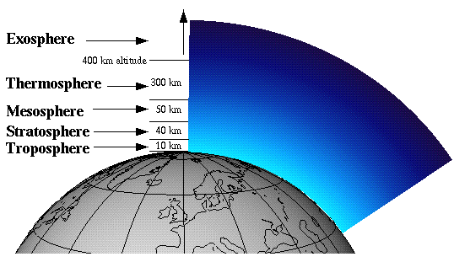
As you know, the atmosphere does three main things -- it absorbs energy from the Sun, recycles water and other chemicals, and works with electrical and magnetic forces to give us our moderate climate.
The atmosphere also protects us from high-energy radiation and the frigid vacuum of space -- and it changes as you go higher and higher.
Five distinct layers have been identified in the atmosphere -- using temperature, chemical composition, movement and density as yardsticks.
The Layers of the Atmosphere
The layers of the atmosphere, from the Earth up, are the Troposphere, the Stratosphere and the Mesosphere (which also contains the Ionosphere and the Exosphere).
Here is a graphic which shows these layers:
The Troposphere
The Troposphere starts at the Earth's surface and extends up to about 10 or 11 miles (17 km). This part of the atmosphere is the most dense.
The temperature in the Troposphere decreases as altitude increases, dropping from about +17 to -52 degrees Celsius. Almost all of Earth's weather and clouds are in this region.
The Troposphere is separated from the next layer, the Stratosphere, by the Tropopause. Scientists call the Tropopause and the Troposphere the lower atmosphere.
The Stratosphere
The Stratosphere starts just above the Tropopause and extends up to about 31 miles (50 km).
Compared to the Troposphere, this part of the atmosphere is dry and less dense. It is characterized by a slight increase in temperature (up to about -3 degrees Celsius) and the absence of clouds -- although a few of the very highest clouds do make it to the Stratosphere from time to time.
The increase in temperature is due to the absorption of ultraviolet radiation from the Sun.
The Ozone Layer, which is what absorbs and scatters this ultraviolet radiation, is located within the Stratosphere.
Ninety-nine percent of the "air" is located in the Troposphere and Stratosphere.
The Stratopause separates the Stratosphere from the next layer up, the Mesosphere.
The Mesosphere
The Mesosphere starts just above the Stratopause and extends up to about 50 miles (80 km). In this region, temperatures decrease in as you increase in altitude. It can get as cold as -93 degrees Celsius.
The chemicals here are in an excited state, as they absorb a great deal of energy from the Sun. The Mesopause separates the Mesophere from the next layer up, the Thermosphere.
The Stratosphere, Stratopause, Mesosphere and Mesopause are called the middle atmosphere.
The Thermosphere (Including the Ionosphere and Exosphere)
The Thermosphere starts just above the Mesopause and extends up to about 300 or 400 miles, or -- if you include the Exosphere -- up to about 800 miles (1280 km), which is where scientists think outer space begins.
The Thermosphere is called the upper (or outer) atmosphere.
Temperatures increase with altitude in the Thermosphere, due to the Sun's energy. Temperatures in this region can go as high as 1,727 degrees Celsius. Chemical reactions occur much faster here than on the surface of the Earth.
The Thermosphere contains both the Ionosphere and the Exosphere.
The Ionosphere is located in the lower part of the Thermosphere, beginning at about 43-50 miles from the surface of the Earth.
The Exosphere starts at about 400 miles up. Here is where the magnificent Auroras (Northern Lights) originate.

Handout courtesy of http://www.etap.org/demo/Earth_Science/es8/lesson.html

