Isobar and Pressure Maps

Part I. Isobar Map (online class activity)

Air pressure is determined by the weight of the overlying air and it varies from place to place and over time. Pressure variations bring about air motions that set the stage for much of the weather we experience. Knowing patterns of pressure across the country is basic to understanding what the weather is about.

Part II. Drawing Isobars on a Real Surface Air Pressure Map

Note: Lowest Pressure value And note: Highest Pressure Value
__________ ______________________________ ____________

Analysis Questions
- There were several areas of low and high pressure on this day (Did you remember to label these areas on the map with an H or L?). For the following areas, indicate whether the minimum or maximum pressure value in that area is a relative Low or High by circling the appropriate choice and list its value in millibars

Area Pressure Type Pressure value(mb)
Southern California High ….. Low ___________
Central East Coast High ….. Low ___________
Colorado High ….. Low ___________

Part III. Current Isobar Map.
Name:
Date:

- Name: Date:

Part III. Completing a Current Isobar Map
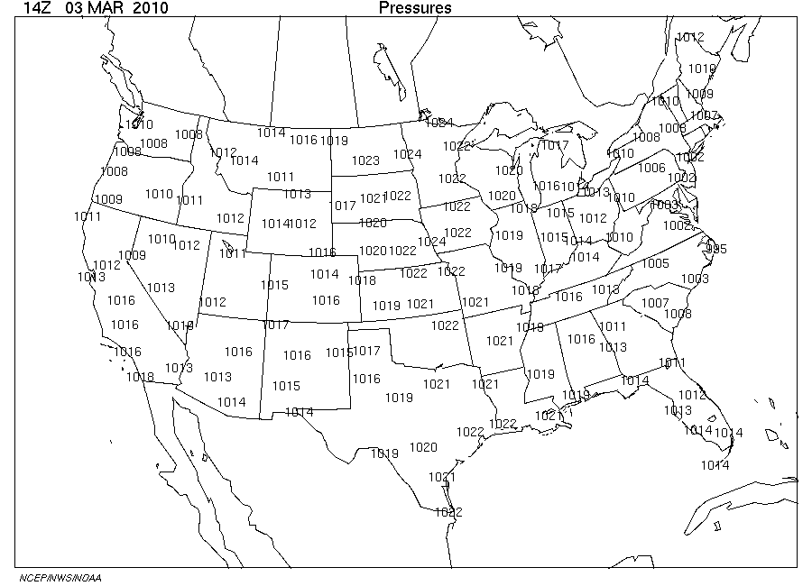
Name: Date:

Part III. Completing a Current Isobar Map (An duplicate in case you make a mistake)

