Surface Station Model
Temp (F)  Weather  Dewpoint (F) | 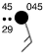 | Pressure (mb)  Sky Cover  Wind (kts) | Data at Surface Station  Temp 45 °F, dewpoint 29 °F,  overcast, wind from SE at 15 knots,  weather light rain, pressure 1004.5 mb

Upper Air Station Model
Temp (C)  Dewpoint (C) | 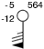 | Height (m)  Wind (kts) | Data at Pressure Level - 500 mb  Temp -5 °C, dewpoint -12 °C,  wind from S at 75 knots,  height of level 5640 m

Forecast Station Model
Temp (F)  Weather  Dewpoint (F) | 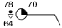 | PoP (%)  Sky Cover  Wind (kts) | Forecast at Valid Time  Temp 78 °F, dewpoint 64 °F,  scattered clouds, wind from E at 10 knots,  probability of precipitation 70% with rain showers

Map Symbols
Sky Cover | Wind  Shaft is direction wind is coming from | Fronts and Radar | Selected  Weather Symbols
clear | Calm | cold front | Rain
1/8 | 1-2 knots (1-2 mph) | warm front | Rain Shower
scattered | 3-7 knots (3-8 mph) | stationary front | Thunderstorm
3/8 | 8-12 knots (9-14 mph) | occluded front | Drizzle
4/8 | 13-17 knots (15-20 mph) | trough | Snow
5/8 | 18-22 knots (21-25 mph) | squall line | Snow Shower
broken | 23-27 knots (26-31 mph) | dryline | Freezing Rain
7/8 | 48-52 knots (55-60 mph) | Radar Intensities  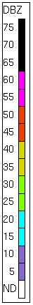 | Freezing Drizzle
overcast | 73-77 knots (84-89 mph) |  | Fog
obscured | 103-107 knots (119-123 mph) |  | Haze
Multiple rain or snow symbols indicate intensity,  i.e. light, moderate, heavy |  |  | Smoke
 |  |  | Dust or Sand
 |  |  | Blowing Snow

Station Model
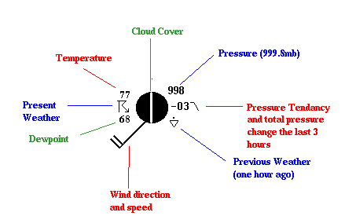

77: Temperature
68: Dewpoint
998: Pressure, to the nearest tenth of a millibar. Add either a 10 or 9 in front based on which would bring the value closer to 1000. The pressure here is 999.8 millibars (mb).
-03: Pressure tendency the last 3 hours, to the nearest tenth of a millibar. The pressure here has fallen .3 mb the last 3 hours
Middle Circle (filled in w/ mostly black): Cloud cover. It's mostly black showing that this station is mostly cloudy. Technically, this represents a broken sky with 7/8 of the sky covered with clouds.
Black line, extending from circle: Wind barb. It points to where the wind is coming from. The wind here is from the southwest, hence a southwest wind. The two lines extending represent 20 knot winds with each line representing 10 knots.
Symbol between 77 and 68: This is the present weather field and in this case shows that there is a thunderstorm occuring at the station
symbol next to -03: That line is the pressure tendency. The 1st hour the pressure was steady, then fell the last two hours.
Triangle(with a dot above it): Previous weather, or the weather one hour ago. In this case it was a light rain shower.

