Fronts
A front describes the boundary between two air masses containing different temperature and/or water vapor content.
Why do I care? Frontal passages mark changes in weather conditions and can be accompanied by rain, clouds, and even severe weather.
I should already be familiar with: Air Masses, Stability, Convergence & Divergence

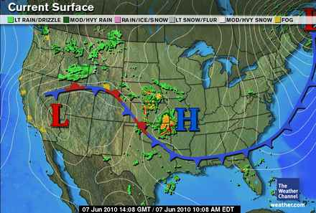
Figure A: Fronts Located on a Surface Weather Map
Image from The Weather Channel
Fronts mark the boundary between two air masses. The air masses can have large temperature contrasts over a short distance on either side of the front. There is often a shift in wind direction across the front as well as changes in temperature and humidity. Fronts on a weather map can also be located by the change in pressure along the front, since fronts are often associated with areas of low pressure. Warm fronts are represented by red semi-circles on a weather map. Cold fronts are represented by blue triangles on a weather map, and stationary fronts are represented by interchanging the symbols for warm and cold fronts on weather maps.
Warm Front
A warm front is the surface boundary between a warm air mass and a cold air mass it is overtaking. The warm air moves into an area of colder, drier air. The air masses do not readily mix; therefore the warm air rises slowly over the colder air because it is less dense. This produces clouds and precipitation well ahead of the approaching warm front, since warm air in the southeastern US usually has higher water vapor content than cool air. Steady precipitation usually persists along the boundary of a warm front. This amount of precipitation, however, depends on the amount of moisture in the air ahead of the surface front. If the warm air is relatively dry and stable, precipitation would not be likely to occur. If the air is moist and conditionally unstable, heavy precipitation could occur over a broad area.
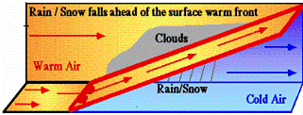
Figure B: Warm Front Weather Conditions
Image from NOAA
During the winter, an approaching warm front is likely to bring about hazardous winter weather conditions. Along the warm front, near the surface, where temperatures are relatively warm, rain will be the likely precipitation form. Outside of this rain area ahead of the warm front, sleet or freezing rain will persist in an area that is at or just below freezing. Snow will be the likely precipitation component further ahead of the warm front where the temperature profiles are completely below freezing.
Precipitation increases over an area as the front approaches. Winds ahead of the approaching warm front will be out of the south or southeast in the Northern Hemisphere. After the warm front has passed, the winds will shift to out of the south or southwest and the air temperatures will have warmed and leveled off. Behind the warm front is a warm sector, where the air mass is usually relatively warm and moist. Severe storms could possibly be located in this warm sector that is ahead of the approaching cold front if the air mass is unstable.
Cold Front
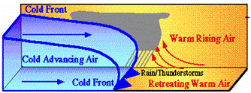
Figure C: Cold Front Weather Conditions
Image from NOAA
A cold front separates a cold, dry air mass from a warm air mass. The cold air mass pushes under the warm air mass because of its higher density, forcing this warm air to rise. If enough moisture exists in the atmosphere at this time, then clouds and possibly thunderstorms could develop. Cold fronts move much faster than warm fronts. Cold fronts are represented as blue triangles on a map and move in the direction that these “teeth” are pointing. Cold fronts are usually accompanied with areas of low pressure. Winds blow counter-clockwise around an area of low pressure in the Northern Hemisphere. With this in mind, the wind direction before a cold front passes would usually be out of the south or southwest with warm air temperatures. After the cold front passes, the winds would shift to out of the west or northwest and the air temperature would steadily drop.
A narrow band of precipitation is likely ahead of the cold front boundary. Depending on the amount of moisture in the air and the speed of the approaching cold front, the area of precipitation could in fact range from no precipitation to heavy precipitation. During the summer months, an approaching cold front is likely to bring thunderstorms with the possibility of severe storms. This occurs in the warm sector between the warm and cold fronts where severe thunderstorms and tornadoes are likely to occur.
Stationary Front
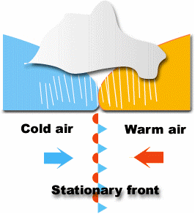
Figure D: Stationary Front
Image from University of Illinois
A stationary front is the boundary between two different air masses with different densities when neither is advancing. The air masses are not moving strongly enough to overtake each other, so the front remains in one place. Winds along a stationary front are usually parallel to the front blowing in opposite directions on either side which is one reason why the front does not move. Stationary fronts essentially have no surface movement, or very slow movement of less than 5 mph at the surface. However, warm air from the warm air mass can still be moving over the top of the colder air farther up in the atmosphere.
When one of the air masses moves into the other air mass, the stationary front will begin to move. When this transition occurs, the front will then either be classified as a warm front or a cold front, depending on which air mass is pushing ahead.
Along some stationary fronts, the weather is clear to partly cloudy. If both of the air masses are relatively dry, then no precipitation will fall. However, in some stationary fronts where there is a lot of water vapor in the warmer air mass, significant rain or freezing rain can occur. Some of the worst ice storms and flooding in the Southeast occur in these conditions because rain falls continuously over an area for several days as the front stays in one place.

Occluded Front
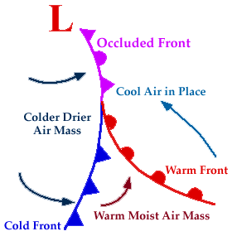
Figure E
Image from University of Illinois
Occluded fronts form when a cold front catches up to a warm front because cold fronts move along much faster than warm fronts do. The cold front over takes the warm front and cold air moves into cooler air ahead of the warm front. Occluded fronts are represented on weather maps as alternating warm and cold front symbols in purple pointing in the direction the front is moving. Occluded fronts are not particularly common in the southeast US. The low pressure centers may begin in the south, but will typically move to the northeast and form an occlusion farther north. The precipitation patterns for an occluded front typically follow the same patterns as a cold front. Temperature will vary after the occluded front passes depending on the different air masses that are interacting with the occlusion.
Figure E is an example of an occluded front. The colder, drier air is moving in to replace the cooler air above the warm front. The cooler air will rise up over the colder, drier air and the front will move in the direction the purple symbols are pointing.

