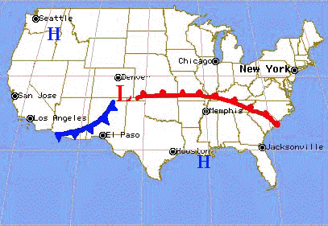
Fronts

What happens along cold fronts and warm fronts?
The boundary between two air masses is called a front. As a result, moving fronts indicate a change in the weather. On a weather map fronts are drawn where there is large change in temperature and a shift in wind direction. A front can also be described as the boundary between adjacent Highs with different conditions.
On a weather map, fair weather is generally associated with Highs while stormy weather is associated with Lows and with the portions of fronts that extend from them. Highs and Lows are usually hundreds or thousands of miles across. Both Highs and Lows tend to travel from west to east across the United States, bringing changing weather as they move.
The image above shows an example of a weather map containing a warm and cold front. A cold front means a cold air mass is pushing into a warmer air mass, and is shown with blue sharp "teeth" pointing the direction of the moving cold air. A warm front means a warm air mass is pushing into a colder air mass, and is shown with red rounded "teeth" pointing the direction of the moving warm air.

Exercise 3:
- This activity will assist you in interpreting weather maps on which fronts are already identified. Use the map above to complete the following activity.
Imagine that you are located at El Paso, Texas on the map.
1. As the cold front approaches, what changes in the sky condition do you expect?
2. What changes in wind direction will occur as the front passes?
3. At the time the front passes what change in temperature will occur?
Imagine that you are located at New York City, New York on the map.
4. What changes will occur in the sky condition prior to the arrival of the warm front?
5. As the warm front passes, what changes do you expect in wind direction?
6. After the front passes, what changes in weather do you predict?
The rainfall is usually different along cold fronts and warm fronts. Along cold fronts, the air is pushed up rapidly and the front quickly passes. The rain is often more stormy and relatively brief. Along warm fronts, the air is pushed more slowly over the cold air mass. The rainfall is usually more gentle and extended in duration.
7. Over which city, New York or El Paso, are thundershowers more likely to occur? Why?
8. Draw a table similar to the one below and fill in the characteristics of Highs and Lows in the blanks.
Characteristic | HIGH | LOW
Pressure | ________________ | ________________
Surface Winds | ________________ | ________________
Sky Condition | ________________ | ________________

