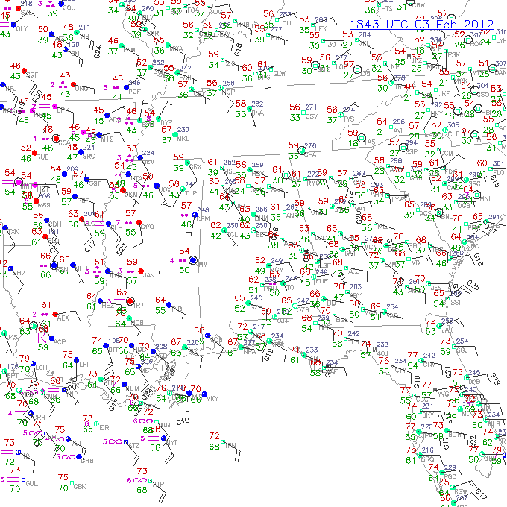
Southeast Surface Map (Feb. 3, 2012)

