Name: __________________________
Date:___________________
Thunderstorms Quiz
- When there are advancing cold and warm fronts, what kind of thunderstorm is created?
- Thunderstorms are classified by:
- What effect does an increase in the instability of the air have on the strengths of a thunderstorm’s updrafts and downdrafts?
- In the developing (cumulus) stage of a thunderstorm, what happens?
- Label the fronts on the image:
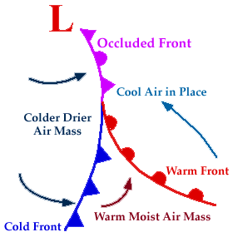
- _________________
C. _______________

B. _______________

