Drawing Conclusions Activity Packet-ANSWER KEY

ANSWER KEY Activity 1: Learning Lesson: Drawing Conclusions - Surface Pressure Map Solutions

Solution 1
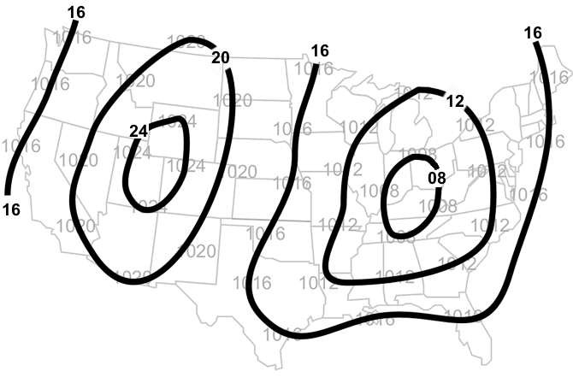
Solution 2
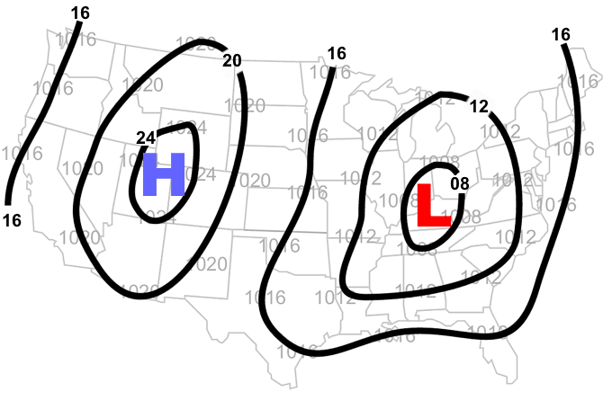

Solution 3
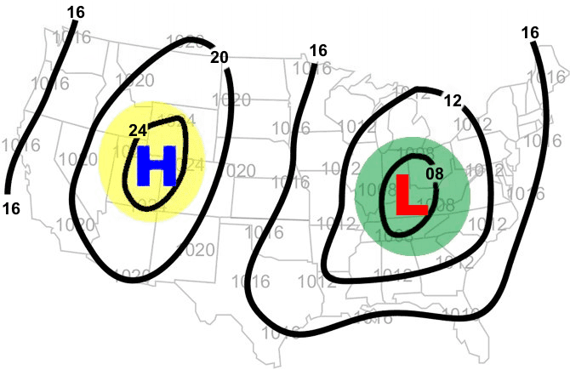

Solution 4
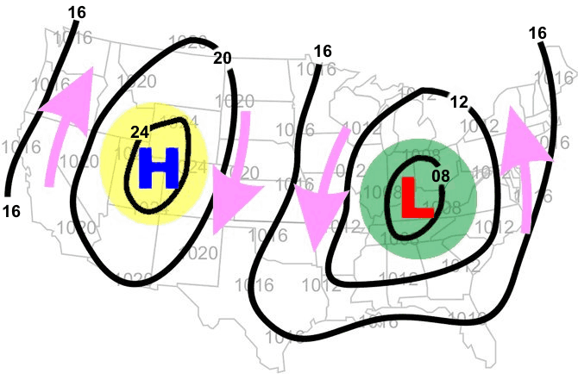

ANSWER KEY Activity 2: Learning Lesson: Drawing Conclusions - Surface Temperature Map Solutions

Solution 1
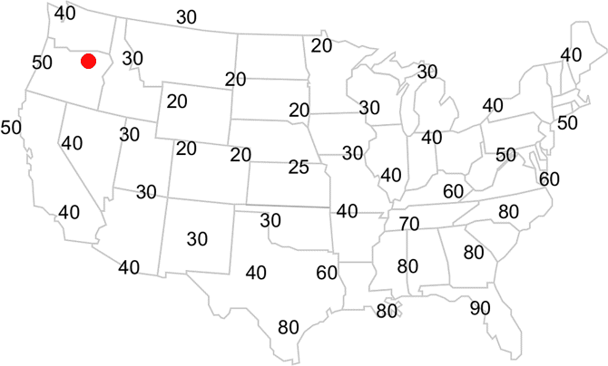
Solution 2
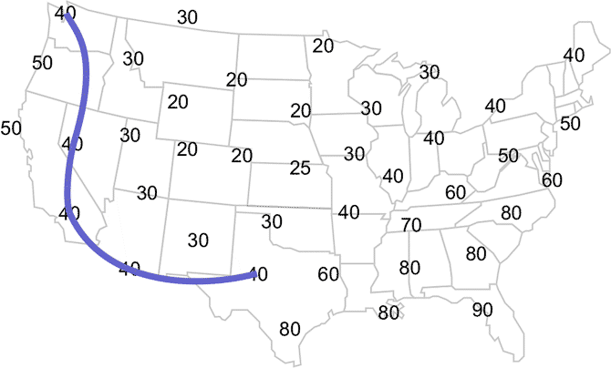

Solution 3
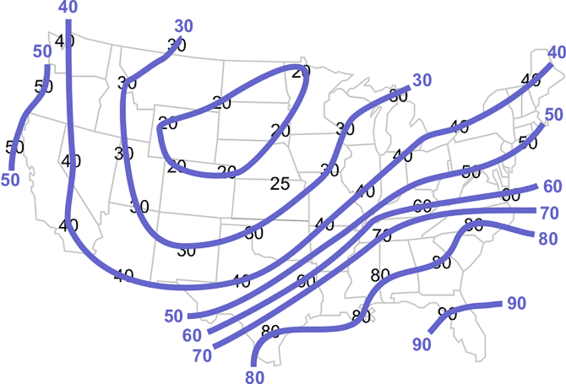

Solution 4
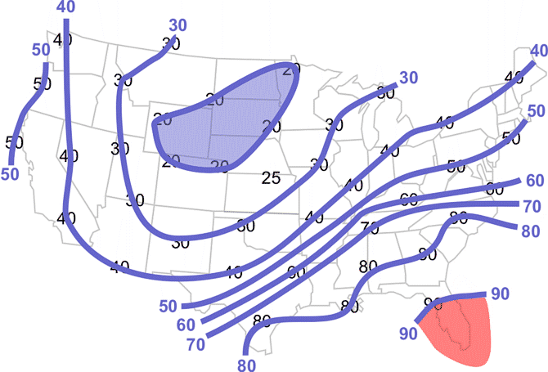

ANSWER KEY Activity 3: Learning Lesson: Drawing Conclusions - Dewpoint Temperature Map Solutions

Solution 1
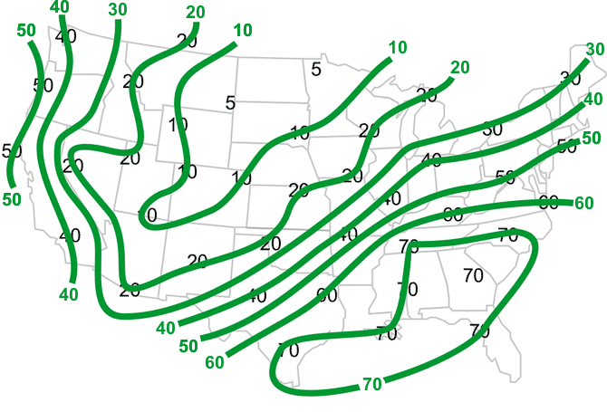

Solution 2
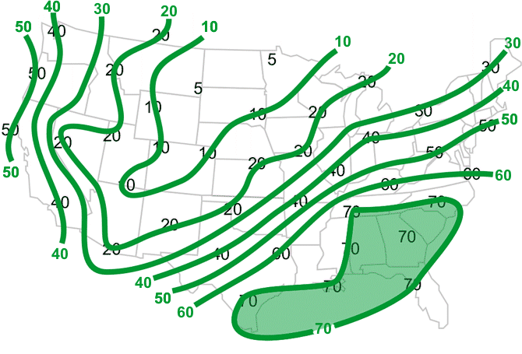

ANSWER KEY Activity 4: Learning Lesson: Drawing Conclusions - Surface Pressure Change Map Solutions

Solution 1
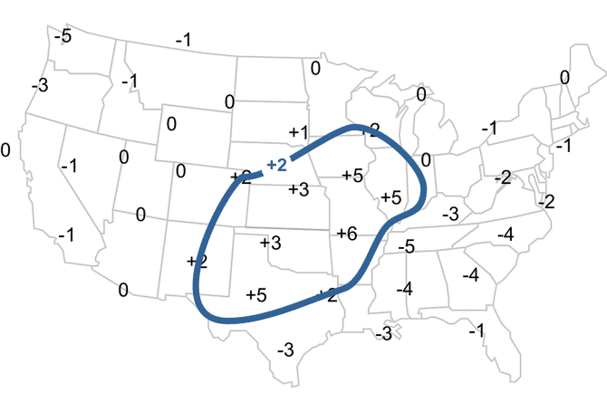
Note: Every value within the blue circle has a pressure change greater than +2 millibars.

Solution 2
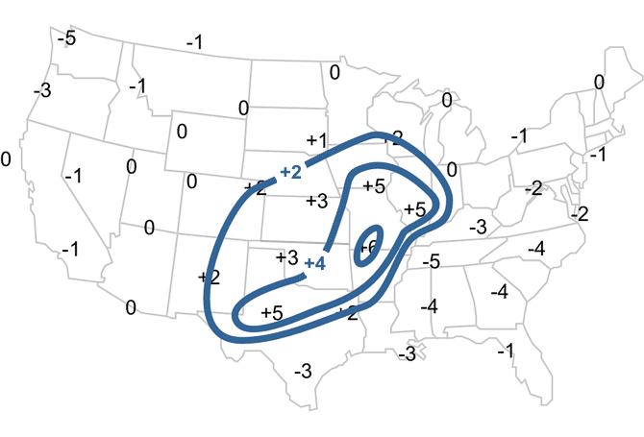

Solution 3
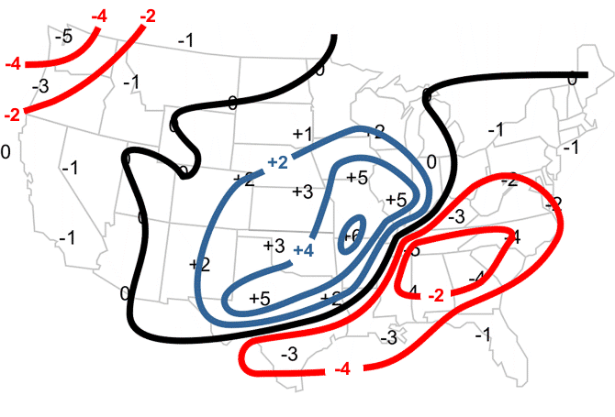

Solution 4
