Forecast Process Exercise
Chicago Forecast: "Current weather is cloudy with drizzle as a warm front is passing; temperatures will rise and the skies will clear as the front moves past our area; winds will continue from the southwest; air pressure will remain relatively steady."
1. 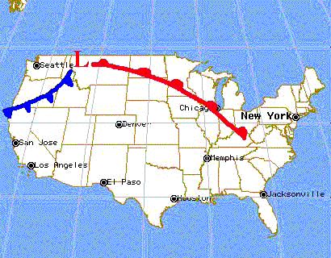 2. 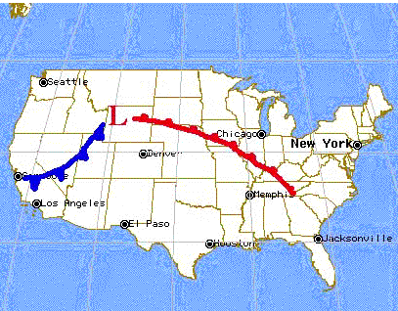
3. 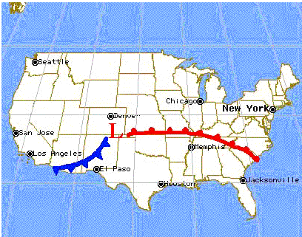 4. 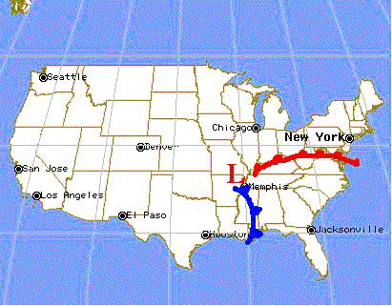
5. 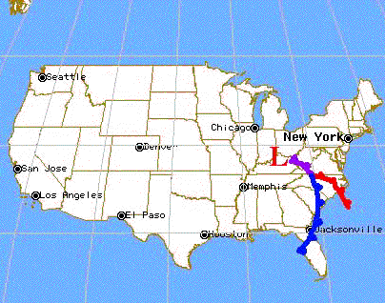
Study the pictures. Notice that as the Low moves across the country, the associated fronts advance around the center of the Low. It works somewhat like a spinning top traveling across a floor. As the top moves across the floor, the top itself continues to spin. Also notice the relative speed of motion of the two fronts around the center of the Low. The cold front, advancing more quickly than the warm front, eventually "catches" the warm front. The approaching cold front "arm" pushes the warm, moist air upward like a bulldozer pushes dirt. Recall that precipitation occurs as the warm moist air ahead of a cold front rises. (The "squeeze play" involves a fast-moving bulldozer (cold front) rear-ending a slower moving truck (warm front) ahead of it, moving in the same direction. When the collision occurs, the contents of the truck (precipitation) are pushed out.)
Prediction Activity #1:
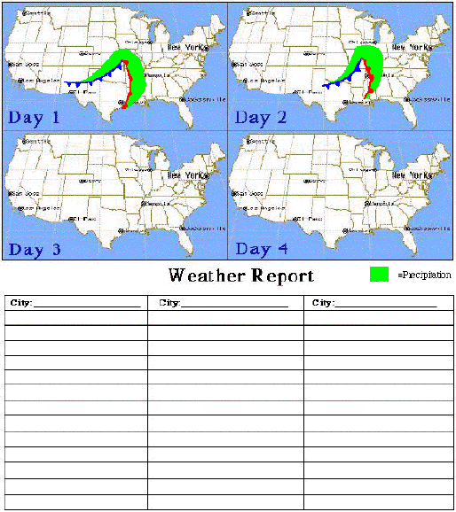
1. You are a weather forecaster. Given the first two days of a four day forecast sequence, predict and draw the sequence of forecast images for the next two days (complete on the image above). Notice the distance the Low (L) and High (H) travel in a one day period, and use that to predict how it will travel over the last two days. Use the first two day sequence to estimate the speed at which the cold front approaches the warm front.
2. As a weather forecaster you must explain these maps to your viewing or reading audience. Write a weather report explaining your forecast sequence. Include forecasts for Denver, Memphis, and Chicago. Discuss changes in pressure, wind direction, wind speed, temperature, and sky condition.
Have a class discussion and check your prediction before continuing on to the next section.
Your task now is to make a forecast for the next several days and compare it with the real weather that occurs.
Prediction Activity #2:
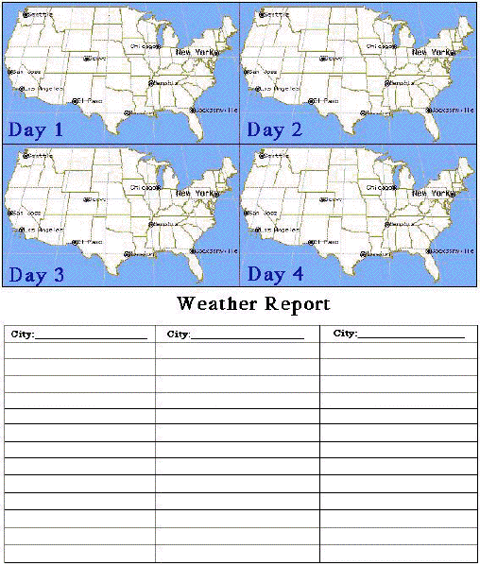
1. You are a weather forecaster. Have your teacher pull up today's forecast and place fronts and Highs and Lows on the Day 1 map. Return tomorrow to check the weather and observe movements over 24 hours.
2. In the Day 2 map draw the location of fronts and Highs and Lows on your second day of observations. Given the first two days of a four day forecast sequence, predict and draw the sequence of forecast images for the next two days. Use the shifts that have occurred between day 1 and day 2 to estimate the locations of warm and cold fronts in relation to each other in your drawings.
3. As a weather forecaster you must explain these maps to your viewing or reading audience. On a separate sheet of paper, write a weather report explaining your forecast sequence. Include forecasts for Chicago, Memphis, and Denver. Discuss changes in pressure, wind direction, wind speed, temperature, and sky condition.
4. Check your predictions and forecast reports over the next two days. Discuss the accuracy of your predictions and suggest possible factors that may have resulted in inaccuracies.
Have a class discussion and check your prediction before continuing on to the next section.
In reality, low-pressure centers and fronts rarely move at constant speed and in exactly the same direction from day to day. Many variables will influence predictions over several days. (eg- the jet stream, high-pressure movement, mountains, large bodies of water, high altitude conditions, etc.). You, as well as all forecasters, cannot expect to be perfect in your predictions. It is, however, interesting to test our skills of prediction.
CONGRATULATIONS! You are on your way to forecasting. You may not have been 100% accurate, but you have learned some of the basic skills used in the science of predicting the weather. There are many more factors you can research and skills you can learn to become a better forecaster.
Good luck. Keep practicing, revising and checking your skills.

