Forecast Process Exercise ANSWER KEY

Prediction Activity #1 Answer:
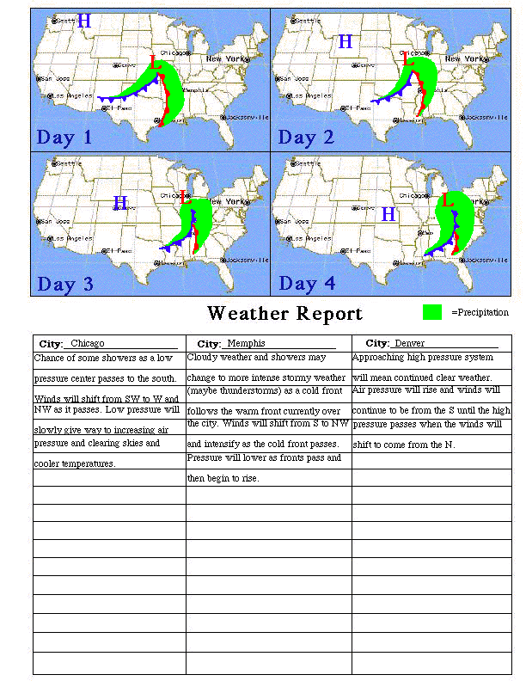

Prediction Activity #2 Answer:
Answers will vary based on the day you start the activity. Check the daily report at http://maps.weather.com/maps/maptype/currentweatherusnational/uscurrentweather_large.html

