Radar and Thunderstorms

Background Material
How it works and how it’s used in meteorology
Similar to last week, below you will find informational notes for radar. Imbedded in these notes you will find figures which are very helpful in understanding what radar is, how it works, and the different types used in meteorology. Included in the exercise are some examples, to get you used to the different kinds of radar imagery.
Starred (*) figures are taken from the WW2010 Project at the Department of Atmospheric Science, University of Illinois-Urbana/Champaign. Figures noted with a (+) appear courtesy of Pete Chaston, National Weather Service, Ret.

RADAR
  - Radio Detection and Ranging
  - Sends out a pulse, listens for return signal
  - Wavelength of 5-10 cm
  - Beam is typically 1° inclined and 1.5° wide, and rotates to see a full circle or sweep
  - Typically sweeps out 200 nautical miles
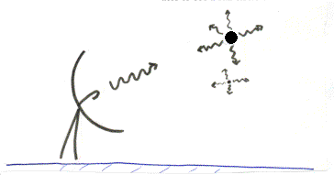
CONVENTIONAL radar
  - The more signal which bounces back, the more intense the echo or reflectivity = more intense precipitation
  - Echoes are displayed on a radar screen
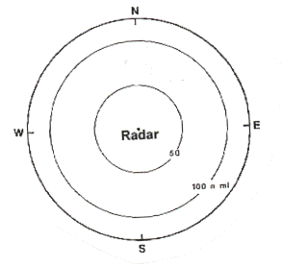
  - Radar screen is color enhanced to show intensity of precip
  - Can not only sweep in a circle, but can also be moved up and down in clouds, look at different levels, individual storms
  - These images are usually labeled BASE REFLECTIVITY

Conventional radar Good for:
  - Seeing bands/location of precipitation and their intensity
  - Hook echoes
  - Bow echoes
Some problems:
  - Ground clutter, bouncing off things other than precipitation
  - Overestimation/Underestimation of precipitation (See Handouts)
  - Cannot tell type of precipitation by radar alone!! (Have to use temperatures, actual observations, etc.

DOPPLER Radar
  - Operates on principle of Doppler shift
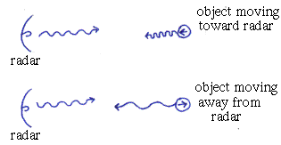
  - Measures the actual speed/direction of the wind NOT the actual amount of signal reflected. Image will be labeled with some kind of VELOCITY term, like STORM RELATIVE VELOCITY
  - Many so-called Doppler radars can operate in either a conventional or Doppler mode. The weather community shows reflectivities, or conventional data, to the general public. I.E...
    - As a civilian, you will almost NEVER see the velocity or Doppler wind field image!
    - Just because they call it a Doppler doesn’t mean it’s in Doppler mode...
Doppler Good for:
  - Showing tornado vortex signatures, mesocyclones (also see below)
  - Wind shear
  - Anything for which you need information about the wind field

NEXRAD- Next Generation Radar - A specific kind of Doppler
  - A software used with the WSR-88D series Doppler radar (Weather Service Radar, 1988 Doppler)
  - Uses data obtained by both Doppler and Conventional radar to work out algorithms for detecting mesocyclones, hail, tornadoes, etc.
Good for:
  - Short term forecasting and warnings during severe weather events
  - Finding mesocyclones, tornado vortex signatures, microbursts, hail and hook echoes. Might catch these things before the human eye does!
  - Can monitor storm motion
LIDAR- Light detection and ranging
- Experimental, but small wavelength makes it useful
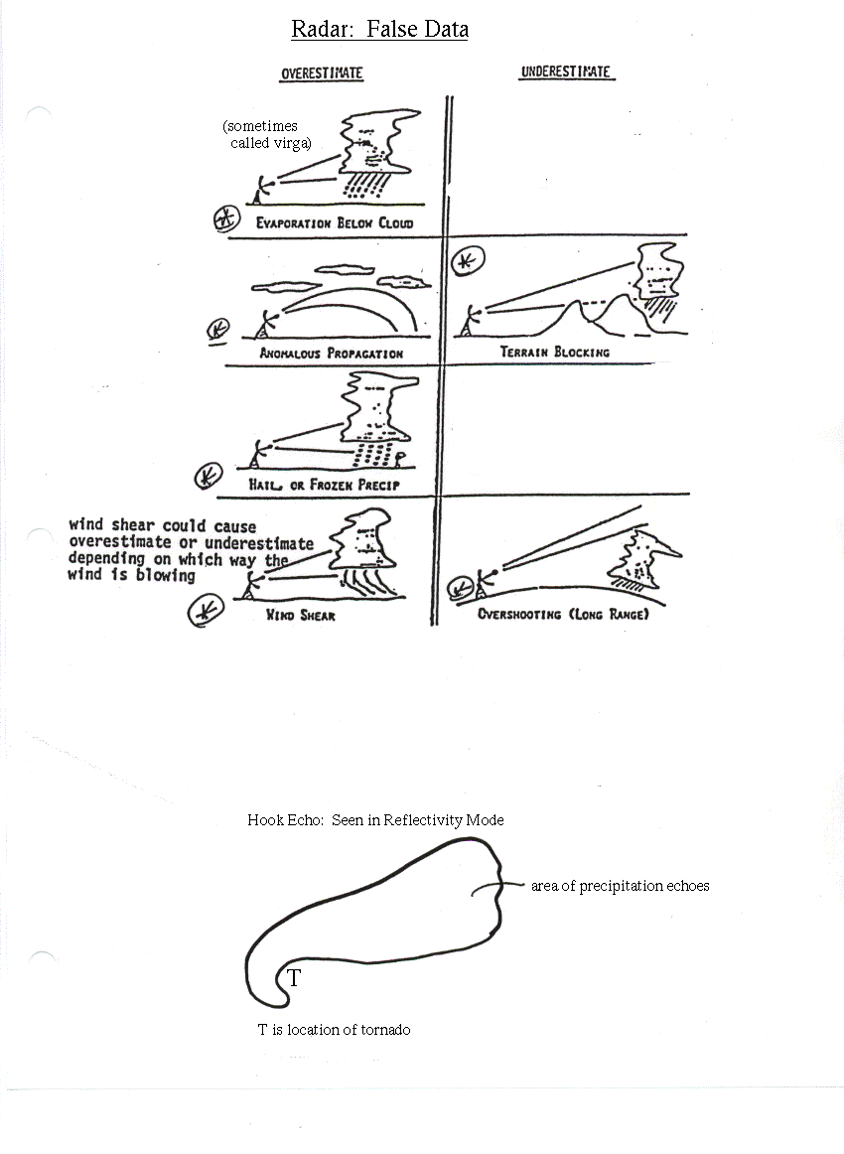
- More resolution--Can actually see clear air convection using very tiny particles such as aerosols

