Upper Air Maps
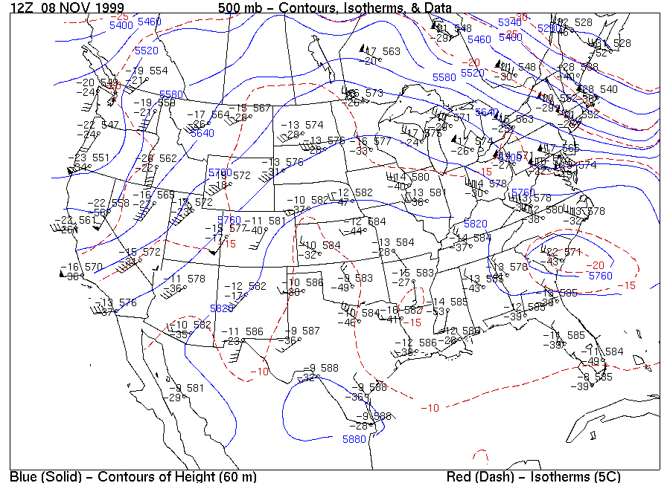
Here is an 500 mb upper air map. The height contours are in blue and the red dotted lines are temperature. Notice, that high heights are associated with warmer air.

It is important to identify the troughs and ridges on these upper air maps. Circle the large scale ridge with a green pen or marker. Circle the large scale trough in black.
Here is an example of the relationship between the weather at the surface and the flow of air at middle levels of the atmosphere. Using red, blue, and yellow pens or markers, draw in all of the fronts. In particular, note the position of the cold front and low pressure system at the surface on the west coast. Is this under a trough or a ridge when viewing the upper air map at 500 mb? Also notice the upper level ridge of the 500 mb map that is over the central US (i.e. Nebraska, Kansas, Iowa, etc.) and the weather at the surface. Do notice a relationship between the cloudiness beneath the ridge?
Now make observations about the relationship between the weather at the surface and the flow at 300 mb.
