Name: _________________________
500mb Chart vs. Surface Chart

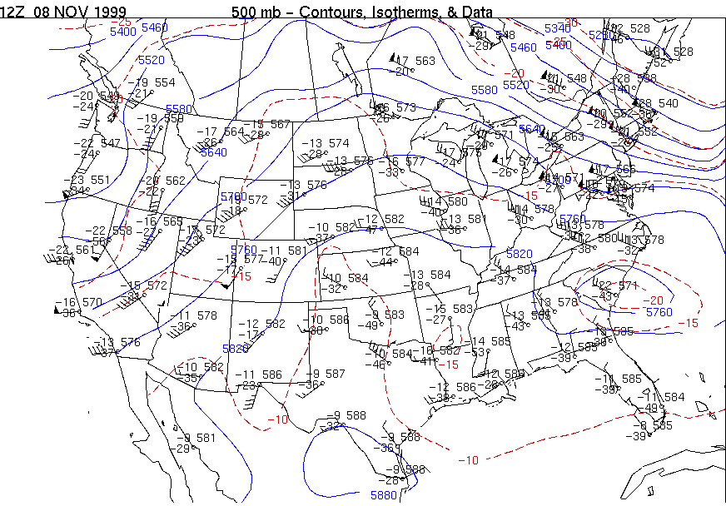

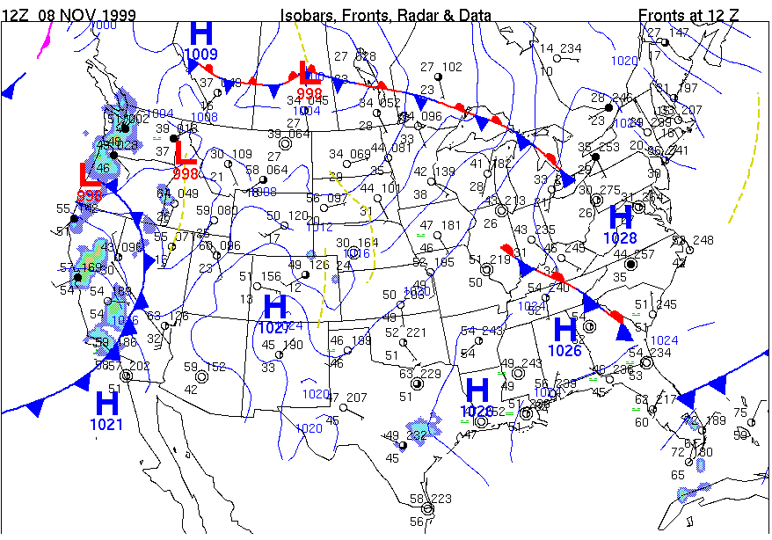

What are the differences between the 500mb chart and the surface chart?

