Jet Stream Activity with Directions for Making Pressure Blocks

Module 9 / Westerlies and the Jet Stream

http://www.cmos.ca/ProjectAtmosphere/module9_westerlies_and_the_jet_stream_e.html

Adopted from Project Atmosphere Canada

Project Atmosphere Canada
Project Atmosphere Canada (PAC) is a collaborative initiative of Environment Canada and the Canadian Meteorological and Oceanographic Society (CMOS) directed towards teachers in the primary and secondary schools across Canada. It is designed to promote an interest in meteorology amongst young people, and to encourage and foster the teaching of the atmospheric sciences and related topics in Canada in grades K-12.
Material in the Project Atmosphere Canada Teacher's Guide has been duplicated or adapted with the permission of the American Meteorological Society (AMS) from its Project ATMOSPHERE teacher guides.

Acknowledgements
The Meteorological Service of Canada and the Canadian Meteorological and Oceanographic Society gratefully acknowledge the support and assistance of the American Meteorological Society in the preparation of this material.
Projects like PAC don't just happen. The task of transferring the hard copy AMS material into electronic format, editing, re-writing, reviewing, translating, creating new graphics and finally format- ting the final documents required days, weeks, and for some months of dedicated effort. I would like to acknowledge the significant contributions made by Environment Canada staff and CMOS members across the country and those from across the global science community who granted permission for their material to be included in the PAC Teacher's Guide.
Eldon J. Oja
Project Leader Project Atmosphere Canada
On behalf of Environment Canada and the Canadian Meteorological and Oceanographic Society
All rights reserved. No part of this publication may be reproduced, stored in a retrieval system, or transmitted, in any form or by any means, electronic, mechanical, photocopying, recording or otherwise without the prior written permission of the publisher.
Permission is hereby granted for the reproduction, without alteration, of materials contained in this publication for non-commercial use in schools or in other teacher enhancement activities on the condition their source is acknowledged. This permission does not extend to delivery by electronic means.
Published by Environment Canada © Her Majesty the Queen in Right of Canada, 2001Cat. no. En56-172/2001E-IN
ISBN 0-662-31474-3

Contents

The Upper-Air Westerlies
Introduction
Activity

The Jet Stream
Introduction
Basic Understandings
Activity

Introduction - The Upper-Air Westerlies

The Upper-Air Westerlies
Many properties of the atmosphere vary dramatically as we move upward from the surface. Because most of the sun's rays readily pass through the clear atmosphere to warm the planet's surface, the atmosphere is strongly heated from below. Thus, the highest temperatures are typically found at the Earth's surface and decrease as altitude increases. This bottom atmospheric layer of decreasing temperatures, ranging from 6 to 16 km in depth, is called the troposphere or "weather layer".
Above the troposphere, we find a layer of air whose temperature increases with altitude. The cause of this heating is the absorption of solar ultraviolet radiation by oxygen species and chemical reactions which form and dissociate ozone (the three-atom species of oxygen). Here ozone is naturally formed and destroyed, and several of the components of the process release heat which is then transferred to the surrounding air. The effect of this warming produces a layer of constant temperature topped by a layer of increasing temperatures with altitude. This layer is called the stratosphere or "stable layer". The boundary zone between the troposphere and the stratosphere, where the temperature stops decreasing and becomes constant with height, is termed the tropopause.
Both air pressure and air density decrease with increasing altitude. Air pressure is the weight per unit surface area of an air column extending from the given height to the top of the atmosphere. Therefore, atmospheric pressure is greatest at sea level.
Air is highly compressible, as is readily seen by inflating a tire. Therefore, it is most dense at the bottom of the atmosphere where the weight of the air above compresses it to high densities. At higher altitudes, the air is less dense because of the lesser weight of overlying air at upper levels. The result is that both air pressure and air density initially decreases very rapidly with altitude and then decrease more slowly. Half of all air molecules are found within only 5.5 km of sea level. The next one-quarter of the atmospheric mass is located between 5.5 to nearly 11 km.
Not only do atmospheric properties such as temperature, pressure and density vary with altitude, but so does the nature of the air's motion. On the planetary (or global) scale the winds blowing at middle latitudes in the middle and upper troposphere blow predominantly from the west. These upper-air, prevailing westerlies encircle the globe in a wave-like pattern, undulating north and south as they flow along the latitude belt.
The upper-air winds play an important role in the daily march of weather across the planet. They push air masses from their regions of origin and steer storm systems from one place to another.
Understanding the basic characteristics of these upper-air (tropospheric) westerlies is a prime key to understanding the variability of mid-latitude weather.

Activity - The Upper-Air Westerlies
After completing this activity, you should be able to:
- Describe the wave patterns exhibited by the meandering upper-air westerlies.
- Explain the general relationships between the upper-air westerlies and the paths surface air masses and storms take.

Investigations
- The upper-air westerlies flow generally from west-to-east around the planet in a wave-like pattern of ridges and troughs undulating northward and southward as shown in Figure 1. Ridges are topographic crests, usually pointing northward, and troughs are elongated depressions, usually pointing southward, on constant-pressure surfaces in the Northern Hemisphere. In Figure 1, the "H" locates ridges and "L" locates troughs on this constant-pressure map.

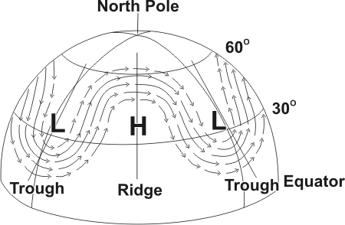
Figure 1 - Northern Hemisphere depicting upper-air westerlies with troughs and ridges
- The upper-air westerlies exhibit clockwise (anticyclonic) curvature in ridges. As shown in Figure 1, a line can be drawn that divides a ridge into two, often symmetrical, sectors. Such a line is known as the ridge line. Note that west of the ridge line, winds are from the southwest (a warm weather direction) and east of the ridge line, winds are from the northwest (a cold weather direction). We conclude that winds to the west of a ridge line favour (cold, warm) advection, and winds to the east of a ridge line favour (cold, warm) air advection.
- The upper-air westerlies curve counterclockwise (cyclonic) in troughs. As shown in Figure 1, a line can be drawn that divides a trough into two roughly symmetrical sectors. The line is known as a trough line. Note that west of the trough line, winds are from the northwest (a cold weather direction) and east of the trough line, winds are from the southwest (a warm weather direction). We conclude that winds to the west of a trough line favour (cold, warm) air advection, and winds to the east of a trough line favour (cold, warm) air advection.
- Ridges and troughs usually progress from west to east so that as a ridge line shifts eastward, a location that had been experiencing cold air advection then experiences warm air advection. Similarly, as a trough line moves eastward, a location that had been experiencing warm air advection then experiences cold air advection.
- Upper-air winds steer low pressure systems as well as air masses in the direction of their flow. A surface low that is centred to the east of a trough line and west of a ridge line can be expected to move toward the (northeast, southwest).
- The wavy pattern of the upper-air westerlies consists of ridges alternating with troughs. The distance between successive ridge lines or, equivalently, between successive trough lines is termed the wavelength. At any one time, the number of waves encircling the Earth in the middle latitudes is usually 3, 4, or 5. The amplitude of the wave pattern is the distance between the extreme northern position of the ridge line and the extreme southern position of the trough line. At one extreme, shown in Figure 2a, upper-air westerlies blow almost directly from west to east with little sign of ridges and troughs. This westerly flow pattern is described as zonal, because the flow is along the latitude zones, and the amplitude is small. At the other extreme, shown in Figure 2b, upper-air westerlies blow in huge north/south loops with high amplitude ridges and troughs. This westerly flow pattern is described as meridional because the flow tends to align itself more with the meridians. The circulation patterns displayed in Figures 2a and 2b are the opposite extremes of many possible patterns exhibited by middle latitude upper-air westerly waves.
- With time the wave pattern of the upper-air westerlies moves and changes. These changes may involve a change in the number of waves, the wavelength, or the amplitude of the wave.
- When the upper-air westerly flow pattern across Canada is zonal, the source region for much of the air over Canada is from the Pacific Ocean. On the other hand, when the upper-air flow pattern is meridional, the air over Canada generally originates from cold air masses from the High Arctic (in areas where winds are from the northwest) or warm air masses from the southern United States and/or the Gulf of Mexico (where winds are from the southwest).
- Go to the Environment Canada Web Site to view the latest 500 hPa upper-air analysis chart: http://weatheroffice.ec.gc.ca Navigate to the Weather Maps page, select Analysis Charts and click on the 500 hPa Analysis Chart
- Using the 500 hPa analysis provided in Figure 3, examine the analysis and the patterns, troughs and ridges drawn on the map from the perspective of:
  - Describing the wave patterns exhibited by the meandering upper-air westerlies.
  - Explaining the general relationships between the upper-air westerlies and the paths air masses and storms take.
- As a supplementary activity, examine the latest 500 hPa analysis found on the Environment Canada Web Site to view the upper-air westerlies within the context of "today's" weather patterns.

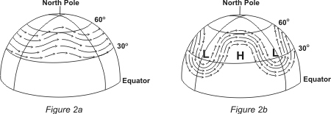

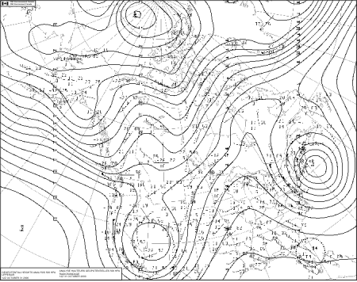
Figure 3 - Environment Canada 500 hPa Analysis for 12Z Oct 31, 2000. The solid lines on the chart are called 'contours" or iso-lines where the height above sea level of the 500 hPa level are the same. Click on the figure to enlarge for viewing

Introduction - The Jet Stream
As World War II was approaching its conclusion, the United States introduced the first high-altitude bomber, an airplane called the B-29. It could fly at altitudes well above 6 kilometres. When the B-29s were being put into service from a Pacific island base, two air force meteorologists were assigned to prepare wind forecasts for aircraft operations at such altitudes.
To make their prediction, the meteorologists primarily used surface observations and what is known in meteorology as the “thermal wind” relationship. In plain language, this relationship states that if you stand with your back to the wind, and the air is colder to your left and warmer to your right, the wind speed on your back will get stronger as you ascend in the atmosphere. Using this relationship, the meteorologists predicted a 168-knot wind blowing from the west. Their commanding officer could not believe the forecast, believing the forecast speed much too high. However, on the next day, the B-29 pilots reported wind speeds of 170 knots from the west as predicted! The jet stream, as it would come to be known, was discovered.
Actually atmospheric scientists had theorized the existence of jet streams at least as early as 1937. The bomber pilots just confirmed it. Today, almost every radio and television weathercast mentions the positions of jet streams and their impact on daily and coming weather events.

The Jet Stream
The jet stream is a narrow current of relatively strong winds concentrated as in the upper atmosphere. There are two main jet streams found in the global circulation: the subtropical jet stream and the polar-front jet stream (also known as the polar jet stream and often just the jet stream).
The subtropical jet stream is found between the tropical and middle latitude atmospheric circulations. Although not as clearly related to surface weather features as its polar counterpart, the subtropical jet sometimes reaches as far north as the southern United States. It is an important transporter of atmospheric moisture into storm systems.
The polar-front jet stream occurs over the polar front, where relatively cold air at higher latitudes comes in contact with warm air from the lower latitudes, and near the tropopause. It has an important influence on the weather of the middle latitudes. This is of special interest to meteorologists because of its influence on the development and maintenance of middle-latitude storm systems which evolve where warm and cold air masses come in contact.
The polar-front jet stream encircles the globe at altitudes between 9 and 13 kilometres above sea level in segments thousands of kilometres long, hundreds of kilometres wide, and several kilometres thick. It generally flows from west to east in great curving arcs as it undulates north and south. It is strongest in winter when core wind speeds are sometimes as high as 400 kilometres per hour.
The polar-front jet stream's location is one of the most influential factors on the daily weather pattern across North America. Meteorologists focus on the nature and position of the polar-front jet stream as they prepare weather forecasts. Changes in the jet stream indicate changes in the movement of weather systems and thus changes in weather.
The jet stream is also of great importance to aviation, as the B-29 pilots quickly found out. Westbound, high-altitude flight routes are planned to avoid the jet-stream head winds, which would slow the aircraft and consume precious fuel. Eastbound flights welcome time-saving tail winds from the jet stream to increase their speed and thus save fuel. However, the jet stream produces strong wind shears, large changes in wind speed over short vertical and horizontal distances, in some locations. The resulting air turbulence experienced in shear zones can be very hazardous to aircraft and passengers.

Basic understandings - The Jet Stream

Characteristics of the Polar-Front Jet Stream
- Jet streams are relatively high speed west-to-east winds concentrated as narrow currents at altitudes of 9 to 14 kilometres above sea level. These meandering “rivers” of air can be traced around the globe in segments thousands of kilometres long, hundreds of kilometres wide and several kilometres thick.
- Two high-altitude jet streams affect the weather of middle latitudes; they are the subtropical jet stream and the polar-front jet stream.
- The subtropical jet stream is located between tropical and middle latitude atmospheric circulations. Although not clearly related to surface weather features, it sometimes reaches as far north as the southern United States. It is an important transporter of atmospheric moisture into storm systems.
- The polar-front jet stream is associated with the boundary between higher latitude cold and lower latitude warm air, known as the polar front. Because of its link to surface weather systems and features, the polar-front jet stream is of special interest to weather forecasters.
- The polar-front jet stream is embedded in the general upper-air circulation in the middle latitudes where winds generally flow from west to east with broad north and south swings. As seen from above, these winds display a gigantic wavy pattern around the globe.
- The maximum wind speeds in the polar-front jet stream can reach speeds as high as 400 kilometres per hour.
- The average position of the polar-front jet stream changes seasonally. Its winter position tends to be at a lower altitude and at a lower latitude than during summer months.
- Because north-south temperature contrasts are greater in winter than in summer, the polar-front jet stream winds are faster in winter than in summer.
- Small segments of the polar-front jet stream where winds attain their highest speeds are commonly known as a jet streak or jet max (maximum). One or two jet streaks are usually present in the polar-front jet stream crossing North America.

What Causes the Polar-Front Jet Stream?
- Fundamental to the formation of the polar-front jet stream is the physical property that warm air is less dense than cold air when both are at the same pressure.
- The polar front represents the boundary between higher latitude cold air and lower latitude warm air. This temperature contrast extends from the Earth's surface up to the altitude where the polar-front jet stream is found.
- In the vicinity of the polar front, air pressure drops more rapidly with an increase in altitude in the more dense cold air than in the less dense warm air.
- The effect of temperature on air density results in air pressure at any given altitude being higher on the warm (equatorward) side of the polar front than on the cold (poleward) side.
- When cold and warm air reside side by side, the higher the altitude, the greater the pressure difference between the cold and warm air at the same altitude.
- Across the polar front, at upper levels (including the jet stream altitude), horizontal pressure differences cause air to flow from the warm-air side of the front towards the cold-air side of the front.
- Once this air is in motion, it is deflected by the Earth's rotation (called the Coriolis effect) from flowing directly from high to low pressure. Upper-level air flowing poleward from higher pressure towards lower pressure is deflected to the right in the Northern Hemisphere (or to the left in the Southern Hemisphere). The resulting flow produces a jet stream moving generally towards the east, parallel to and above the polar front.

Relationships between the Polar-Front Jet Stream and Our Weather
- The polar-front jet stream exists along the region where cold polar air and warm air masses are in contact. Hence, weather is relatively cold when the polar-front jet stream is south of a particular location and relatively warm when the jet stream is north of the location.
- The polar-front jet stream can promote the development of storms. Storms are most likely to develop under a jet streak.
- As a component of the planetary-scale prevailing westerly circulation, the polar-front jet stream steers storms across North America, generally from west to east.
- Go to the Environment Canada Web Site to view the latest 250-hPa upper-air analysis chart: http://weatheroffice.ec.gc.ca Navigate to the Weather Maps page, select Analysis charts and click on the 250 hPa Analysis Chart
Using either the Environment Canada 250 hPa analysis from the web or the sample CMC Environment Canada 250 hPa Analysis Chart found in Figure 4, examine the patterns, troughs and ridges drawn on the map from the perspective of:
- Describing the wave patterns exhibited by the meandering upper-air westerlies.
- Explaining the general relationships between the upper-air westerlies and the Jet Steam.

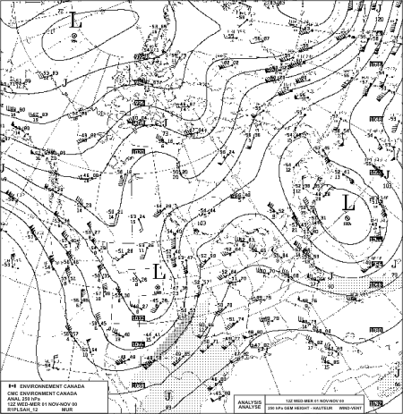

Figure 4 - CMC Environment Canada 250 hPa Analysis Chart for 12Z Nov 1, 2000

Activity - The Jet Stream

Jet Stream Investigation
The location of the polar-front jet stream is often closely related to the daily weather pattern across North America. The following two activities investigate the causes of jet streams and the relationships of the polar-front jet stream with surface weather.
Each activity can be stand-alone. One activity does not need to be done before the other. However, Activity 1 requires the construction of two sets of five pressure blocks. There are two sets of instructions for making the pressure blocks. The first suggestion is for the construction of a permanent set of pressure blocks while the second option uses more readily available but less durable material for classroom exercises. Finally, Activity 1 requires more time to complete than Activity 2.

Pressure Blocks Construction
Materials
- 1 red file folder, 1 blue file folder, tape, scissors, ruler, pencil
Procedure
- You will be making two sets of pressure blocks, 5 large red blocks and 5 small blue blocks. Both sizes of blocks will be constructed from the same size card shown below.
- The pattern below has guidelines for the large and small blocks. Copy and cut out the pattern. On the red file folder, trace the pattern edges for a set of 5 cards. Make tick marks indicating the position of the LARGE guidelines. Draw the LARGE guidelines across each card. On the blue folder, repeat the process except make tick marks for and draw in the SMALL guidelines across each card. Cut out all 10 cards.
- To form a block, fold a card along the top and bottom guidelines you have drawn. Make a sharp crease. Unfold the card.
- Fold the card in half, bringing the short sides together. Make a sharp crease. Fold the card in half again in the same direction. Make a sharp crease. Unfold the card.
- With scissors, clip the long edge of the card on the fold creases up to the line you drew.
- Fold the card into a box (short sides together). Tape edge. Fold and tape down flaps at either end. Repeat for all cards (blocks).
- Since the same size card was used in every block, you now have 10 blocks each of equal weight. The bases of the blocks also have the same size.

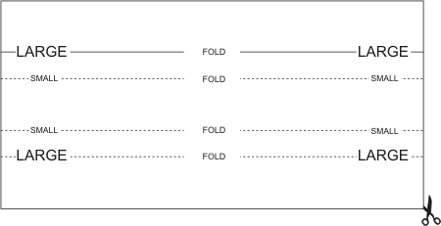

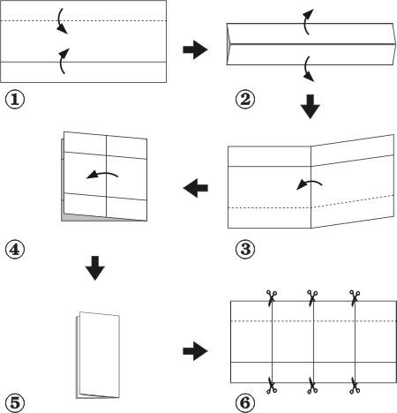
Construction of a Permanent Set of Pressure Blocks
Cut blocks from solid materials such as wood or insulation material. The blocks should all have the same size square bases. The tall blocks should be twice the height of the short blocks. All blocks should weigh the same. Adjust the weight by drilling holes in the short blocks and inserting metal weights. Paint short blocks blue and tall blocks red.

Activity 1 - Pressure, Air Pressure and Jet Streams
Upon completing this activity, you should be able to:
- Explain what pressure is and how it can vary vertically and horizontally.
- Describe how density contrasts between warm and cold air produce pressure differences at different levels in the atmosphere.
- Explain how pressure differences in the atmosphere can lead to high-speed winds called jet streams.

Introduction
One of the most important properties of the atmosphere is air pressure. It is important because differences in air pressure from place to place put air into motion just as in the case of air rushing out of the open valve of an inflated tire. Pressure differences at altitudes of nine or more kilometres lead to the development of high-speed winds, called Jet Streams.
This activity uses sets of blocks to investigate basic understandings about pressure and pressure differences produced by density variations. These understandings are then applied to the atmosphere to introduce the basic causes of jet streams.

Materials
- Two 5-block sets of Pressure Blocks (See Pressure Blocks Construction)
- Two 8 cm X 13 cm cards (or index cards), pencil, straight edge

Investigations
To study pressure, we must first define it. Pressure is a force acting on a unit area of surface Air pressure is the weight (weight is a force) of a column of air acting on a unit area of horizontal surface, e.g. kilopascal (kPa) is a pressure unit. To represent the concept of pressure concretely, two sets of blocks with the following characteristics will be used.

- all blocks have the same weight,
- all blocks have the same size square bases,
- all blocks exert the same downward pressure on the surface beneath them (because the same weight is acting on the same size base).
- Take one block from each set and place it on its square base on a table surface. Because both blocks weigh the same and their bases have the same area, the blocks exert (equal), (unequal) pressure on the table.
- The shorter blocks have half the volume of the taller blocks while containing the same mass (we know this since they weigh the same). Because density is mass per unit volume, the smaller blocks are (twice) (half) as dense as the larger blocks.
- Place another identical block on top of each block already on the table. Each stack is now exerting (the same) (twice the) amount of pressure on the table as it did initially. The pressure exerted on the table by the tall stack is (equal) (not equal) to the pressure exerted on the table by the short stack.
- Position the two stacks side-by-side and add another identical block to each stack (for a total of 3 in each stack). Insert an index card horizontally through the two stacks so that two shorter blocks and one taller block are positioned beneath the card. Compare the pressures exerted on the card by the overlying blocks. The taller-block stack exerts (greater) (equal) (less) pressure on the card than does the shorter-block stack.
- Add a short block to its respective stack. Lift the top tall block and overlay the stacks with another index card. Add the rest of the blocks to their respective stacks. The pressure exerted on the table by the tall stack remains (equal) (unequal) to the pressure exerted on the table by the short stack.
- Each block exerts one unit of pressure (1 UP) on the surface beneath it. In the table below, indicate the pressure in UP units each stack exerts on each surface. For each surface, compute and record the pressure difference between the two stacks.
- Starting at the table top and moving upward, the difference in downward pressure exerted by the overlying portions of the stacks (increases) (decreases). In the (taller less dense), (shorter more dense) stack, the pressure decreases more rapidly with height.
- Look at Figure 5: Pressure Blocks, Side View. Following the examples shown, draw lines on the chart to record the positions of the tops/bottoms of all the blocks so the chart represents a side view of the two stacks. Place a large dot at the mid-point of each top/bottom line you drew. Following the examples given, use a straight edge to draw lines from the dots in one stack to the dots in the other stack representing the same pressures. These lines connecting equal pressure dots become (more) (less) inclined with an increase in height.
- Figure 6: Vertical Cross Section of Pressure shows a cross-section of the atmosphere based on upper-air soundings obtained simultaneously at Norman, Oklahoma (OUN) and at The Pas, Manitoba (YQD) approximately 2,175 kilometres to the north of Norman. Air pressure values in hectopascals (hPa) are plotted as dots at the elevations where they were observed, starting with nearly identical values at the surface. At Norman (OUN), the air pressure at approximately 12,300 meters above sea level was (300) (250) (200) hPa.
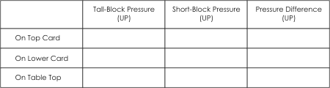

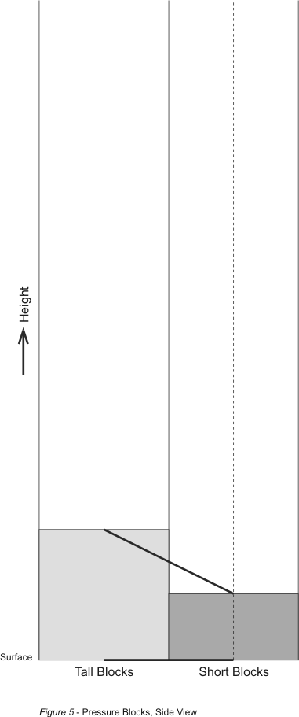
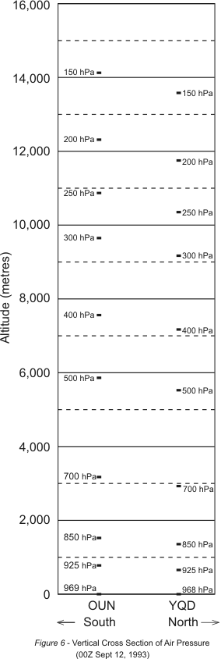

- Air above The Pas, station YQD, was colder and therefore more dense than the air above the more southern station, OUN. Following the examples shown at the surface and at 925 hPa, draw straight lines connecting equal air-pressure dots on the graph. Above the Earth's surface these lines representing equal air pressures are (horizontal) (inclined).
- Compare the lines of equal pressure you drew on the two figures. They appear quite different because one deals with rigid blocks while the other deals with air, and secondly, their scales are much different. However, both reveal the effect of density on pressure. The lines of equal pressure slope (downward) (upward) from the lower-density tall blocks or warm air column above OUN to the higher-density short blocks or cold air column above YQD, respectively.
- Because of the sloping of the equal-pressure lines in Figure 6, it can be seen that at 12,300 meters above sea level the air pressure in the warmer air at OUN is (higher than) (the same as) (lower than) the air pressure in the colder air at YQD.
- Because air is gaseous, air pressure at any point acts in all directions. Differences in air pressure arising from differences in air density produce horizontal forces directed from higher to lower pressure. Thus, air is put into motion horizontally from where the pressure is higher towards where the pressure is lower. Draw a horizontal arrow at the altitude of 12,300 meters to show the direction the horizontal force is acting at that elevation. This arrow points towards the (north) (south).
- Air put into motion by these horizontal forces does not flow directly towards lower pressure. It is deflected by the Earth's rotation. This change in direction is called the Coriolis effect. In the Northern Hemisphere, air is deflected to the right of the direction towards which it is moving until it is travelling along a path perpendicular to the pressure-generated force. Which statement best describes the motion of the air under the influence of a pressure generated force (represented by your arrow) and the Coriolis effect?
  - Air flowing southward turns right until it is moving towards the west.
  - Air flowing northward turns right until it is moving towards the east.
- At the time the upper-level observations were made, the highest wind speeds were recorded where the air pressure was near 200 hPa. Accordingly, the maximum wind speed was probably occurring near the altitude of (10,000 ), (12,000), (14,000 ) meters above sea level.
- These upper-level high-speed winds, produced in large part by the density differences between warm and cold air, tend to concentrate in "rivers" of air. They are called jet streams. In Figure 7, the Upper-Level Exercise Map, the dark line represents the approximate location of the jet stream at the time the OUN and YQD observations were made. Draw an arrowhead on one end of the jet stream to show the direction the air is flowing.

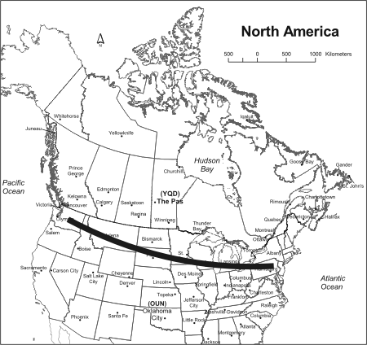
Figure 7 - Upper-Level Exercise Map

Activity 2 - The Polar - Front Jet Stream
Upon completing this activity, you should be able to:
- Determine the location of the polar-front jet stream based upon upper-atmosphere wind data.
- Describe influences of the polar-front jet stream on weather and aviation.

Introduction
The polar-front jet stream is like a high-speed river of air in the upper atmosphere. It separates warm and cold regions at the Earth's surface. It may be several hundred kilometres across from north to south, 1,500 to 3,000 meters thick and at an altitude of 9,000 to 13,000 meters. The polar-front jet stream generally flows from west to east, and is strongest in the winter when core wind speeds are sometimes as high as 400 kilometres per hour. Changes in the jet stream indicate changes in the circulation of the atmosphere and associated local weather.

Materials
- pencil

Investigations
The highest upper-level wind speeds are frequently observed at altitudes of approximately 9 to 13 kilometres above sea level. In Figure 8, the upper air data chart displays plotted data depicting wind speed and direction observed at 12Z (7 a.m. EST) at altitudes where the air pressure was 250 hectopascals (hPa). At map time, the actual altitudes at which the air pressure was 250 hPa varied from 9,030 metres to 10,970 metres above sea level. Upper level data are routinely displayed on constant-pressure charts because of the usefulness of such charts to meteorologists. The data were acquired by tracking balloon-borne weather instruments, called radiosondes, which measure and transmit weather data as they rise through the atmosphere.
Wind information is depicted by "arrows" or “wind barbs” at locations on the map where radiosondes were launched. On the wind bard, the straight line represents the wind direction while the feathers represent the wind speed. Winds are named for the direction from which they are blowing. Wind speed is reported in knots (1knot equals 1.9 kilometres per hour); each full-length feather represents 10 knots, each half feather stands for 5 knots, and each flag means 50 knots. For example, in Figure 8, the plotted 250 hPa upper air data for The Pas, MB at 12Z on September 13, 2000 depicts a wind from the west-north west with a speed of 60 knots (or 114 km/h).

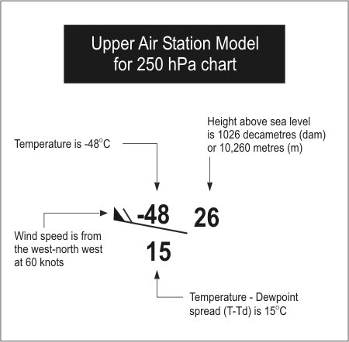

The wind information at the 250 hPa level received from each radiosonde can be plotted on a chart and used to analyze the upper air wind patterns and to locate the jet stream. In Figure 9, you will find the upper air 250 hPa data for 12Z Ocotber 13, 2000 plotted and also a number of shaded area. Within the shaded areas, the wind speeds at 250 hPa are 60 knots or greater. The darker the shading the higher the wind speed, i.e. 60 kts, 90 kts and 120 kts, which will help you identify the jet stream and the jet streak or jet max (or maximum). In this case, the jet maximums exceed 100 knots. The dotted lines encircling these shaded areas connects the points where the winds speed is 60 knots and are referred to as isotachs.
1. Using Figure 8, with a pencil, draw a line or lines to enclose the region(s) where the 250 hPa wind speeds are 60 knots or greater. Lightly shade the enclosed area. Draw a dark, heavy, smooth, curved arrow through the core of highest wind speeds. Add an arrowhead to show wind direction. Note: In Figure 8, you will see 4 stations with a dotted circle around them, which have been flagged by the computer that some aspects of the data set may have an error. So do not use those circled stations in your analysis.
2. The large arrow you drew on your map approximates the location of the existing polar-front jet stream across North America. Now imagine that you are in a gondola attached to a helium-filled balloon that is located over Prince George, BC. Assuming your balloon stays at the 250-hPa level, describe your path as you travel across the country. Over what cities, provinces or US states are you likely to pass over as you cross North America? At what point would you leave the east coast?
______________________________________________
______________________________________________
______________________________________________
______________________________________________
______________________________________________
3. What is your approximate speed measured with respect to the surface of the Earth?
_______________________________________________
4. Even though the wind speed is 60 knots or greater, as measured relative to the ground, an anemometer attached to the gondola shows the wind to be calm. Explain why.
_______________________________________________
______________________________________________
______________________________________________
______________________________________________
______________________________________________
______________________________________________
______________________________________________
______________________________________________

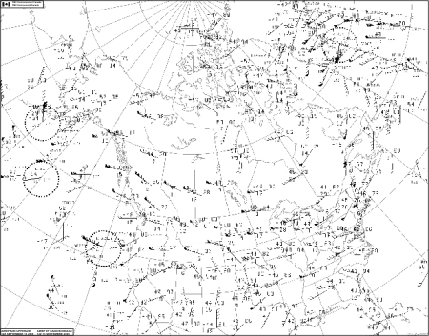
Figure 8 - CMC Environment Canada 250 hPa upper air chart depicting plotted data for 12Z September 13, 2000. Wind speeds are plotted in knots (1knot equals 1.9 km/h). Click on the figure to enlarge for viewing

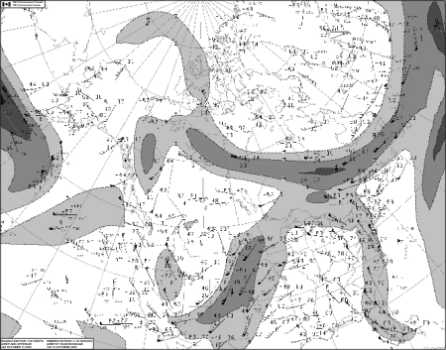
Figure 9 - CMC Environment Canada 250 hPa upper air chart depicting plotted data and Jet Stream analysis for 12Z October 13, 2000. Wind speeds are plotted in knots (1knot equals 1.9 km/h). Click on the figure to enlarge for viewing

5. Look at winds on either side of the jet. The winds on either side of the jet are (slower) (faster) than the jet stream winds and have (the same), (a different) direction.
6. The polar-front jet stream is like a "river" of high-speed air embedded in the planetary-scale circulation of the atmosphere. The drawings below in figures 10a and 10b illustrate the wavy and westerly (or eastward) flow of air at upper levels in the middle latitudes of the Northern Hemisphere (planetary-scale circulation). The wave pattern can vary considerably in amplitude (latitude range).
a) Indicate which drawing (10a) or (10b) best matches the upper-air flow of Figure 4.
b) Which drawing (10a) or (10b) best matches today's the upper air flow as depicted by the 250 hPa analysis found on the Environment Canada web site?
7. Across North America, storms tend to follow the path of the polar-front jet stream. In Figure 9, a storm in the Denver area at map time is likely to be moving towards (the Great Lakes), (Florida).
8. Knowledge of the location of the jet stream is very important to commercial aviation. Explain why at map time on figure 8, an airline flight from Montreal to Vancouver would take considerably more time than a flight from Vancouver to Montreal.
_____________________________________________
_____________________________________________

