Aviation Navigation Measurement
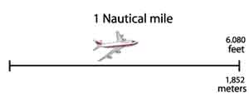 | Knots and Nautical Miles  Knots and Nautical Miles All navigation uses the Nautical Mile as the unit of distance. Traditionally a nautical mile is 6,080 feet but more precisely 6,076.11549 feet. In metric measurement it is 1,852 meters, which is one minute of arc of a great circle of the Earth. Even under the metric system, the unit of distance for navigation is still called the nautical mile. One knot converted to miles per hour (mph) would be approximately 1.15 mph. One mile per hour would be 0.868 knots. A statute mile is the common "mile" with a length of 5,280 feet. Therefore a statute mile is not as long as a nautical mile. One nautical mile would equal approximately 1.15 statute miles. Making the conversion from nautical miles to statute miles would be done as 120 nautical miles x 1.15 statute miles = 138 statute miles. Converting from statute to nautical miles would require dividing by 1.15. Therefore 200 statute miles would equal (200 / 1.15 = 174) 174 nautical miles.  Many of the air navigational terms come from our heritage of sea navigation. In the days of wooden sailing vessels, the speed of a sailing ship was measured by unraveling a knotted rope into the water behind the moving ship. The number of knots in the rope that passed over the railing in a given amount of time would indicate how fast the ship was moving (its number of knots). It is this same term that is used in aeronautics and aviation to indicate flight speed, however without the knotted rope trailing behind the aircraft.
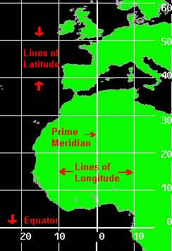 | Latitude / Longitude  A reference system is used with which an exact location on the Earth's surface can be pinpointed. This system uses designated lines of latitude and longitude. Latitude measures north and south of the equator, and longitude measures east and west of the prime meridian (located in Greenwich, England).The latitude of an exact location is expressed in terms of degrees, minutes and tenths of a minute. One minute of latitude equals 1/60th of a degree. The North Pole, for example, is 90 degrees north of the equator. This is written as N9000.0. The South Pole is located at 90 degrees south of the equator and is written as S9000.0. The longitude of an exact location is expressed in terms of degrees, minutes and tenths of a minute, also. One minute of longitude equals 1/60th of a degree. The longitude of the airport at Miami, Florida is located, for example, approximately 80 degrees west of the prime meridian. Precisely, this is written as W08016.6, and expressed as 80 degrees and 16.6 minutes west of the zero meridian. The airport at Perth, Australia is located approximately 115 degrees east of the zero meridian and is written as E11557.5. This is expressed as 115 degrees and 57.5 minutes east. Combining both latitude and longitude, the location of the airport in Miami, Florida is N2547.1 and W08016.6. This measure is used globally and communicates clearly to all pilots the same locations.
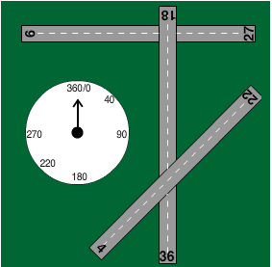 | Compass Directions  In navigation and surveying all measurement of direction is performed by using the numbers of a compass. A compass is a 360° circle where 0/360° is North, 90° is East, 180° is South, and 270° is West. Runways are laid out according to the numbers of a compass. A runway's compass direction is indicated by a large number painted at the end of each runway. A runway's number is not written in degrees, but is given a shorthand format. For example, a runway with a marking of "14" is actually close to (if not a direct heading of) 140 degrees. This is a southeast compass heading. A runway with a marking of "31" has a compass heading of 310 degrees, that is, a northwest direction. For simplicity, the FAA rounds off the precise heading to the nearest tens. For example, runway 7 might have a precise heading of 68 degrees, but is rounded off to 70 degrees.  Move Cursor over Runway Designator and  Observe Compass Heading
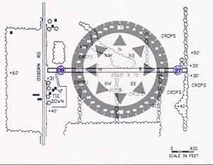 | Each runway has a different number on each end. Look at the diagram at left. One end of the runway is facing due west while the other end of the runway is facing due east. The compass direction for due west is 270 degrees ("27"). The compass direction for due east is 90 degrees ("9"). All runways follow this directional layout. This runway would be referred to as "Runway 9-27" because of its east-west orientation.
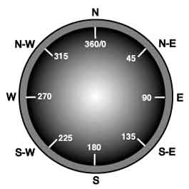 | Applying this to navigation means that pilots do not turn right or left, or fly east or south exactly. To fly east the pilot would take a heading of 90° . To fly south, the compass heading would be 180°. Look at the compass at left to note the compass headings for northeast, southwest and west.

