Real Time Flight Tracker Activity Handout
Another way to add vectors is to use mathematics, in particular the Pythagorean theorem and/or the trigonometric functions sine, cosine, and tangent.
Pythagorean Theorem & Trig Functions
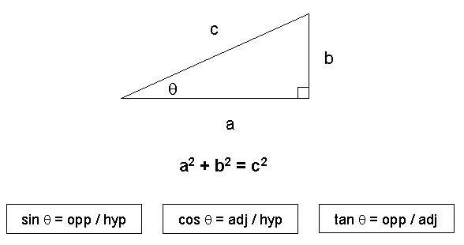
A) Real Time Flight Data
- Write down all of the flight information given to you by your teacher. You will also be using this information for Lesson #5.
- Review the flight terms given on the website and answer the following questions.
a) What is the definition of altitude?
b) What are the units for altitude?
c) What is the definition of distance?
d) What are the units for distance?
- Find and record the following information. One of these conversion calculators may help you.
a) What is the plane's current location?
b) What is the plane's arrival location?
c) What is the distance between the plane's current and arrival locations (in km)?
d) What is the plane's altitude (in km)?

B) Determine Resultant
Draw a diagram like the one below that shows all of the information from above on the diagram. Make sure that altitude and distance are given in the same units.
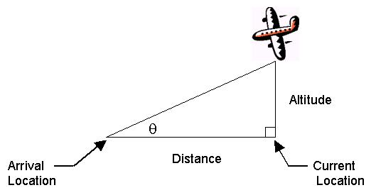

- Find the distance between the plane's location in the air and the arrival location on the ground using the Pythagorean Theorem. Do the results surprise you? Why or why not?
- Find the angle q that the plane makes with the ground (in degrees) using one of the trig functions.
- Draw a sketch of the triangle above to scale. Use the values of altitude, distance from current location to arrival location, and angle to construct the triangle. What would happen to the resultant if q got even smaller? What would happen to the resultant if q got larger?
- Check your work on the web site below. Record the distance and directional heading between your plane's current nearest city and the arrival city.
How Far is it? - Find the distance between two cities (km) and directional heading (degrees)
- How does the distance between the plane's current nearest city and arrival city compare with the distance between the plane's current location and arrival location given on the Flight Tracker site? Which one do you think is more accurate? Why?
- Should the angle the plane makes with the ground be similar to the plane's directional heading? Why or why not?
C) Ready to Become a Pilot?
- A captain is heading his boat directly across a river with a very strong current. As the first mate, you must advise him how the river current will affect the boat's movement. Prepare a drawing, diagram, 3D model or other representation that you can use to show the captain the boat's resultant velocity.
- Make up a football, soccer, or other sports play that uses two or more vectors at right angles to each other. Write out the details of the play as if you were an announcer covering the game. Then give the sports play to one of your classmates and have your classmate find the displacement of the play using the Pythagorean Theorem and one of the trig functions.

- Find examples of typical values for plane velocities and wind velocities. (Optional)

