Wind Triangle Instructions
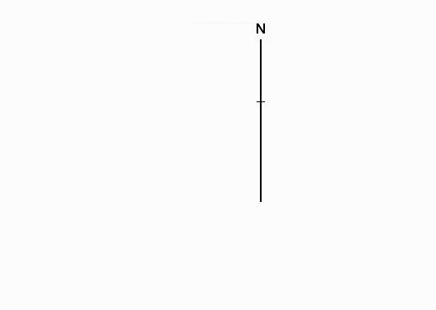

1. Draw a vertical line representing a meridian line. In this instance, the line is to the right of the paper and to the top since the aircraft's true course on the first leg is south-westerly. Want to leave room on the page for plotting.
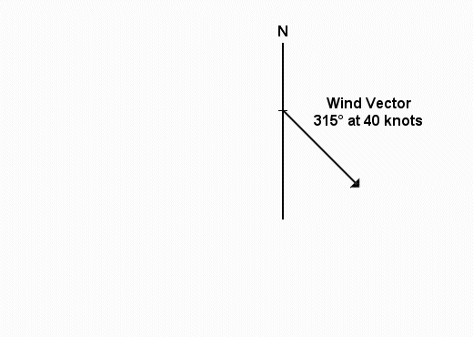

2. Next draw the vector for the wind. Use any scale, but keep it consistent for all vectors. I find 1 mm = 1 kt a workable scale. Wind FROM the north-west, 315°, is wind going TO the south-east. Measure all angles carefully.
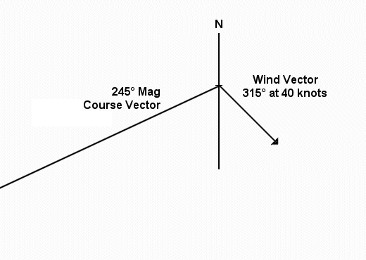

3. Draw the vector for the Magnetic Course. Here it is 245°. Remember, FS Winds are Magnetic North. The line should be "long" as the pertinent length will not be known until the third side of the triangle is entered, on the next step.
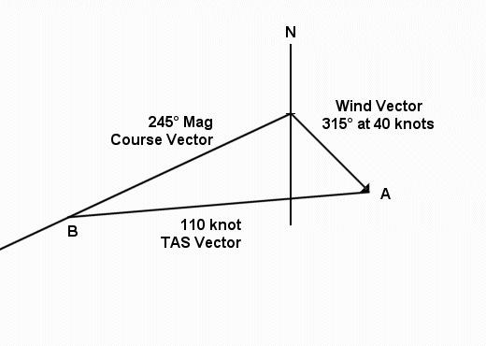

4. Put in the TAS vector. In this example, it is 110 units long for 110 kts. Hold the "zero" of the ruler at point A and rotate the ruler until the 110-unit mark intersects the Magnetic-Course vector, here at B. Draw the line from A to B. The triangle construction is now complete.
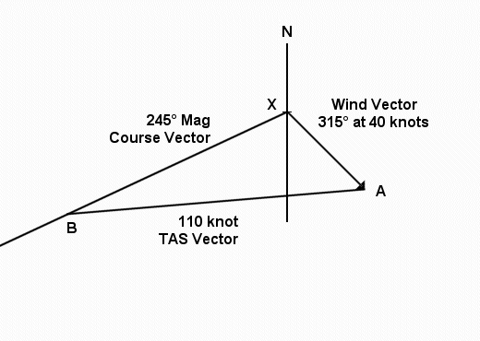

5. Measure the distance along the Magnetic-Course vector, from point X, the origin, to point B, where the TAS vector intersects. This distance is the aircraft's Ground Speed. In this case, it is 90 knots.

6. To determine the Wind Correction Angle measure the inside angle at B, between the Mag-Course Vector and the TAS vector. Here the angle is 20°. If the wind is from the right of the aircraft, add the WCA; if from the left, subtract the WCA. In this case, the wind is from the right, so the WCA is plus.

After practicing the wind triangles, use the Second Flight Activity Worksheet and complete the following:
Now climb into your Nav Trainer, with the Flight Sim weather set for a wind of 40 kts from 315°, note the headings, etc., in your Flight Planning Worksheet, and be on your way. Start the panel stopwatch as you roll down Lawrence Airport's Runway 33 and stop it after touchdown at Worcester. Compare your flight time with the predicted flight time.
Be sure to use the proper runway at Worcester. Land on Runway 33, not Runway 29. With this very strong wind, you could not keep the aircraft on the runway using any runway except 33.

