INTRODUCTION TO COLOR
Georgia CTAE Resource Network – Instructional Resources

Why is Color Important?
Color is one of the most powerful tools in business, marketing, and design. Because of the subconscious or cultural associations that people make with colors found in nature, color can have a profound emotional impact on the viewer. Cool colors, like blues, greens, and purples, can have a calming effect; warm colors, like reds, yellows, and oranges, can be exciting or energizing. Students in interior design, horticulture, landscaping, floral design, graphic communications, marketing, fashion marketing, culinary arts, and other related fields can all benefit from having an understanding of color.

Color choices can directly affect a consumer’s purchasing decisions. Marketing research has shown that warm colors like red, orange, and yellow tend to stimulate hunger, and as a result many successful restaurants can be found whose primary design colors are warm. Poor color choices, on the other hand, can result in poor product sales, as shown when ketchup companies tried unsuccessfully to market green and blue colored ketchup. The influence of color is so strong that it can actually alter perception: When given a choice between vanilla ice cream that is cream-colored, vanilla ice cream dyed with red food coloring, or vanilla ice cream dyed with green food coloring, a majority of participants claim that the cream-colored ice cream tastes better, even though all three samples should taste exactly the same.

What is Color?
How many colors are there? You might remember “ROYGBV” and answer “Red, orange, yellow, green, blue, violet…So there are six colors.” But in reality, there are millions of colors. Some computer monitors today can display up to 16.7 million distinct colors. A color we have a name for, like “green” for example, is actually a range that encompasses over a million colors. A certain green might have a little more yellow in it, or a little more blue, or might be darker, lighter, brighter, or duller (See Fig. 1).
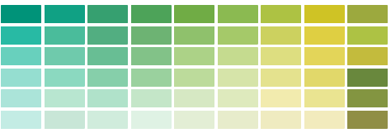
Figure 1: Fifty-four different tints and hues of green

Why do we have so many colors? This is because of the properties of color: hue, value, and saturation. These different variables make a color unique. The hue of a color varies with the wavelength or frequency of the light waves. We have names for specific hues like red, yellow, green, blue, and purple. The value of a color is the measure of how dark or light it is. When mixing paint, adding black or white changes the value of the color. Adding white to make a color lighter creates a tint, adding black to make a color darker creates a shade, and adding grey to make a color duller creates a tone. The measure of brightness (or intensity) versus dullness of a color is called saturation.

There are two ways to mix colors to get different hues. Subtractive color mixing describes the mixing of paints or pigments (See Fig.2), and additive color mixing explains the mixing of colored light (See Fig.3). Colors of paint absorb all of the light frequencies and reflect back only the color you see. Thus, mixing paints together is called subtractive because each color that is introduced to the mix absorbs more light frequencies, subtracting them from the total mixture. With additive color, when we mix colors together we are adding a light frequency to the mix.

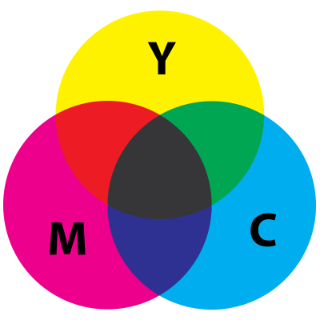
Figure 2: Subtractive color mixing with paint

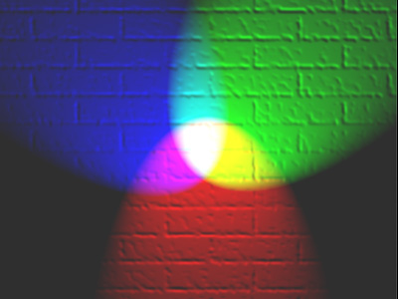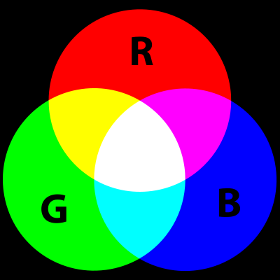
Figure 3: Additive color mixing with flashlights

The traditional standard for subtractive coloring includes mixing the three primary colors (red, yellow, and blue) in order to get the three secondary colors (orange, green, and violet). Mixing red and yellow creates orange, mixing yellow and blue creates green, and mixing blue and red creates violet. Tertiary colors are those in-between a primary and a secondary, such as red-orange or blue-green. Mixing all of these primaries together creates black. This system is known as the RYB color model for subtractive color. In color printing however, the CMYK color model is used for subtractive mixing, which uses cyan, magenta, and yellow as primary colors. These all combine to create black. In this case, white is the absence of color. (See Fig. 2). The color model used for additive color mixing, on the other hand, is RGB, which is used in computer imagery since a computer screen emits colored light. The primary colors are red, green, and blue. These all combine to create white light. In this case, black is the absence of color. (See Fig. 3). As we can see by comparing Figure 2 and Figure 3, the CMYK system and the RGB system are inverses of one another: The secondary colors of CMYK are red, green, and blue, and the secondary colors of RGB are cyan, magenta, and yellow. Black and white are also inverted when we compare the two systems.

How is Color Used?
We can combine colors in a variety of schemes, the most common being monochromatic, analogous, complementary, and triadic. All other color schemes are called polychromatic, meaning three or more unrelated colors are used. In a monochromatic color scheme, only tints shades and tones of a single hue are used, such as light blue, dark blue, and medium blue (See Fig.4).
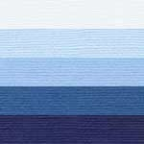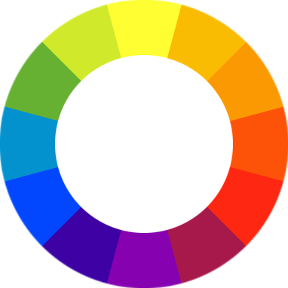
Figure 4 (left): Monochromatic color scheme using a blue hue
Figure 5 (right): A color wheel

Many color schemes are based on a color’s relationship to the location of the other colors on a color wheel (See Fig. 5). In an analogous color scheme, for example, three colors next to each other on the color wheel are used, such as red, orange, and yellow (See Fig. 6). In a complementary color scheme, two colors opposite each other on the color wheel are used, such as yellow and violet, red and green, or orange and blue (See Fig. 7). In a triadic color scheme, three colors that are equally spaced on the color wheel are used, such as red, blue, and yellow (See Fig. 8). See Figure 9 to see all four color schemes on the color wheel.

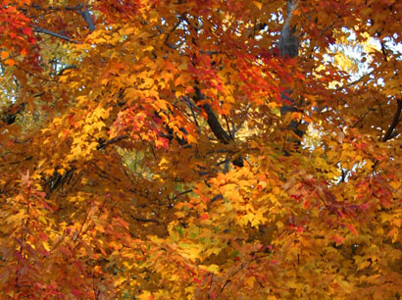
Figure 6 (left): Analogous color scheme with red, orange, and yellow
Figure 7 (right): Complementary color scheme with red and green
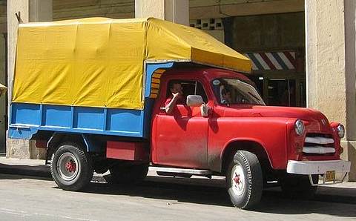
Figure 8: Triadic color scheme with red, yellow, and blue

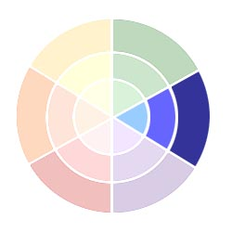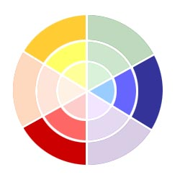
Monochromatic
Triadic

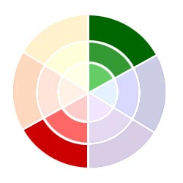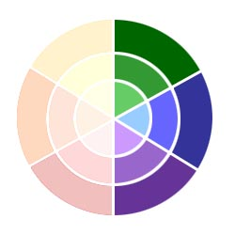
Complementary
Analogous
Figure 9: The four main color schemes
What Effect does Color have on People?
It is color’s capacity to evoke emotion that makes it such a powerful tool in business and design. Depending on the culture, however, a color may symbolize different things. In certain western cultures, for example, white can represent rebirth, purity, and truth, while black can represent death, evil, and mystery. In certain eastern cultures, however, it can be just the opposite: white can represent death and black can represent life (See Fig. 10). Even within a single culture, the meaning of a color can change over time. Today, pink and blue represent female and male, but before the early 1900s, pink was actually considered masculine and blue considered feminine.

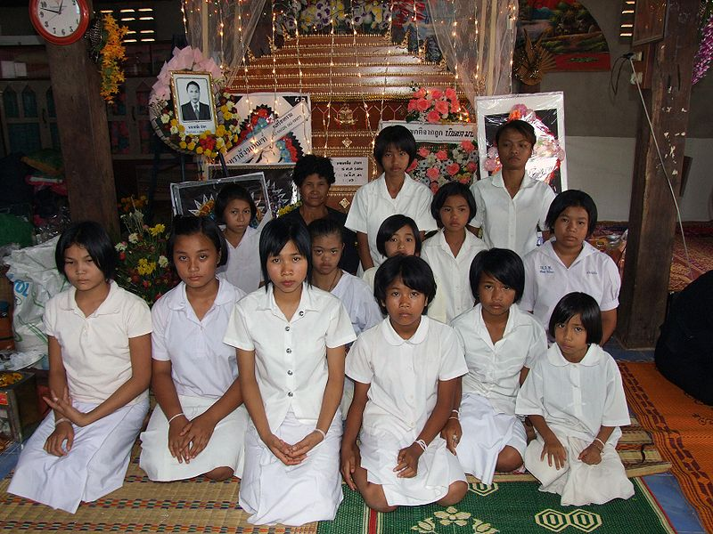
Figure 10: White clothes of mourning for a funeral in Thailand, versus black clothing in the U.S.

Here are some examples of current western color associations:
Red: We associate red with blood and fire. Red can be fast, hot, passionate, or angry. Red can be romantic, powerful, dangerous, or stimulating. Red sports cars, red lipstick, red fire trucks, and red boxing gloves all convey these ideas.

Orange and Yellow: Because we associate these colors with sunshine, orange and yellow can be warm, energetic, and happy. Very bright variants of these colors can be jarring and loud, but good when used for warnings or attention-getters, such as road signs, safety vests, taxi cabs, or school buses.

Green: Because green is the most predominant color in nature, it tends to receive the most votes for favorite color. Green is growth, life, hope, and progress. A yellowish or brownish green, however, can be sickness or disgust because of associations with mold or vomit.

Blue: Blue is by far the most popular design color. A lighter blue is peaceful and infinite like the ocean or sky. Darker blues, however, can be sad, cold, or lonely.

Violet: Purple became a symbol of royalty because violet dye was made from mollusks and only the very wealthy could afford it. Purple can also be mystery, magic, or the exotic since it is not found often in nature.

Grey: Grey is the color of a rainy day. It is sadness, depression, boredom, tiredness, and loneliness.

Brown: Brown is an earthy tone that represents stability. It can also represent dirtiness and filth.

Black and White: As mentioned before, black and white represent opposites: good and evil, life and death, knowledge versus darkness. In combination, however, these colors represent sophistication and class. White dress shirts became a symbol of class status because those who wore white were able to live a lifestyle that would not stain or dirty the fabric. Today, black and white remind us of timelessness because of black and white movies and photographs.

How is Color used in the Professions?
Interior Design: Whether in a home or a business setting, the color choices in a room can create different emotional reactions. A room painted bright red or orange can cause anxiety or energetic feelings, while a room painted subtle green or blue can cause calming, relaxing feelings. Dark colors can make the room feel smaller and claustrophobic while lighter colors make the room feel more open.

Fashion Marketing: People use colors to communicate and express themselves. A person wearing black and white might want to seem sophisticated and classy. Or a person wearing all black might want to seem rebellious and tough, while a person wearing all white might want to seem innocent and pure. A person wearing earth tones might want to blend in and seem more natural, while a person wearing bright neon colors might want to get your attention.

Horticulture, Landscaping, and Floral Design: If a client wants a garden they can use for relaxation, for example, cool colored flowers in blues and purples would be the best choice.
If the goal is to create a focal point, on the other hand, red, yellow, or orange flowers would be best. Color choices can also affect sense of scale. A small space can be made to look larger by placing warm colors in front, cool colors behind, and pale cool colors in the very back. This creates depth because warm colors appear to advance and cool colors seem to recede.

Graphic Communications, Graphic Design, Marketing, and Small Business: Color choices in advertising and company branding directly affect consumer purchase decisions. For a business large or small, visual presence is important: packaging, logo design, website design, interior design, and advertisements all require attention to color. Colors found in nature are often used by businesses to convey a certain message. Many companies today, for example, tacitly imply their products are more natural by using greens, browns, and beiges in their packaging design. Because associations with the sky and ocean create positive associations for consumers, light blues are the most popular colors used in website design today.

Culinary Arts: The color of our food can actually alter our perception of its taste. Apples grown in Washington State sell much more than apples grown in Georgia because of their rich red color. Georgia apples look poor in comparison, being duller and blending greenish tones with red ones. In taste tests however, most people choose the Georgia apples as tasting better once the apples are peeled and sliced.

Summary
Color is one of the most powerful elements of design. It is used to communicate and evoke emotions and ideas. Color affects almost every human activity, including purchase decisions. Businesses can greatly benefit from using color effectively and from being informed about the power of color. An understanding of color is important in most career areas, including interior design, horticulture, landscaping, floral design, graphic communications, marketing, fashion marketing, culinary arts, and other businesses of all kinds.

Review Questions
1. Why is color important?
2. List and define the three main properties of color.
3. List and define the three types of value variations for a color.
4. List and define the five main color combination schemes.
5. What is the difference between additive and subtractive color?
6. What is the difference between RGB and CMYK?
7. Besides CMYK, what is the common color system for mixing paints or pigments?
8. Explain how color is used in a profession that interests you.

Discussion Questions
1. Imagine what it would be like if the default color for wall paint in your school was black instead of white. How would this change the learning environment?
2. What is your favorite color? Why do you think you like this color more than the others?
3. What are the top two most popular colors in your country? Why?
4. Pick a country in Asia, South America, or Africa and research what their top two colors are. Are these colors different or the same as in your country? Why do you think this is?

