Evaluating Thank You Notes

Name: ________________________ Date: ____________

Directions: Rank the following thank you notes in order from 1 to 4 according to how appropriate they are for an interview follow up. 1 should describe the best and 4 should describe the worst. Record your answers on the following page along with notes on the mistakes made.
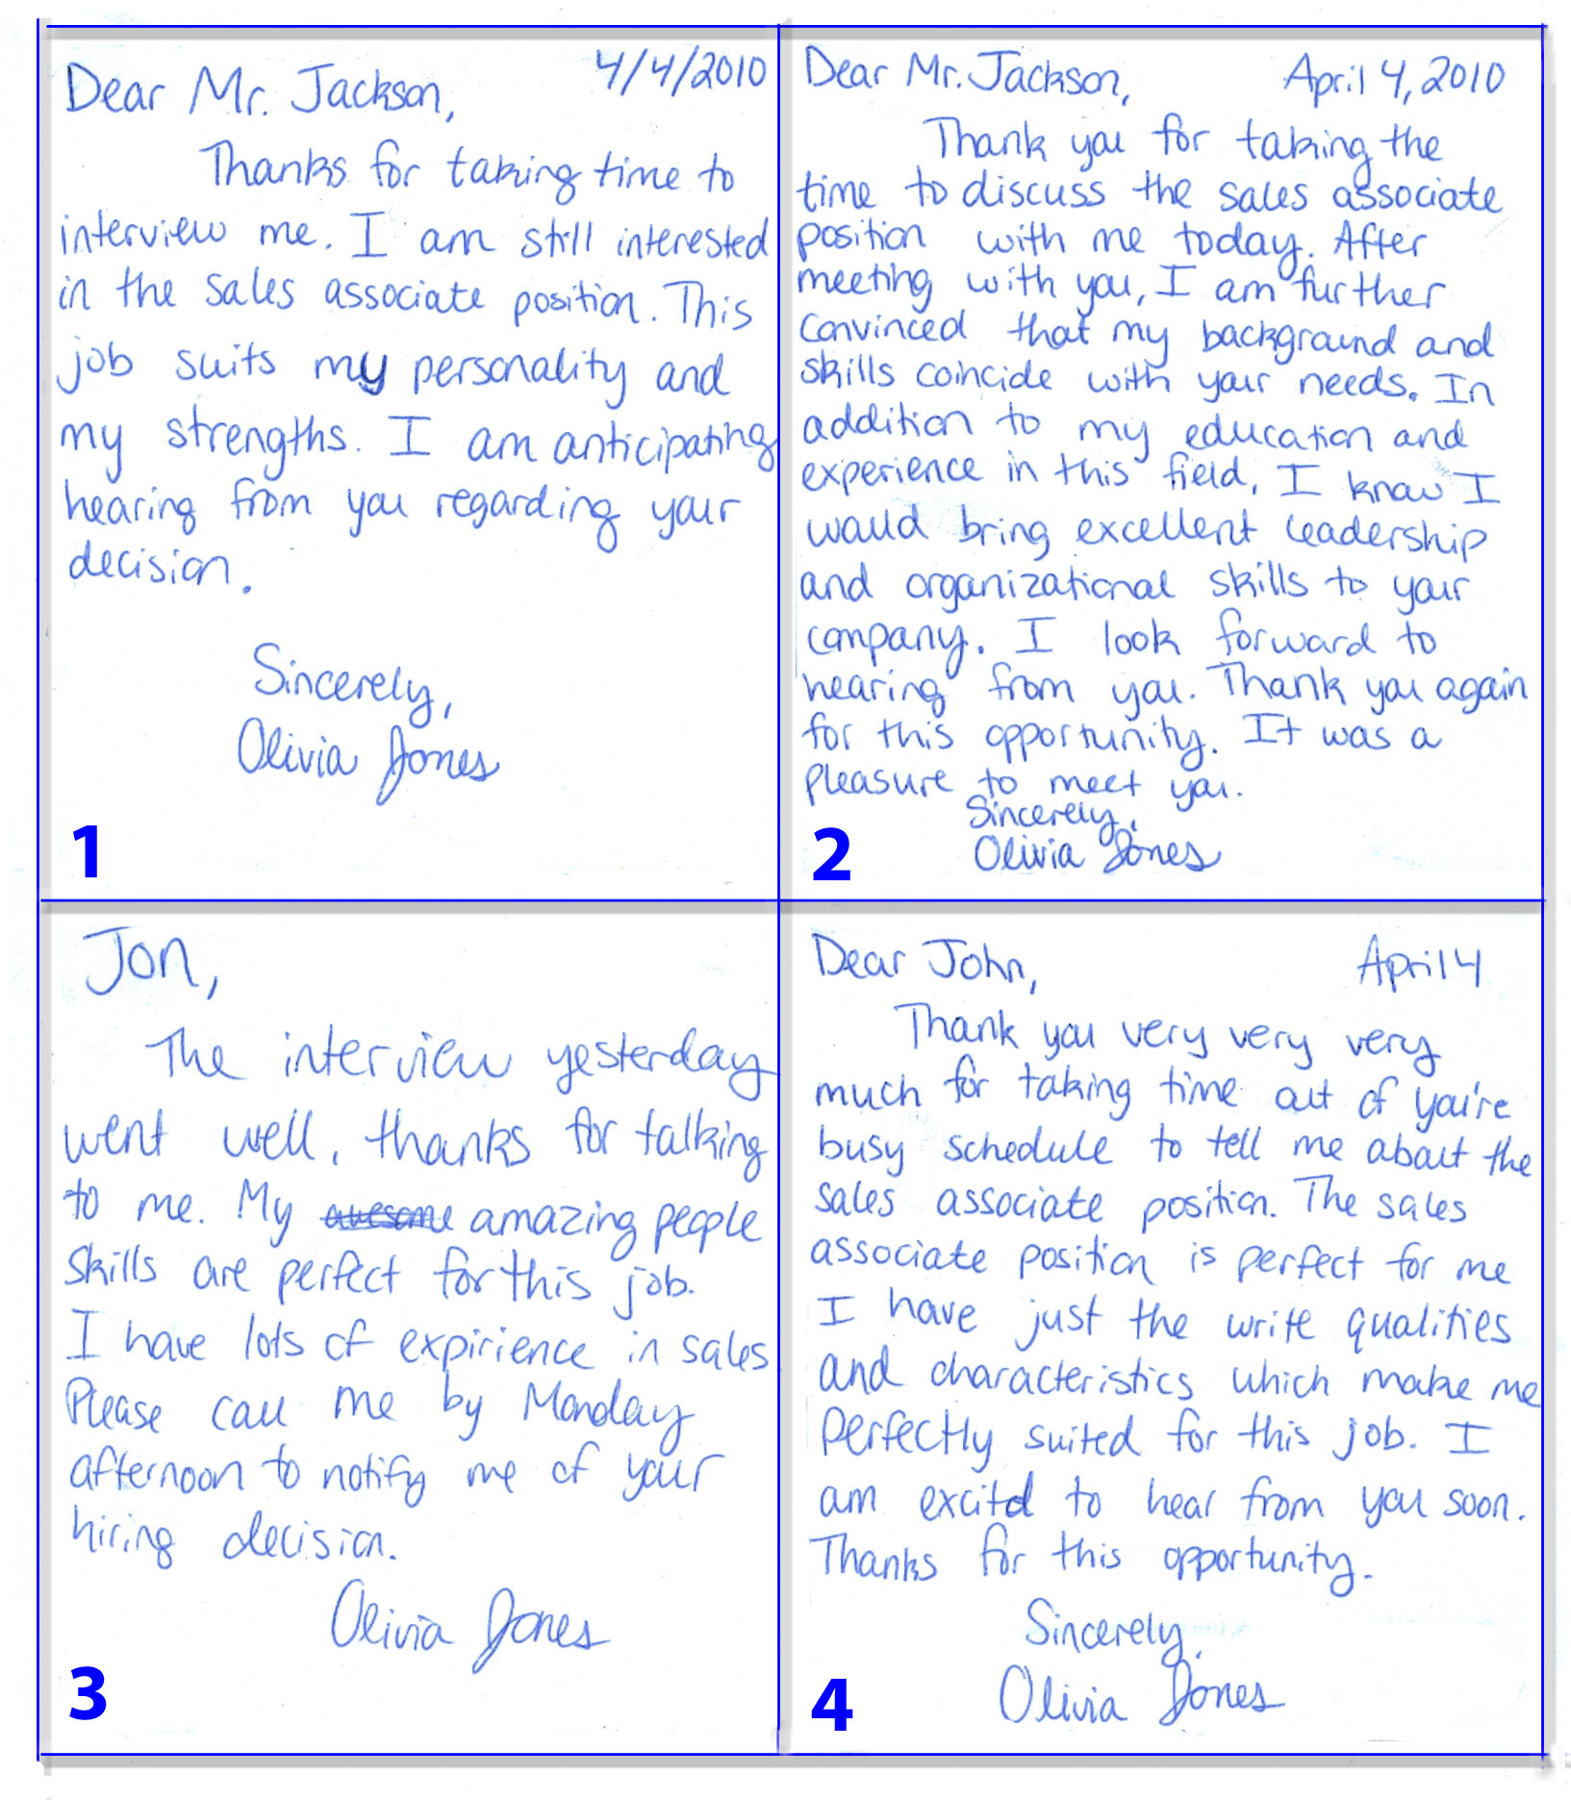

Evaluating Thank You Notes (Continued)
Name: ________________________ Date: _____________

List the mistakes you found in each thank you note.

1. Rank of Note 1: ________
________________________________________________________________________________________________________________________________________________________________________________________________________________________________________________________________________________________________

2. Rank of Note 2: ________
________________________________________________________________________
________________________________________________________________________
________________________________________________________________________________________________________________________________________________

3. Rank of Note 3: ________
________________________________________________________________________
________________________________________________________________________________________________________________________________________________
________________________________________________________________________

4. Rank of Note 4: ________
________________________________________________________________________
________________________________________________________________________
________________________________________________________________________

