Bernoulli’s Principle Demonstration
Four stations should already be setup around the room. Students should be assigned to 4 groups. Each station should only take 5 or 7 minutes to complete.
1. Ask students to explain Bernoulli’s principle in their own words.
2. Review the definition of Bernoulli’s principle.
3. Briefly review the different applications of Bernoulli’s principle.
4. Discuss what the materials are and how to use them for each station. Ask the students to record and explain what happened during the activities at each station.

Station 1: A setup of 2 empty drink cans or plastic cups and straws are needed. Place two cans beside each other an inch or two apart.
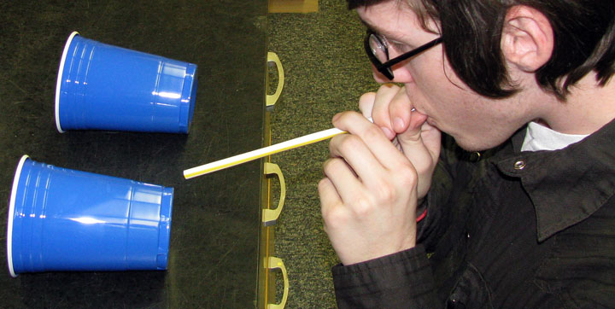
Then have the students blow through the straw directly in between the two cans.
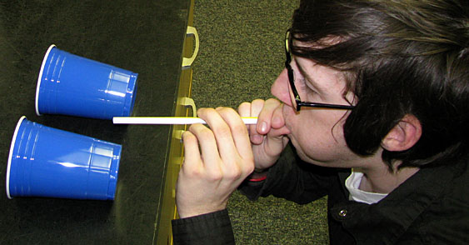
The two cups will roll together. Make sure the stream of air is not bouncing off the table. The straighter the stream is directly through the middle the better it will work.
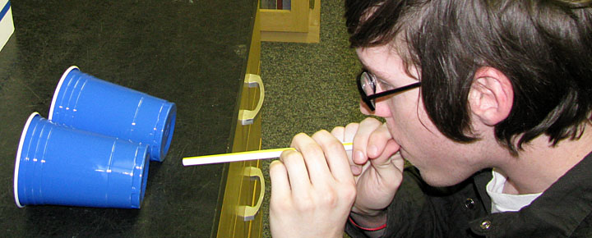
Have students document what happened and have them explain why they think it happened.

(What should happen): The two cups will roll together rather than apart. The velocity of the stream you produce is higher than the velocity of air around the two cans. That means the pressure around the two cans is higher than the pressure of the stream of air you produce, thus pushing the two cans together.

Station 2: A setup of a ping pong ball, tape and paper is needed. Ask the students to make a paper funnel and a paper tube as shown below. Have the students try to blow the ping pong ball out of the tube and then out of the funnel.

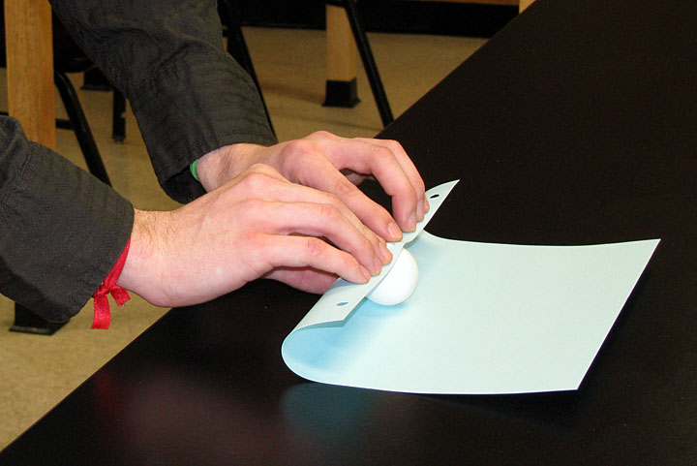
Roll the ping pong ball in a sheet of paper to create a tube the same size as the ball.
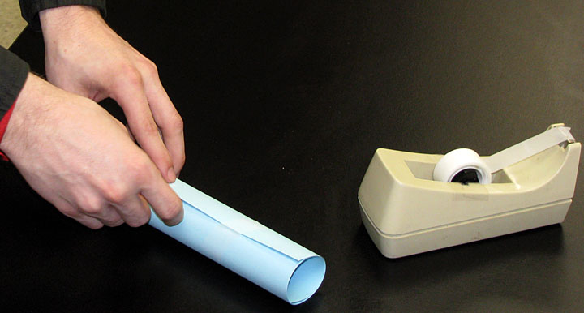
Tape the tube together.
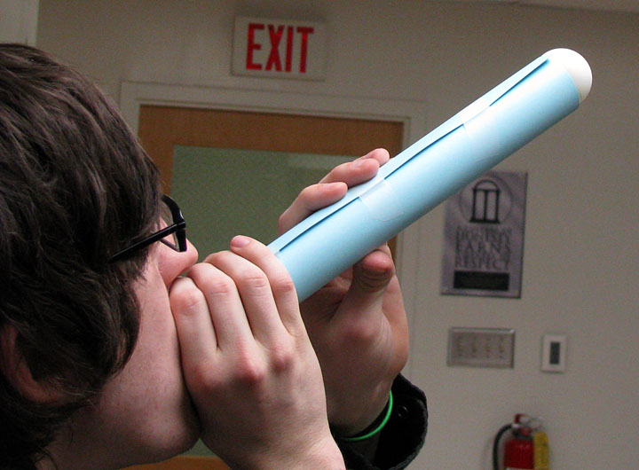
Demonstrate that there is low pressure around the ball because the ball flies out when blown into the tube.
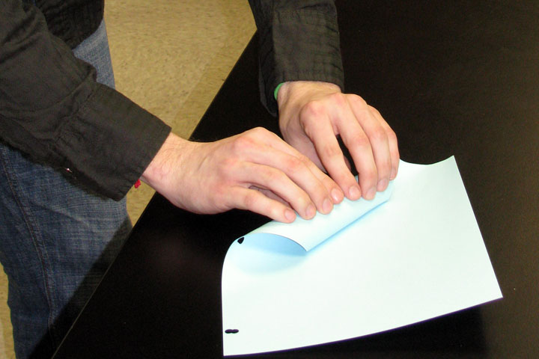
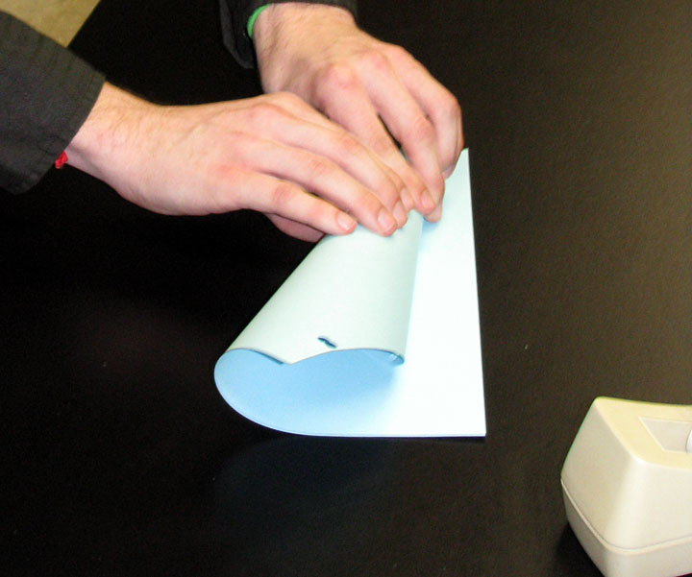
Ask the students to make a paper funnel. Make sure the top of the funnel has a rather large opening.
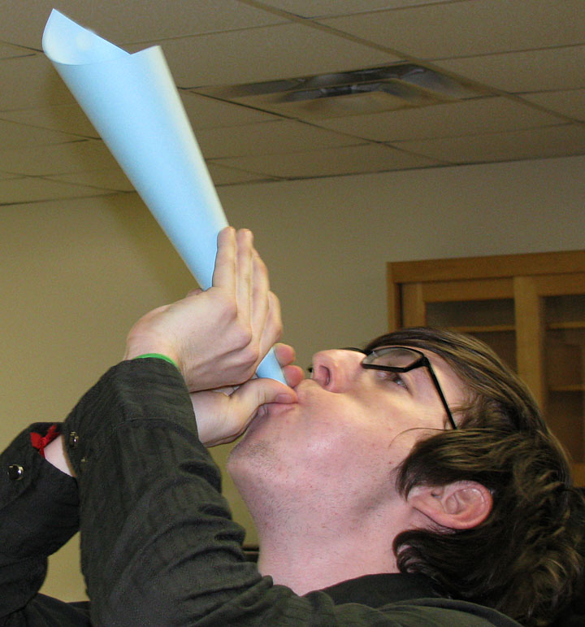
Demonstrate that it is impossible to blow the ball out because pressure is surrounding all sides of the ball. Notice you can feel the ball hovering inside the funnel.

(What should happen): The students should not be able to blow the ping pong ball out. The pressure around the outside of the ball should hold the ball within the funnel while it stays stationary in the air.

Station 3: A setup of a straw and a beaker filled partially full of water (adding food coloring to the water will in observing this activity.)
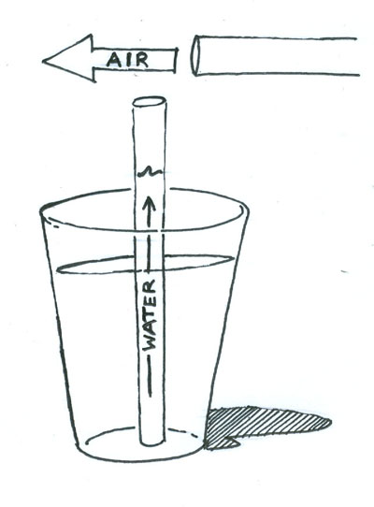
Have the student blow directly over the top of the straw and document what happened and explain why they think it happened.

(What should happen): The water from the beaker should shoot up through the straw. The velocity of the stream over the top of the straw creates low pressure around the top of the straw. The air and water moves up the straw to fill the void.

Station 4: A setup of 20 oz trash bags is needed.

Instructions: Ask the students to see how many breaths it takes to fill the bag with air. It should take more than one.

After a few tries, tell the students you can fill it up in one breath. Follow these instructions: Lay the bag flat on the table as shown.
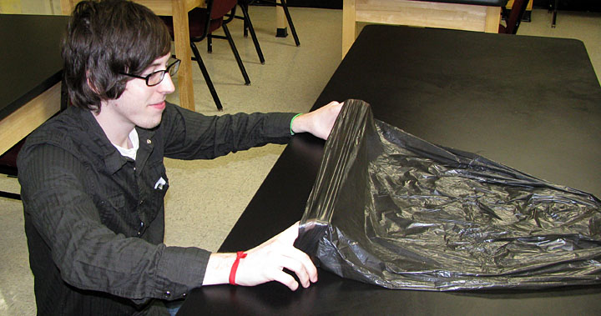
Hold the bag open with your hands about an inch apart and blow directly into the middle of the bag opening.
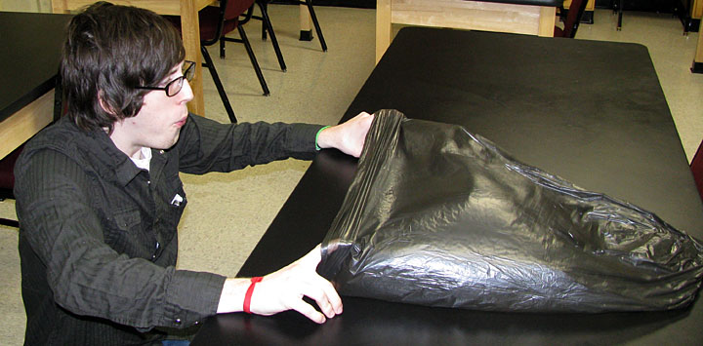
Finally close the opening and hold the air inside.
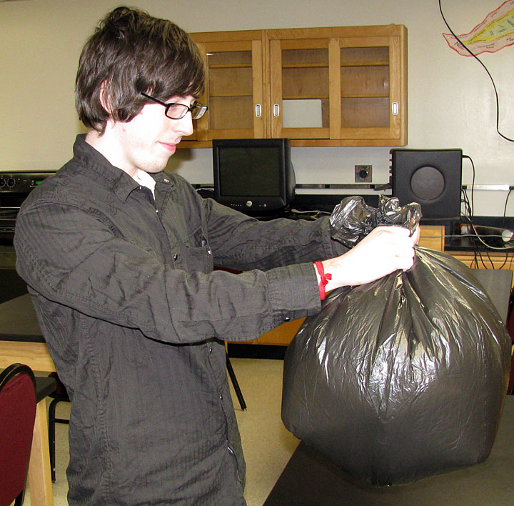

(What should happen): The students will not be able to fill the bag in one breath, if they try to blow it up the traditional way – mouth to bag. If the students do not figure out the correct way to fill the bag, the teacher must demonstrate the above instructions.

