
BERNOULLI’S PRINCIPLE

BERNOULLI’S PRINCIPLE

Engineering and Technology
CTAE Resource Network, Instructional Resources Office, 2010
Georgia Performance Standards:
ENGR-FET2 – Students will describe the history of technological advancement.
ENGR-FET4 – Students will apply mathematics and science to the solution of a technological problem.
ENGR-STEM6 – Students will enhance reading by developing vocabulary and comprehension skills associated with text materials, problem descriptions, and laboratory activities associated with engineering and technology education.
ENGR-EP-3 – Students will differentiate between fluid power systems and apply the laws that govern each.
See the end of this document for complete GPS listing

Student Information Guide
Directions:
Use the information in this student information sheet to complete the accompanying student study sheet. Complete all items on the study sheet and turn in to the teacher.
 Bernoulli’s Principle

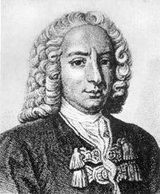
History

Bernoulli's principle is named after the Dutch-Swiss mathematician Daniel Bernoulli who published his principle in his book Hydrodynamica in 1738. He was the son of Johann Bernoulli, a famous Swiss mathematician and the son of a spice trader, who taught the even more famous Leonhard Euler. He is said to have had a poor relationship with his father. Upon Daniel and his father entering and tying for first place in a scientific contest at the University of Paris, Johann, unable to bear the "shame" of being compared to his offspring, banned Daniel from his house. Johann Bernoulli also plagiarized some key ideas from Daniel's book Hydrodynamica in his own book Hydraulica which he backdated to before Hydrodynamica. Daniel Bernoulli was a close friend and colleague of Euler, who helped him and his father generalize the theory into its modern form. Together, Bernoulli and Euler had an immense and still standing impact on kinetics and fluid dynamics. Although Daniel was considered by many to be “by far the ablest of the younger Bernoullis,” it is clear that wealth and connection to fame were of immense help.

Description
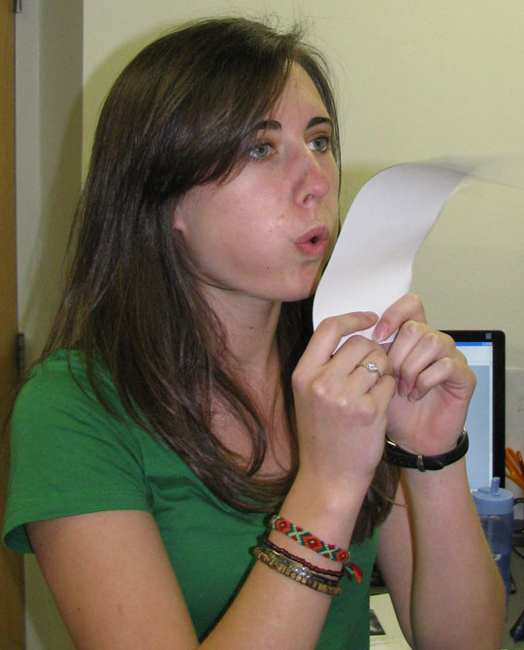
Bernoulli's Principle can be used to calculate the lift force on an airfoil if you know the behavior of the fluid or gas flow in the vicinity (area) of the foil. For example, if the air flowing past the top surface of an aircraft wing is moving faster than the air flowing past the bottom surface then Bernoulli's principle implies that the pressure on the surfaces of the wing will be lower above than below. This pressure difference results in an upwards lift force. Whenever the distribution of speed past the top and bottom surfaces of a wing is known, the lift forces can be calculated (to a good approximation) using Bernoulli's equations—established by Bernoulli over a century before the first man-made wings were used for the purpose of flight. Bernoulli's principle does not explain why the air flows faster past the top of the wing and slower past the underside.
Photo (right): Blowing over the top of a sheet of paper causes a lower pressure on top of the paper and a higher pressure underneath. This makes the paper lift!
Bernoulli’s Principle is also an explanation behind how sailboats move through the water with the wind blowing against them.
Interesting Fact: Many explanations for the creation of lift (on airfoils, propeller blades, etc) can be found; but some of these explanations can be misleading, and some are false. This has been a source of heated discussion over the years. In particular, there has been debate about whether lift is best explained by Bernoulli's principle or Newton's laws of motion. Modern writings agree that Bernoulli's principle and Newton's laws are both relevant and correct.

Terms and Definitions
Bernoulli’s Principle: Bernoulli’s Principle states that for an inviscid flow, an increase in the speed of the fluid occurs at the same time as a decrease in pressure or a decrease in the fluid's potential energy. This can be derived from the principle of conservation of energy. This states that in a steady flow the sum of all forms of mechanical energy in a fluid along a streamline is the same at all points on that streamline. This requires that the sum of kinetic energy and potential energy remain constant. Meaning, if pressure increases in one area, it must decrease in another in order to maintain that constant overall sum. Fluid particles (like in a liquid or a gas) are subject only to pressure and their own weight. If a fluid is flowing horizontally and along a section of a streamline, where the speed increases it can only be because the fluid on that section has moved from a region of higher pressure to a region of lower pressure; and if its speed decreases, it can only be because it has moved from a region of lower pressure to a region of higher pressure. Consequently, within a fluid flowing horizontally, the highest speed occurs where the pressure is lowest, and the lowest speed occurs where the pressure is highest.
Inviscid: In fluid dynamics there are problems that are easily solved by using the simplifying assumption of an ideal fluid that has no viscosity. The flow of a fluid that is assumed to have no viscosity is called inviscid flow. The flow of fluids with low values of viscosity agrees closely with inviscid flow everywhere except close to the fluid boundary where the boundary layer plays a significant role.
Viscosity: the resistance of a fluid (liquid or gas). In everyday terms, viscosity is “thickness.” Thus, Bernoulli’s principle is effectively applied to water and air (which have a low viscosity and are assumed in calculations to be “inviscid,” but could not be used to navigate a sea of honey.
Lift force: A fluid or gas flowing past the surface of a body exerts a surface force on it. Lift is defined to be the component of this force that is perpendicular to the oncoming flow direction. It contrasts with the drag force, which is defined to be the component of the surface force parallel to the flow direction.
Airfoil: An airfoil is the shape of a wing or blade (of a propeller, rotor or turbine) or sail as seen in cross-section.

Math

Bernoulli developed his principle from his observations on liquids, and his equation is applicable only to incompressible fluids, and compressible fluids at very low speeds (perhaps up to 1/3 of the sound speed in the fluid). It is possible to use the fundamental principles of physics to develop similar equations applicable to compressible fluids, like air. In engineering situations, elevations are generally small compared to the size of the Earth, and the time scales of fluid flow are small enough to consider the equation of state as adiabatic, meaning there is no heat transfer with the environment to take into account. In this case, Bernoulli’s Equation looks like this:
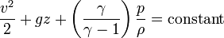 (constant along a streamline)
where:
p is the pressure
ρ is the density
v is the flow speed
γ is the ratio of the specific heats of the fluid
g is the acceleration due to gravity
z is the elevation of the point above a reference plane
Tacking

Tacking or coming about is a sailing maneuver by which a sailing vessel turns its bow (the front of the boat) through the wind so that the direction from which the wind blows changes from one side to the other. For example, if a vessel is sailing on a starboard (right side of the boat) tack with the wind blowing from the right side and tacks, it will end up on a port (left side of the boat) tack with the wind blowing from the left side. See the image below; the red arrow indicates the wind direction. In practice, the sails are set at angle of 45° to the wind for conventional sailboats and the tacking course is kept as short as possible before a new tack is set in.
Thus when a ship is tacking, it is moving both upwind and across the wind.

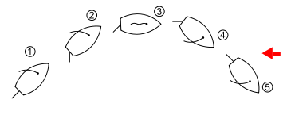

Diagram: Tacking from starboard tack to port tack. ① on starboard tack, ② turning to windward (towards the wind) to begin the tacking maneuver or "preparing to come about",③ headed into the wind where momentum carries the vessel forward,④ powering up on the new port tack by sheeting in the mainsail, ⑤ on port tack.

Faster than the wind? Due to Bernoulli’s Principle, how the force of the wind acts on the sails to create a higher pressure on the front of the sail than the pressure inside the sails, boats sailing at 45 degree angles into the wind can actually sail at a faster speed than the wind.

Georgia Performance Standards
ENGR-FET2: Students will describe the history of technological advancement.
a. Identify key historical events and their impact on engineering and technology.
b. Describe the issues of wealth, fame, power, and necessity that have influenced innovation and technological development.
c. List key persons who have contributed to technological change.
ENGR-FET4 – Students will apply mathematics and science to the solution of a technological problem.
a. Describe the role of mathematics and science in technological development.
b. Construct a mathematical model for a known technological system.
c.. Explain the scientific principles behind a basic machine.
ENGR-STEM6 – Students will enhance reading by developing vocabulary and comprehension skills associated with text materials, problem descriptions, and laboratory activities associated with engineering and technology education.
a. Reading in all curriculum areas.
c.. Building vocabulary knowledge.
d. Establishing context.
ENGR-EP-3. Students will differentiate between fluid power systems and apply the laws that govern each.
c. Describe how a fluid is able to transfer force as well as change the relationship between force and distance or speed.
d. Solve mathematical problems involving changes in pressure, temperature, and volume in fluid power systems.
License & Verification
Text is available under the Creative Commons Attribution-ShareAlike License; additional terms may apply. See Terms of Use for details. - http://creativecommons.org/licenses/by-sa/3.0/
Wikipedia® is a registered trademark of the Wikimedia Foundation, Inc., a non-profit organization.
Website Sources: http://en.wikipedia.org/wiki/Viscosity
http://en.wikipedia.org/wiki/Inviscid_flow
http://en.wikipedia.org/wiki/Bernoulli%27s_principle
http://en.wikipedia.org/wiki/Tacking_(sailing)
http://en.wikipedia.org/wiki/Daniel_Bernoulli
http://en.wikipedia.org/wiki/Adiabatic
http://en.wikipedia.org/wiki/Johann_Bernoulli

This document, originally from Wikipedia, has been modified
and the information has been independently verified.

