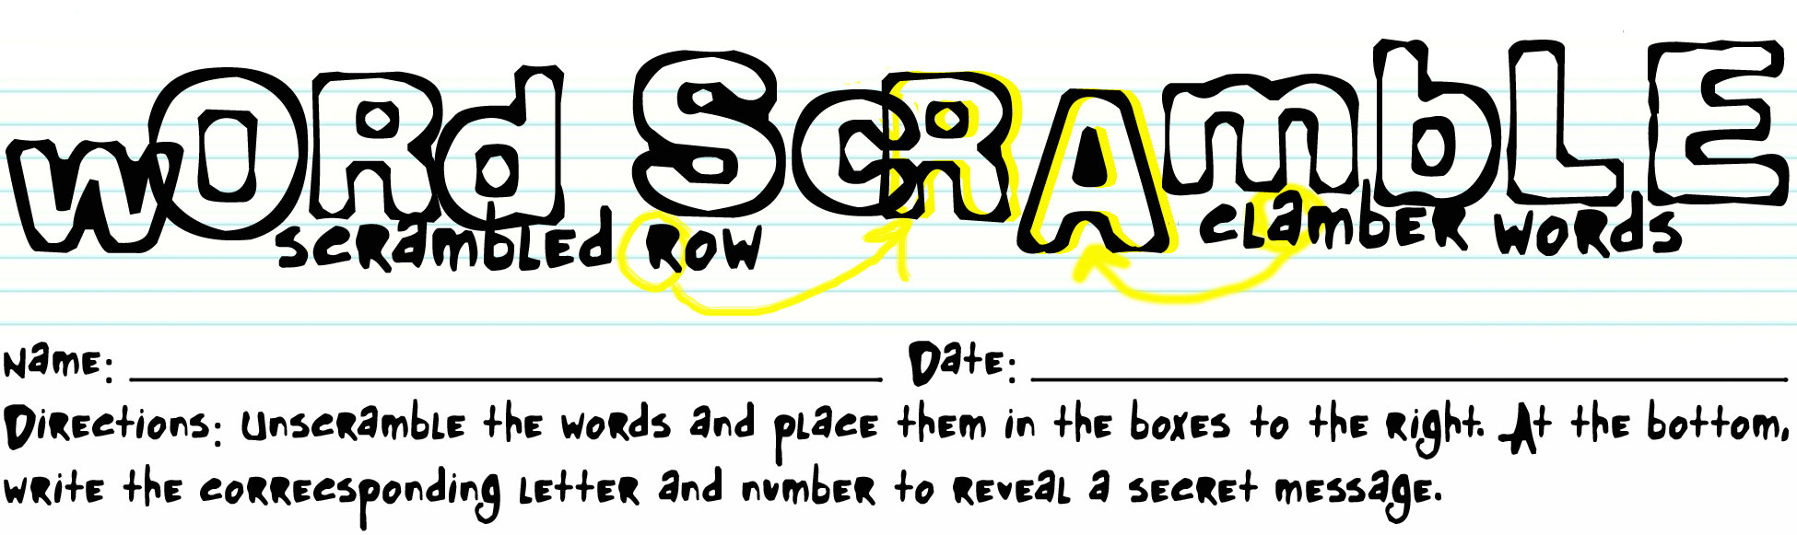

Subject: Handling Customer Complaints
tohsolubetor
Def: to determine what problems exist and how to correct them |  |  |  |  |  |  |  | 9

ranameg
Def: a person who has control or direction of a company or business |  |  |  |  |  | 10

teseoargum gcssrevi
Def: a customer who readily complains, often loudly and at length |  |  |  |  |  | 3 |  |  | 12

lmoapitcn
Def: communication from a customer that alleges deficiencies after a purchase has been made |  |  | 6

rrut reohgs mhleolic
Def: a customer who expects the absolute best and is willing to pay for it |  |  |  |  |  | 8 |  |  |  |  |  |  | 14

skem rmoectue
Def: a customer who will generally not complain |  | 7 |  |  |  |  |  |  |  |  |  | 15

letlicene
Def: clients of a company or business |  |  |  |  |  | 4

pomnior cclerianch
Def: a customer who is never satisfied and feels that there is always something wrong | 1 |  |  |  |  | 13

rom tur pifocsef
Def: customer who wants to get something they are not entitled to receive | 11 |  |  |  |  |  |  |  |  | 2

nisesogn aocihcs
Def: when a manager trains employees how to properly handle given situations |  | 5

1 | 2 | 3 | 4 | 5 | 6 | 7 | 8 |  | 9 | 10 | 11 | 12 | 13 | 14 | 15

KEY: Handling Customer Complaints
tohsolubetor | T | R | O | U | B | L | E | S | H | O | O | T
Def: to determine what problems exist and how to correct them |  |  |  |  |  |  |  | 9

ranameg | M | A | N | A | G | E | R
Def: a person who has control or direction of a company or business |  |  |  |  |  | 10

teseoargum gcssrevi | A | G | G | R | E | S | S | I | V | E |  | C | U | S | T | O | M | E | R
Def: a customer who readily complains, often loudly and at length |  |  |  |  |  | 3 |  |  | 12

lmoapitcn | C | O | M | P | L | A | I | N | T
Def: communication from a customer that alleges deficiencies after a purchase has been made |  |  | 6

rrut reohgs mhleolic | H | I | G | H |  | R | O | L | L | E | R |  | C | U | S | T | O | M | E | R
Def: a customer who expects the absolute best and is willing to pay for it |  |  |  |  |  | 8 |  |  |  |  |  |  | 14

skem rmoectue | M | E | E | K |  | C | U | S | T | O | M | E | R
Def: a customer who will generally not complain |  | 7 |  |  |  |  |  |  |  |  |  | 15

letlicene | C | L | I | E | N | T | E | L | E
Def: clients of a company or business |  |  |  |  |  | 4

pomnior cclerianch | C | H | R | O | N | I | C |  | C | O | M | P | L | A | I | N | E | R
Def: a customer who is never satisfied and feels that there is always something wrong | 1 |  |  |  |  | 13

rom tur pifocsef | R | I | P |  | O | F | F |  | C | U | S | T | O | M | E | R
Def: customer who wants to get something they are not entitled to receive | 11 |  |  |  |  |  |  |  |  | 2

nisesogn aocihcs | C | O | A | C | H | I | N | G |  | S | E | S | S | I | O | N
Def: when a manager trains employees how to properly handle given situations |  | 5

C | U | S | T | O | M | E | R |  | S | E | R | V | I | C | E
1 | 2 | 3 | 4 | 5 | 6 | 7 | 8 |  | 9 | 10 | 11 | 12 | 13 | 14 | 15

