Man-Hour Activity: Paper Step-Through
This activity is to accompany the unit “Time is Money.”

Directions: In this activity you will pass your body through a single sheet of paper. Before beginning the activity, estimate the number of man-hours it will take to complete the activity on the chart provided. Use decimals if your estimates are less than one hour (e.g. 15 minutes is .25 hours.) Remember to multiply the number of man-hours per person by the number of people in your group to find the total man-hours. For example, if your group of three people completes the activity in 15 minutes, the man-hours for the activity is 45 minutes, or .75 hour. Use the directions provided to cut the paper. Then compare your actual time to your estimated time. Adjust your estimate accordingly and complete the activity again.
For illustration purposes, suppose the paper step-through is a product that your company produces and consumers will purchase. The time it takes to produce the product is very important to making a profit as well as keeping labor costs down. Companies want to produce a quality product at a low cost to attract consumers.

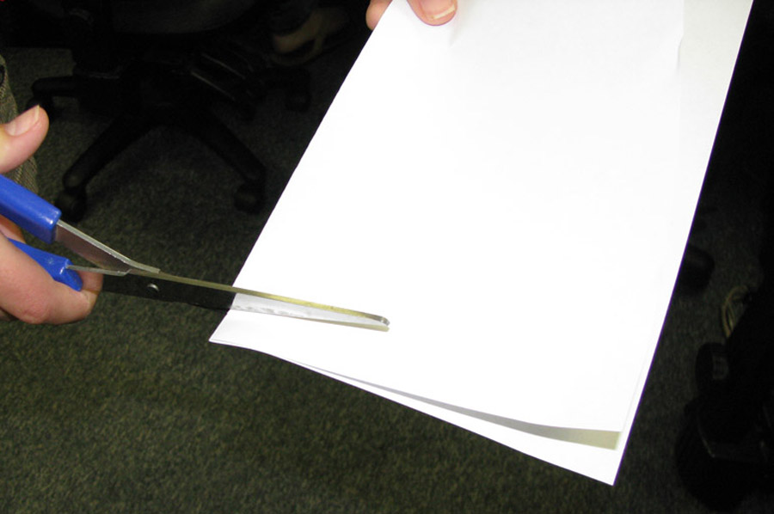
- Fold the piece of paper in half, “hamburger” style, top to bottom.


- Beginning approximately a half inch from the edge of the paper,
cut from the fold to the end of the paper, stopping about an inch
from the end. DO NOT cut all the way to the edge.

- Make another cut approximately a half inch from the first cut,
this time stopping approximately 1.5 inches from the edge.


- Continue alternating these cuts until you reach the other end
of the paper. End on a long cut, about an inch from the end of
the paper. Remember to alternate between cuts that end 1 inch
from the top edge and 1.5 inches from the top edge.


- Unfold the paper.


- Starting on one side, cut from the top of the first long cut to
the top of the second long cut, separating it from the bar at the top.

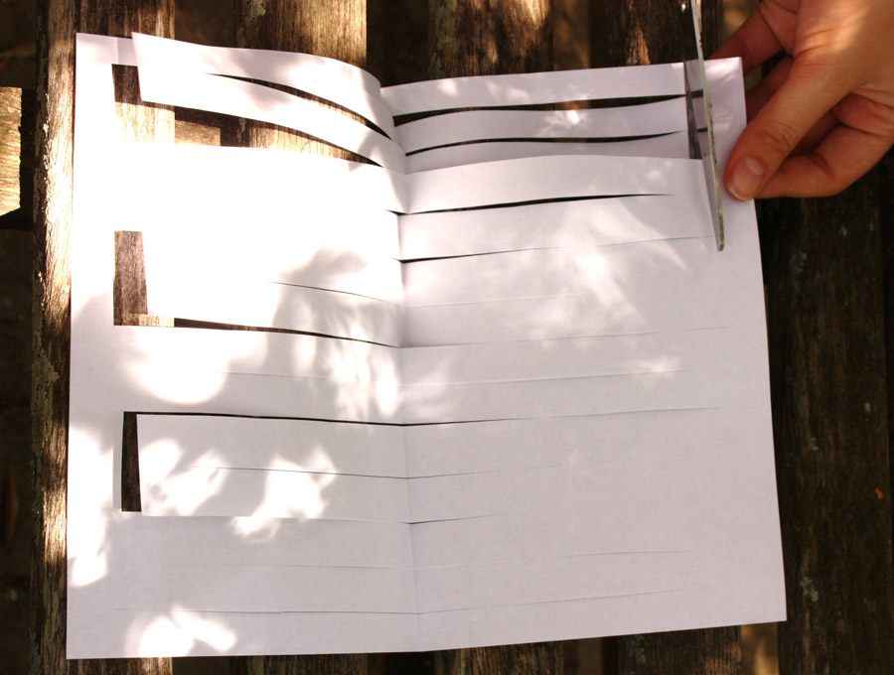
- Repeat this step, cutting from the third long cut to the fourth.
Continue doing this until you reach the last long cut.

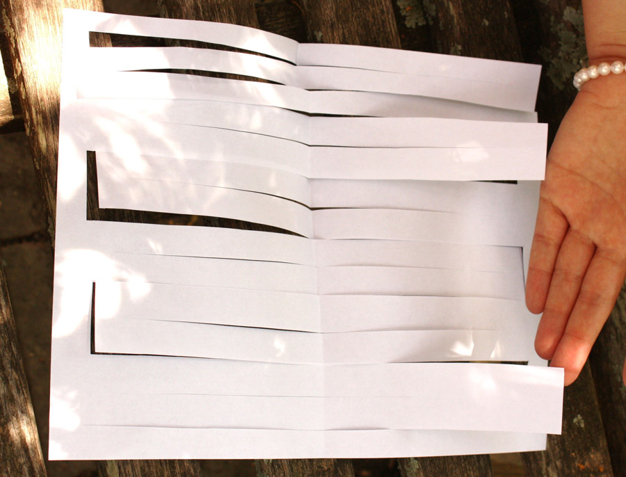
- Perform the same process on the other side of the paper, but
this time cut between the second and third long cuts, the fourth
and fifth, etc.

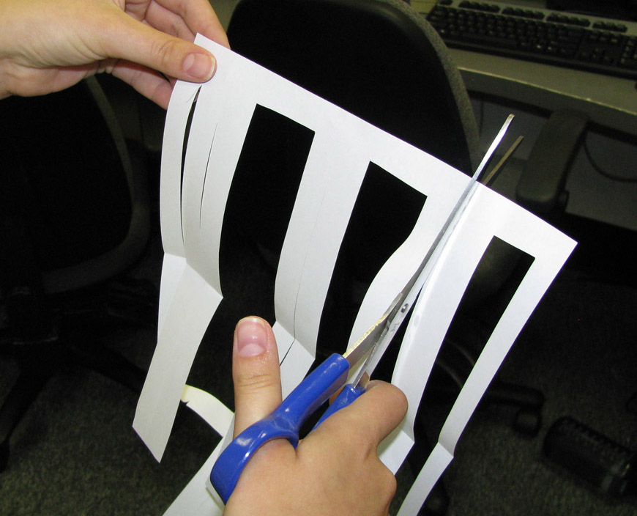
- On both sides of the paper, cut from the edge of the paper to
the short cuts you made earlier.

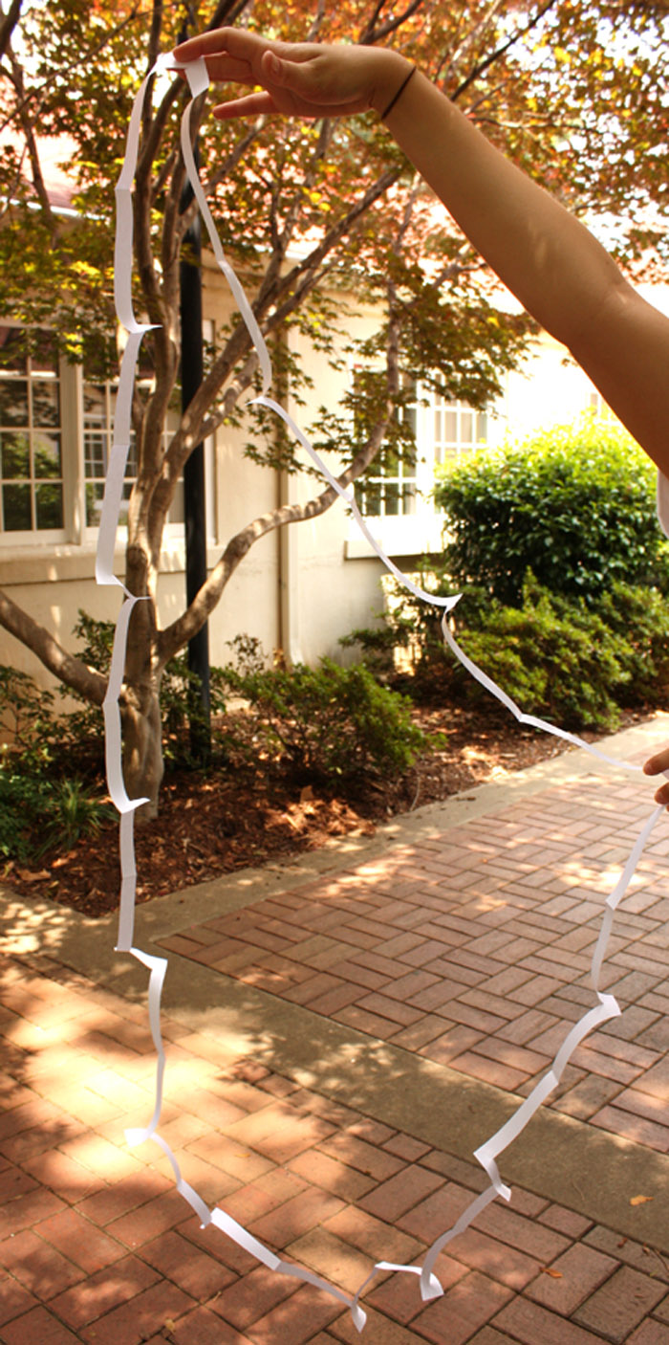
- Unfold the paper and have each person step through
the hoop you have just created.

Trial Number | Estimated Man-Hours | Actual Man-Hours
1
2
3
4

