Identify the parts of the PowerPoint Window.
7 8 9 10 11

1

2

3

4
5
6
12
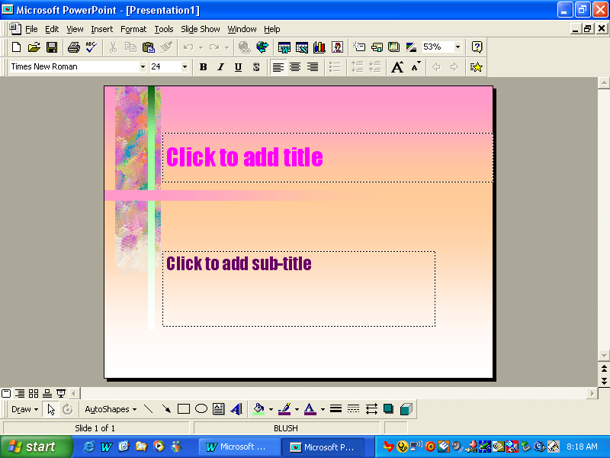
13

1. ______________________________ 7. ______________________________

2. ______________________________ 8. ______________________________

3. ______________________________ 9. ______________________________

4. ______________________________ 10. ______________________________

5. ______________________________ 11. ______________________________

6. ______________________________ 12. ______________________________

13. ______________________________

