

Foundation Skills

PATHWAY: All Pathways
COURSE: All CTAE Courses
UNIT 6.2: Organizational Systems

Introduction
Annotation: Briefly describe the unit topics, tasks, methods, etc.
In this unit, students will learn how organizations are structured by function.

Grade(s):
X | 9th
X | 10th
X | 11th
X | 12th

Time: Two 50 minute periods.

Author: Katherine Hudson and Dr. Frank Flanders

Additional Author(s):

Students with Disabilities:
For students with disabilities, the instructor should refer to the student's IEP to be sure that the accommodations specified are being provided. Instructors should also familiarize themselves with the provisions of Behavior Intervention Plans that may be part of a student's IEP. Frequent consultation with a student's special education instructor will be beneficial in providing appropriate differentiation.

Focus Standards
GPS Focus Standards: Please list the standard and elements covered.
CTAE-FS-6 Systems: Learners understand a variety of organizational structures and functions.

GPS Academic Standards:

National / Local Standards / Industry / ISTE:
ESS05 Systems: Understand roles within teams, work units, departments, organizations, inter-organizational systems, and the larger environment. Identify how key organizational systems affect organizational performance and the quality of products and services. Understand global context of industries and careers.

Understandings & Goals
Enduring Understandings: Enduring understandings are statements summarizing important ideas and have lasting value beyond the classroom. They synthesize what students should understand – not just know.
- Students will understand that as the number of people in an organization increases, oversight becomes too large a task for one person. One effective way to structure an organization is by delegating responsibilities and authority by common business functions.

Essential Questions: Essential questions probe for deeper meaning and understanding while fostering the development of critical thinking and problem-solving skills. Example: Why is life-long learning important in the modern workplace?
- Why are organizations structured?
- What are the advantages and disadvantages of the functional structure?

Knowledge from this Unit: Factual information.
- Students will explain functional organization structure.

Skills from this Unit: Performance.
- Students will be able to define and use an organization chart.
- Students will develop a functional organizational structure for a small business.

Assessment(s)
Assessment Method Type: Select one or more of the following. Please consider the type(s) of differentiated instruction you will be using in the classroom.

 | Pre-test
 | Objective assessment - multiple-choice, true- false, etc.
__ Quizzes/Tests
__ Unit test
 | Group project
 | Individual project
X | Self-assessment - May include practice quizzes, games, simulations, checklists, etc.
__ Self-check rubrics
__ Self-check during writing/planning process
__ Journal reflections on concepts, personal experiences and impact on one’s life
__ Reflect on evaluations of work from teachers, business partners, and competition judges
__ Academic prompts
__ Practice quizzes/tests
 | Subjective assessment/Informal observations
__ Essay tests
__ Observe students working with partners
__ Observe students role playing
 | Peer-assessment
__ Peer editing & commentary of products/projects/presentations using rubrics
__ Peer editing and/or critiquing
 | Dialogue and Discussion
__ Student/teacher conferences
__ Partner and small group discussions
__ Whole group discussions
__ Interaction with/feedback from community members/speakers and business partners
 | Constructed Responses
__ Chart good reading/writing/listening/speaking habits
__ Application of skills to real-life situations/scenarios
X | Post-test

Assessment(s) Title:
- Organizational Chart
- Organizational Systems Exam

Assessment(s) Description/Directions:
- Instruct students to complete the Organizational Chart worksheet according to the directions given.
- The exam should be used to assess the knowledge retained from this lesson. It can be found as an instructional material with this lesson.

Attachments for Assessment(s): Please list.
Organizational Chart
Organizational Systems Exam

Learning Experiences
Instructional planning: Include lessons, activities and other learning experiences in this section with a brief description of the activities to ensure student acquisition of the knowledge and skills addressed in the standards. Complete the sequence of instruction for each lesson/task in the unit.

Sequence of Instruction
1. Identify the Standards. Standards should be posted in the classroom for each lesson.
CTAE-FS-6 Systems: Learners understand a variety of organizational structures and functions.

2. Review Essential Questions.
- Why are organizations structured?
- What are the advantages and disadvantages of the functional structure?

3. Identify and review the unit vocabulary.
Functional organization
Organizational chart
Organizational structure

4. Lesson
Day 1:
- The teacher should introduce the concept of organizational structures and provide an example. (See Organizational Chart transparency below)
  - No two businesses are organized identically because managers, employees, families, and the work involved vary from one business to another. However, because oversight of an entire organization is too large a task for one person, almost all organizations are structured in such a way to make work more efficient. Organizational structure allocates the responsibilities for different business functions to individuals or entire departments, such as a company’s sales department or customer service department. Keys to effective organization are proper planning of the organization, clear relationships among the people in the organization, delegation of responsibility and authority, and a structure that is neither too simple nor complex.
  - An organizational chart is a useful tool to illustrate and understand the organizational structure of a business. The chart typically lists the title of each person’s position and uses connecting lines to show who is in charge of what area and who is accountable to whom. The organization chart shows the chain of command between the top of the organization and the lowest positions. The chain of command represents the formal path a task should take in traveling from the organization’s president to the lower-level employees. The organization chart does not show the informal contacts, communications, and ways of doing things which employees develop; these, of course, might not follow the formal organization structure.
  - As a business grows, the owner-manager needs to delegate some responsibilities and authority to other individuals. As responsibilities are delegated, how should they be organized? One of the most common types of organizing a business, especially one that provides only one product or service, is by function. A functional structure groups employees together based on the functions of specific jobs. For example, a division of an internet service provider (ISP) with a functional organizational structure might be as follows:
Vice President
- Sales Department (sales function)
- Customer Service Department (customer service function)
- Engineering Department (engineering function)
- Accounting Department (accounting function)
Administration Department (administration function)
  - With a functional type of structure, managers are able to specialize and often become more efficient at performing their duties. This structure reduces duplication of managerial responsibility. And it allows the general manager to concentrate on overseeing the entire business, develop and maintain important relationships with customers and suppliers, and establish an overall strategy for the business. Although this structure has its advantages, there can be disadvantages as well. While managers in the various areas can develop expertise in their functional area of responsibility, they may lose sight of how the various parts fit into the whole business.
- The teacher may want to start a discussion by asking students what organizations (i.e. after school job, student organization, church, etc) they are familiar with and how those organizations are structured.
- The teacher may want to have students (individually or in groups) complete the worksheet activity titled Organizational Chart, which can be found as an instructional material with this lesson.
Day 2
- Notepad Organization Activity
- Students present to the class how they organized their notepad business
- Initiate a follow-up discussion by asking the following questions:
  - Was it better to have all students doing all tasks are to divide labor based on function?
  - What are some businesses that follow the functional organization structure?
  - What did you learn about how organizations are structured?

5. Assessment Activity

Attachments for Learning Experiences: Please list.

Organizational Chart
Organizational Systems Exam

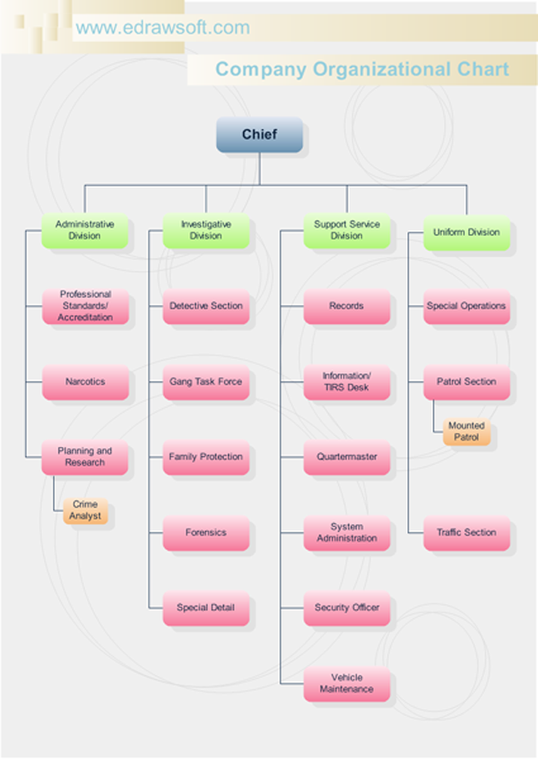

Notes & Reflections: May include notes to the teacher, pre-requisite knowledge & skills, suggestions, etc.
The teacher may want to note that organizations are not only organized by function. Organizations may also be organized by product, or by what is known as a matrix structure, which is a combination of a functional structure and product structure. However, for the purpose of this lesson, the class will focus on a functional organizational structure.

Culminating Performance Task (Optional)
Culminating Unit Performance Task Title: Notepad Production Activity

Culminating Unit Performance Task Description/Directions/Differentiated Instruction:
Divide students into groups of 5 or 6 (or divide the students into groups of varied size to demonstrate to effects this may have on an organization). Tell them that they work for a small notepad business which makes notepads out of recycled paper. Give each group 10 or more pieces of paper from the recycle box, a pair of scissors, a ruler, a pencil, an eraser, and a stapler. Each group will be required to make as many notepads as they can that meets the following criteria:
- 8 pages per notepad
- measures 4 in. x 5 in., accurate to within 1/8 inch
- has two staples along the top of the 4 inch side. The two staples should be centered at 1 inch and 3 inches across the top edge, and should be half an inch down from the top.
- each group should prepare a flyer to advertise their product

Let the groups organize themselves naturally and choose their own leaders. After the activity, lead a discussion about the benefits and disadvantages of different kinds of organizational structures. Determine the amount of quality notebooks each group produced, and discuss the reasons for the failure or efficiency of certain groups.

Organizational Structure Example:
Manager
- Person who measures the dimensions with the ruler
- Person who cuts the paper with the scissors
- Person who staples the notepad together
- Person in charge of marketing (creates a flyer for the product)
- Person in charge of quality control

Did organizing the group in a specialized way produce better results than allowing each member to complete the necessary tasks on their own? Did size of group effect the type of structure chosen?

Attachments for Culminating Performance Task: Please list.
Criteria | Excellent  5 | Very Good  5 | Good  3 | Fair  2 | Poor  1
Speed of Completion

Accuracy

Division of Labor

Teamwork

Overall Rating

Unit Resources
Web Resources:

Attachment(s): Supplemental files not listed in assessment, learning experiences, and performance task.

Materials & Equipment:
Recycled paper
Scissors
Rulers
Staplers

What 21st Century Technology was used in this unit:
Top of Form
 | Slide Show Software |  | Graphing Software |  | Audio File(s)
 | Interactive Whiteboard |  | Calculator |  | Graphic Organizer
 | Student Response System | X | Desktop Publishing |  | Image File(s)
 | Web Design Software |  | Blog |  | Video
 | Animation Software |  | Wiki |  | Electronic Game or Puzzle Maker
 | Email |  | Website
Bottom of Form

