SAFETY DEMONSTRATION

A visual representation of how accidental injuries occur and what must be done to control them.

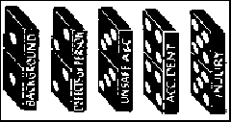
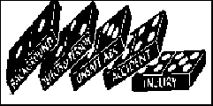
A. In this illustration the 5 dominos show the steps leading to an accident and possible injury. Topple the “Background” domino to illustrate injury.

B. In this illustration, pull out the “Unsafe Acts & Conditions” domino and topple the “background” domino again. This shows that injury can be prevented. A teacher or employer may not be able to do much about a person’s background or their defects in knowledge, attitude or ability but if unsafe conditions and acts are removed then injury is prevented.
