Inserting Formable Earplugs
Student Information Sheet

Directions: Follow the diagrams and instruction below to properly insert earplugs.
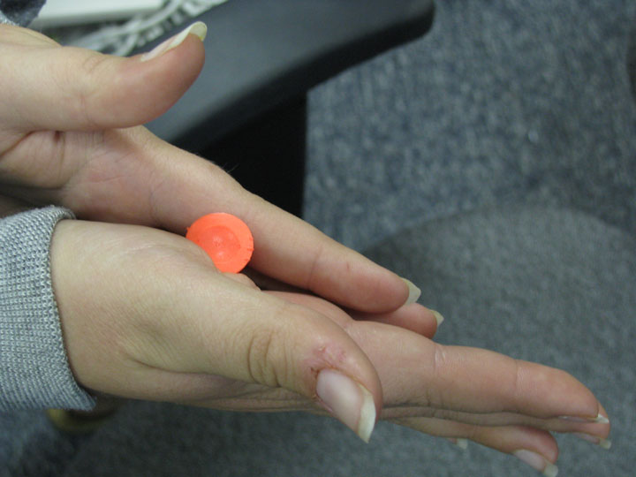

- Roll
- Reach
- Insert
- Hold

Perform the following steps.

- Roll the formable plug between your two hands to compress it into a compact smooth cylinder.
2. Reach over the top of your head and pull up or back on the top of your ear. This straightens out your ear canal so the plugs can go in far enough.
3. Insert the tightly rolled plug into straightened ear canal.
4. Hold the ear plug in place for a few seconds after inserting to give it time to expand and seat itself in the ear canal.
5. The plug must be rolled tightly before inserting into the ear canal. Do not try to push an unrolled formable plug into an ear.

An Inserted Earplug
If the earplug looks similar to this then its:
