The Science of Hearing Loss
Student Information Sheet

Hearing Loss
- Hearing loss can be temporary or permanent.
- Hearing loss can occur at any age.
- Nothing can restore hearing loss. Once it’s gone, it’s gone!
- All types of equipment and tools can cause hearing loss.
- When hair cells in the ear are damaged, they do not grow back unless you’re a reptile!

Parts of the Ear

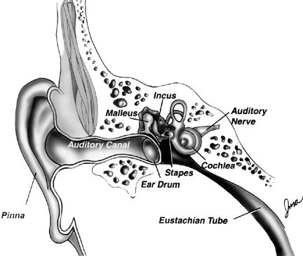
Cochlea
- The Cochlea is the part of the inner ear that is shaped like a snail.
- The inner ear is lined with hair cells that are too tiny to be seen without a microscope.
- There are 18,000 hair cells per cochlea.
- All 18,000 hair cells would fit on the head of a pin.

Undamaged Stereocilia
- Fingerlike projections
- Rock back and forth with the sound waves
- Transmit messages to the brain
- This is how a person hears sound

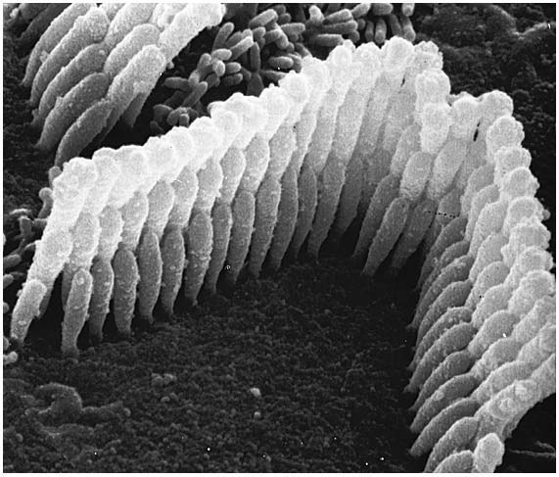
The hair cells are lined with small, thin fingerlike projections called stereocilia. These stereocilia are rocked back and forth by sound waves. The mechanical energy of the movement back and forth of the stereocilia is converted to messages that are sent to the brain. Our brain interprets the message as “I hear something”.

Damaged Stereocilia
- The stronger the sound waves the more damage that is done
- Once damaged, stereocilia cannot be repaired
- This is where hearing loss occurs
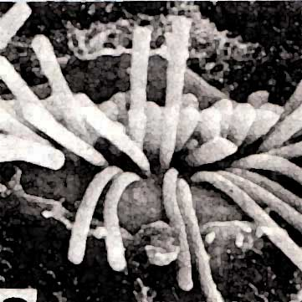

This is a microscopic picture of damaged stereocilia. The stereocilia rock back and forth because of the sounds waves. The louder the sound, the stronger the waves, the more damage that is done to the stereocilia. If the damage is severe, hearing loss is permanent because the stereocilia cannot be straightened back out.

