Types of Hearing Protection
Prevention Aids
There are different types of hearing loss prevention devices.
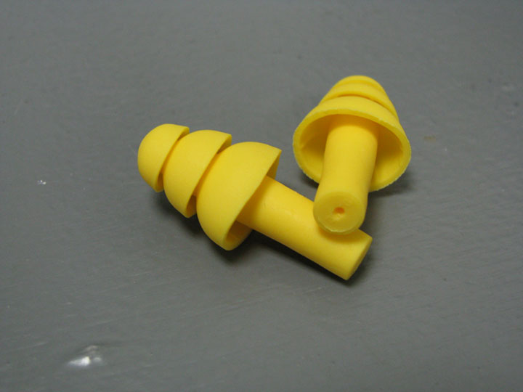
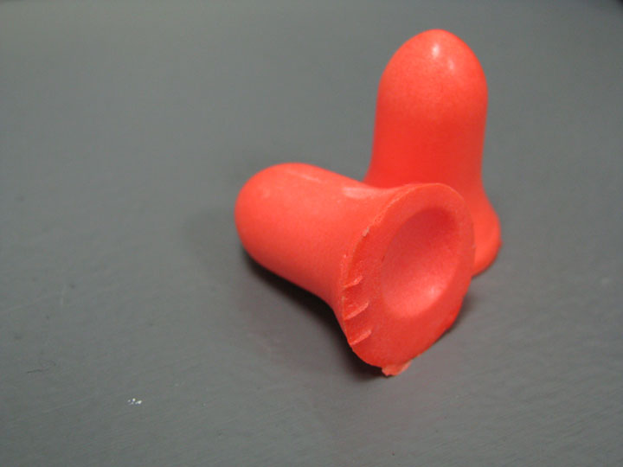

Earplugs-Formable Earplugs- Pre-molded

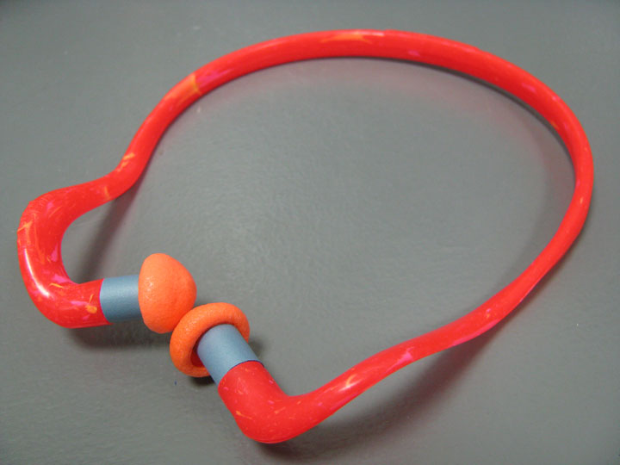
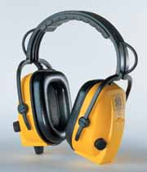

Earmuffs Canal Caps

Myth and Fact
Myth: A person can’t hear people around them or the machine or tool when wearing earplugs.
Fact: Earplugs block background sound and allow you to better hear people around you and the machine or tool.

