Name: Date:

Ruler Reaction Time Game

Steps:
1. Hold a ruler near the end (highest number) and let it hang down.
2. Have another person hold his or her hand at the bottom of the ruler, with thumb and forefinger spread 2 inches apart. They should not be touching the ruler.
3. Tell the person you are going to drop the ruler at random and he or she should try to catch the ruler as quickly as possible after it is dropped.
4. Record the level in inches or centimeters at which they catch the ruler. Test the person 3 to 5 times (varying the time of dropping the ruler) and calculate an average level at which the ruler is caught.
5. Use the conversion chart to find out the reaction time. Switch places, and do the activity again!

For example, if you caught the ruler at the 8 inch mark, then your reaction time is equal to 0.20 seconds (200 ms). Remember that there are 1,000 milliseconds (ms) in 1 second.
Distance | Time
2 in (~5 cm) | 0.10 sec (100 ms)
4 in (~10 cm) | 0.14 sec (140 ms)
6 in (~15 cm) | 0.17 sec (170 ms)
8 in (~20 cm) | 0.20 sec (200 ms)
10 in (~25.5 cm) | 0.23 sec (230 ms)
12 in (~30.5 cm) | 0.25 sec (250 ms)
17 in (~43 cm) | 0.30 sec (300 ms)
24 in (~61 cm) | 0.35 sec (350 ms)
31 in (~79 cm) | 0.40 sec (400 ms)
39 in (~99 cm) | 0.45 sec (450 ms)
48 in (~123 cm) | 0.50 sec (500 ms)
69 in (~175 cm) | 0.60 sec (600 ms)
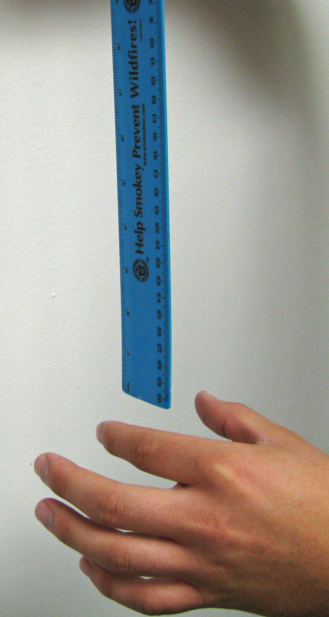

Try variations of the activity! How does reaction time vary if…
- the lights are dimmed?
- one eye is closed?
- you use your non dominant hand?
Optional Activity

If you want to be more precise with measurements, you may utilize the following formulas.

Formula 1
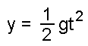
Formula 2
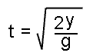
Formula 1 provides you with the distance an object will fall in a given amount of time.
By rearranging Formula 1 into Formula 2, you can get the amount of time it takes an object to fall a certain distance...that's what you want to find out. All you have to do is plug in the distance (in either centimeters or inches) that the ruler fell into Formula 2 - this will give you the reaction time.

In the formulas, t = time (in seconds); y = distance (in cm); g = 980 cm/sec2 (acceleration due to gravity). [Note: you can also use inches in your distance measurement, but you must change g to equal 385.8 in/sec2.]

