Quote of the Day

Using a quote of the day exercise in class can be an inspirational but short activity for character and ethical skill development incorporated in to the Georgia Performance Standards. Quotes will challenge students to think critically and stretch their thinking as they record the quotes and write and discuss their interpretations. Students will remember their favorite quotes for a lifetime.

The 200+ quotations in this document were selected to apply across all CTAE pathways. The teacher is encouraged to add quotes that may relate more directly to their pathway.

Value of a Quote of the Day

In addition to building life skills defined in CTAE Standards, quotations can:
- Build language arts skills such as interpreting, paraphrasing, and using synonyms.
- Help improve student vocabulary.
- Be a great way to open discussion on caring, responsibility, and respect.
- Make instruction more meaningful when related to class curriculum.

Standards

Using a quote of the day meets at least two CTAE Foundation Standards, as well as a State Board of Education Rule.

Georgia Performance Standards:

CTAE-FS-3 Communications: Learners use various communication skills in expressing and interpreting information.

CTAE-FS-9 Ethics and Legal Responsibilities: Learners commit to work ethics, behavior, and legal responsibilities in the workplace.

State Board of Education Rule

The Georgia State Board of Education supports character education. The following rule emphasizes the importance of character and values education.

160-4-2-.33 VALUES AND CHARACTER EDUCATION.
(1) REQUIREMENTS.
(a) Local boards of education shall provide instruction that addresses the core values adopted by the State Board of Education. Local boards of education shall also provide instruction in character education.
(b) Each local board of education shall adopt a plan for implementing values and
character education and shall specify in that plan the instructional materials and strategies to be used.
(c) The department shall develop a values and character education guide which may be used by local boards of education in the development of values and character education programs.
Authority O.C.G.A. § 20-2-145; 20-2-240 .

See the guide at the end of this document for detailed instructions on implementing character education in the classroom.

SUGGESTIONS FOR USE
Class Starters

Make the “Quote of the Day” a Class Starter. When used in this manner, students should know that when the bell rings for class to begin they should read the quote of the day, write it in their journal or notebook and follow other directions given by the teacher. Using a quote as a Class Starter is a positive way to begin class and adds consistency to class routine. Students should know that as soon as the bell rings, the room should be quiet and they should be writing for 3-5 minutes. This procedure should be followed each day. The learning environment is much more positive when starting the class this way.

Challenge Students

The teacher should challenge students to apply the quotations to their own lives. Teachers are sometimes pleasantly surprised that students relate to the quotes with deep sensitivity and interpretation.

Invite Students to Submit Quotes

The teacher may want to invite students to submit their “favorite” quotes to use as a quote of the day or to post on the wall. Students may want to jazz up their quotes on the computer or by hand painting. Students respond better when they feel they have some ownership of a project.

Post Quotes of the Day
Post Quotes of the Day on the class wall after use. Occasionally, students will zone-out or be distracted from class and the quotes give them something positive to look at!
Favorite Quotations
Have students select their favorite quotes, find appropriate photographs, and add the quotes to the photos. Print them out in color if possible and add them to their notebook or post on the wall of the classroom or in the hall – or on the ceiling of the classroom.
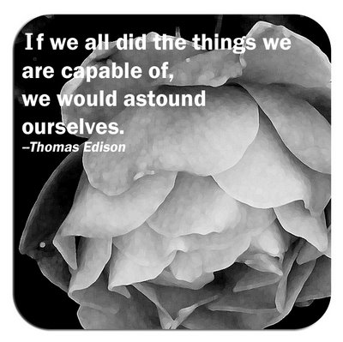
Quick Check

Quotes may be written in student journals or notebooks and dated. The teacher may wish to occasionally ask for the quotations from certain dates. This will help assure students are participating and staying on task. Teachers may give certain dates and ask only for the students’ interpretations of the quote from that day. This is a great way to incorporate the character building quotations into your class.

Displaying and Using Quotations

This set of quotes is intended to be put on display in the classroom. They may be printed and put into a notebook for display. The students should write the quote in their journals, agendas or in the bubble on the worksheet. Students should take a moment to think about what the quote means and write their interpretations on the worksheet. The teacher may want to ask a few students for their interpretations of the quote.
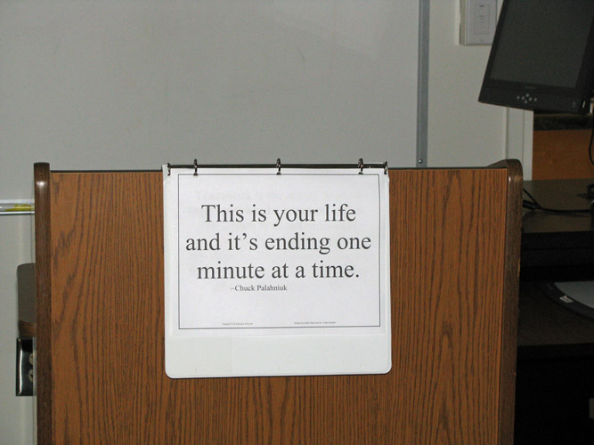
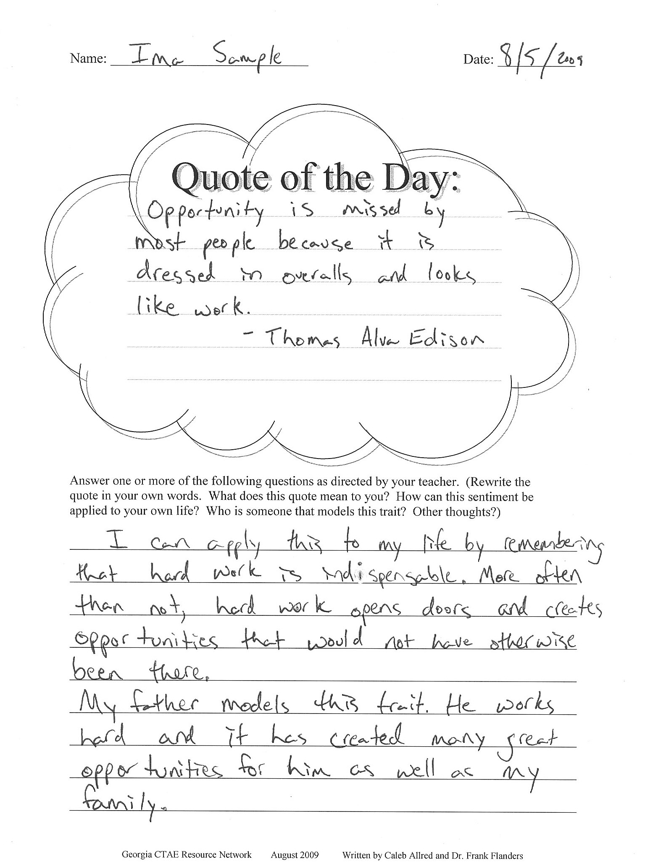

Name: ____________________________ Date: ___________

Quote of the Day:
_____________________________________________________
_____________________________________________________
_____________________________________________________
_____________________________________________________
_____________________________________________________
_____________________________________________________
_____________________________________________________
Answer one or more of the following questions as directed by your teacher. (Rewrite the quote in your own words. What does this quote mean to you? How can this sentiment be applied to your own life? Who is someone that models this trait? Other thoughts?)

________________________________________________________________________

________________________________________________________________________

________________________________________________________________________

________________________________________________________________________

________________________________________________________________________

________________________________________________________________________

________________________________________________________________________

________________________________________________________________________

________________________________________________________________________

Blessed is he who has found his work.
~ Thomas Carlyle

Whether You Think You Can or Can't, You're Right.
~ Henry Ford

Life is a garden. Dig it!
~ David Spade (Joe Dirt)

The best things in life aren’t things.
~ Art Buchwald

You’re only given a little spark of madness. You mustn’t lose it.
~ Robin Williams

Not all who wander are lost.
~ J.R.R. Tolkien

Be kind. Everyone you meet is fighting a hard battle.
~Attributed to both T.H. Thompson and John Watson

Whenever possible, skip rather than walk.
~Author Unknown
I cried because I had no shoes until I met a man who had no feet.
~Anonymous
If you always do what you've always done, you'll always get what you always got, and you'll always feel what you always felt.
~Author Unknown

The reason a dog has so many friends is that he wags his tail instead of his tongue.
~Author Unknown

Dream like you will live forever, live like you will die today.
~James Dean

It is better to light one small candle than to sit and curse the darkness.
~Chinese Proverb

A good friend is hard to find, harder to leave, and impossible to forget.
~Author Unknown

Do or Do not.
There is no try.
~Yoda

"I think there is a world market for about five computers."

~ Thomas Watson, Chairman of IBM, 1943

"I have traveled the length and breadth of this country, and talked with the best people, and I can assure you that data processing is a fad that won't last out the year."
~ Editor of business books for Prentice Hall, 1957

We can only be said to be alive in those moments when our hearts are conscious of our treasures.
~Thornton Wilder
"There is no reason for any individual to have a computer in their home."
~ Ken Olsen, president, founder of Digital Equipment Corp., 1977

"This 'telephone' has too many shortcomings to be seriously considered as a means of communication. The device is inherently of no value to us."
~ Western Union internal memo, 1876

Whatever you are, be a good one.
~Abraham Lincoln

"We don't like their sound. Groups of guitars are on the way out."
~ Decca Recording Company executive rejecting the Beatles, 1962.

"Stocks have reached what looks like a permanently high plateau."
~ Irving Fisher, Professor of Economics, Yale University, 1929.
We should be taught not to wait for inspiration to start a thing. Action always generates inspiration. Inspiration seldom generates action.
~ Frank Tibolt
Never mistake motion for action.
~ Ernest Hemingway

Remember, people will judge you by your actions, not your intentions. You may have a heart of gold - but so does a
hard-boiled egg.
~Author Unknown
People may doubt what you say, but they will believe what you do.
~Lewis Cass

The cyclone derives its powers from a calm center. So does a person.
~Norman Vincent Peale

I believe humans get a lot done, not because we're smart, but because we have thumbs so we can make coffee.
~Flash Rosenberg

An idealist is one who, on noticing that roses smell better than cabbage, concludes that they will also make better soup.
~Henry L. Mencken

Whenever you fall, pick something up.
~Oswald Avery

I have learned to use the word impossible with the greatest caution.
~Wernher von Braun

We cannot direct the wind but we can adjust the sails.
~Author Unknown

Some people are always grumbling because roses have thorns; I am thankful that thorns have roses.
~Alphonse Karr

I have found that if you love life, life will love you back.
~Arthur Rubinstein

There are two types of people - those who come into a room and say, "Well, here I am!" and those who come in and say, "Ah, there you are."
~Frederick L. Collins

Excellence is not a skill. It is an attitude.
~Ralph Marston

You can observe a lot just by watching.
~Yogi Berra

"Who wants to hear actors talk?"
~ Harry M. Warner, president of Warner Brothers Pictures, 1927.
You've got to be very careful if you don't know where you're going, because you might not get there.
~ Yogi Berra

For every minute you are angry, you lose sixty seconds of happiness.
~Author Unknown

There are 86,400 seconds in this day. Have you used one to say "thank you?"
~William A. Ward

The only people with whom you should try to get even are those who have helped you.
~John E. Southard

"Airplanes are interesting toys, but of no military value."
~ Maréchal Ferdinand Foch, 1911.

Teamwork is the ability to work together toward a common vision; the ability to direct individual accomplishment toward organizational objectives. It is the fuel that allows common people to attain uncommon results.
~Andrew Carnegie

If you don't like how things are, change it! You're not a tree.
~Jim Rohn

You can tell more about a person by what he says about others than you can by what others say about him.
~Leo Aikman

It is every man's obligation to put back into the world at least the equivalent of what he takes out of it.
~Albert Einstein
Giving up doesn't always mean you are weak. Sometimes it means that you are strong enough to let go.
~Author Unknown

Promise only what you can deliver. Then deliver more than you promise.
~Author Unknown

Life is like riding a bicycle - in order to keep your balance, you must keep moving.
~Albert Einstein

Am I not destroying my enemies when I make friends of them?
~Abraham Lincoln

There is often less danger in the things we fear than in the things we desire.
~John C. Collins

Dig the well before you are thirsty.
~Chinese Proverb

"Louis Pasteur's theory of germs is ridiculous fiction."
~ Pierre Pachet, Professor of Physiology at Toulouse, 1872
Everyone should learn to do one thing supremely well because he likes it, and one thing supremely well because he detests it.
~Brigham Young

Too many people overvalue what they are not and undervalue what they are.
~Malcolm S. Forbes

Today I bent the truth to be kind, and I have no regret, for I am far surer of what is kind than I am of what is true.
~Robert Brault

Kindness is in our power, even when fondness is not.
~Samuel Johnson

When I was young, I admired clever people. Now that I am old, I admire kind people.
~Abraham Joshua Heschel

You can't live a perfect day without doing something for someone who will never be able to repay you.
~John Wooden

By swallowing evil words unsaid, no one has ever harmed his stomach.
~Winston Churchill

We have two ears and one mouth so that we can listen twice as much as we speak.
~Epictetus

Beginning today, treat everyone you meet as if they were going to be dead by midnight. Extend to them all the care, kindness and understanding you can muster, and do it with no thought of any reward. Your life will never be the same again.
~ Og Mandino

Nobody can make you feel inferior without your consent.
~ Eleanor Roosevelt

A successful person is one who can lay a firm foundation with the bricks that others throw at him or her.
~ David Brinkley

It ain't what they call you; it's what you answer to.
~ W.C. Fields

If you hear a voice within you say "you cannot paint," then by all means paint, and that voice will be silenced.
~Vincent Van Gogh

Confidence comes not from always being right but from not fearing to be wrong.
~Peter T. McIntyre

Aerodynamically the bumblebee shouldn't be able to fly, but the bumblebee doesn't know that so it goes on flying anyway.
~Mary Kay Ash

What lies behind us and what lies before us are tiny matters compared to what lies within us.
~ Ralph Waldo Emerson

The things we hate about ourselves aren't more real than things we like about ourselves.
~ Ellen Goodman

You're never as good as everyone tells you when you win, and you're never as bad as they say when you lose.

~Lou Holtz and John Heisler

It's a poor sort of memory that only works backward.
~ Lewis Carroll (Alice in Wonderland)
If everybody minded their own business, the world would go around a great deal faster than it does.
~ Lewis Carroll (Alice in Wonderland)

Begin at the beginning and go on till you come to the end: then stop.
~ Lewis Carroll (Alice in Wonderland)

If I had a world of my own, everything would be nonsense. Nothing would be what it is, because everything would be what it isn't. And contrary wise, what is, it wouldn't be. And what it wouldn't be, it would. You see?
~ Lewis Carroll (Alice in Wonderland)

Read the directions and directly you will be directed in the right direction.
~ Lewis Carroll (Alice in Wonderland)

There's a large mustard-mine near here. And the moral of that is – The more there is of mine, the less there is of yours.
~ Lewis Carroll (Alice in Wonderland)

"Contrariwise," continued Tweedledee, "if it was so, it might be; and if it were so, it would be; but as it isn't, it ain't. That's logic."
~ Lewis Carroll (Through the Looking Glass: And What Alice Found There)

"You know," he added gravely, "it's one of the most serious things that can possibly happen to one in a battle -- to get one's head cut off."
~ Lewis Carroll (Through the Looking Glass: And What Alice Found There)
"Heavier-than-air flying machines are impossible."
~ Lord Kelvin, British mathematician, physicist, about 1895.
Thinking is the hardest work there is, which is probably the reason why so few engage in it.

~ Henry Ford

Even if you are on the right track, if you sit there long enough, you will get run over.
~ Author Unknown

Generally speaking, the great achieve their greatness by industry rather than by brilliance.
~ Bruce Barton

It’s always the right time to do what is right.
~ Dr. M. L. King Jr.

Victories that are cheap are cheap. Those only are worth having which come as a result of hard fighting.
~ Henry Ward Beecher
Ninety percent of the work done in this country is done by people who don’t feel well.
~ Theodore Roosevelt

A gem is not polished without friction, nor a person perfected without trials.
~ Chinese proverb

Be not afraid of going slowly. Be afraid of standing still.
~ Japanese proverb

Being frustrated is disagreeable, but the real disasters in life begin when you get what you want.
~ Irving Kristol
The quality of a person’s life is in direct proportion to their commitment to excellence, regardless of their chosen field of endeavor.
~ Vince Lombardi

The trouble with being a good sport is that you have to lose in order to prove it.
~ Author Unknown

The roots of education are bitter, but the fruit is sweet.
~Aristotle
Anyone who thinks the art of conversation is dead ought to tell a child to go to bed.
~Robert Gallagher

I have never let my schooling interfere with my education.
~Mark Twain

Education is what remains after one has forgotten what one has learned in school.
~Albert Einstein

Obstacles are those frightful things you see when you take your eyes off your goal.
~Henry Ford

One half of knowing what you want is knowing what you must give up before you get it.
~Sidney Howard

Goals are dreams with deadlines.
~Diana Scharf Hunt

Don't say you don't have enough time. You have exactly the same number of hours per day that were given to Helen Keller, Pasteur, Michelangelo, Mother Teresa, Leonardo da Vinci, Thomas Jefferson, and Albert Einstein.
~Life's Little Instruction Book, compiled by H. Jackson Brown, Jr.

Sometimes the path you're on is not as important as the direction you're heading.
~Kevin Smith

Many are stubborn in pursuit of the path they have chosen, few in pursuit of the goal.
~Friedrich Wilhelm Nietzsche

Vision without action is a daydream. Action without vision is a nightmare.
~Japanese Proverb

Putting off an easy thing makes it hard. Putting off a hard thing makes it impossible.
~George Claude Lorimer

Procrastination is the thief of time.
~Edward Young

If you tell the truth you don't have to remember anything.
~Mark Twain

Who lies for you will lie against you.
~Bosnian Proverb

A half truth is a whole lie.
~Yiddish Proverb

The hardest tumble a man can make is to fall over his own bluff.
~Ambrose Bierce

Men occasionally stumble over the truth, but most of them pick themselves up and hurry off as if nothing had happened.
~Winston Churchill

There's one way to find out if a man is honest - ask him. If he says, "Yes," you know he is a crook.
~Groucho Marx

I am different from Washington; I have a higher, grander standard of principle. Washington could not lie. I can lie, but I won't.
~Mark Twain

The goodness of the true pun is in the direct ratio of its intolerability.
~Edgar Allan Poe

Tell a man there are 300 billion stars in the universe and he'll believe you. Tell him a bench has wet paint on it and he'll have to touch it to be sure.
~Murphy's Law
How is it that our memory is good enough to retain the least triviality that happens to us, and yet not good enough to recollect how often we have told it to the same person?
~François Duc de La Rochefoucauld

How is it one careless match can start a forest fire, but it takes a whole box to start a campfire?
~Author Unknown

Admiration is a very short-lived passion that immediately decays upon growing familiar with its object.
~Joseph Addison, The Spectator

Nothing is as frustrating as arguing with someone who knows what he's talking about.
~Sam Ewing

How can I control my life when I can't control my hair?
~Author Unknown

If in the last few years you haven't discarded a major opinion or acquired a new one, check your pulse. You may be dead.
~ Gelett Burgess

Not until we are lost do we begin to understand ourselves.
~Henry David Thoreau

There is nothing like returning to a place that remains unchanged to find the ways in which you yourself have altered.
~Nelson Mandela

Those who are brutally honest are seldom so with themselves.
~Mignon McLaughlin

"Know thyself?" If I knew myself, I'd run away.
~Johann Wolfgang von Goethe

They must often change, who would be constant in happiness or wisdom.
~Confucius

Men may scoff, and men may pray, but they pay every pleasure with a pain.
~William Henley

No pleasure endures unseasoned by variety.
~Publilius Syrus

The hero is commonly the simplest and obscurest of men.
~Henry David Thoreau

Better a thousand times careful than once dead.
~Proverb

We can be knowledgeable with other men's knowledge, but we cannot be wise with other men's wisdom.
~Michel de Montaigne

It is easier to find a score of men wise enough to discover the truth than to find one intrepid enough, in the face of opposition, to stand up for it.
~A.A. Hodge

Wisdom is the quality that keeps you from getting into situations where you need it.
~Doug Larson

Fathers send their sons to college either because they went to college or they didn't.
~L.L. Hendren

Amateurs compete against each other, professionals compete against themselves.
~ Lee Travino

Everything that can be invented has been invented.
~ Charles H. Duell, Commissioner, U.S. Office of Patents, 1899.

Patience is something you admire in the driver behind you and scorn in the one ahead.
~Mac McCleary

Vegetables are a must on a diet. I suggest carrot cake, zucchini bread, and pumpkin pie.
~Jim Davis

As for butter versus margarine, I trust cows more than chemists.
~Joan Gussow

Striving for excellence motivates you; striving for perfection is demoralizing.
~Harriet Braiker

Better a diamond with a flaw than a pebble without.
~Confucius

They say that nobody is perfect. Then they tell you practice makes perfect. I wish they'd make up their minds.
~Wilt Chamberlain

Most people are awaiting virtual reality; I'm awaiting virtuous reality.
~Eli Khamarov, "Lives of the Cognoscenti"

The trouble with the rat race is that even if you win, you're still a rat.
~Lily Tomlin

A people that values its privileges above its principles soon loses both.
~Dwight D. Eisenhower

Yes, I am positive that one of the great curatives of our evils, our maladies, social, moral, and intellectual, would be a return to the soil, a rehabilitation of the work of the fields.
~Charles Wagner

The only sure thing about luck is that it will change.
~Wilson Mizner

It's hard to detect good luck - it looks so much like something you've earned.
~Frank A. Clark

Luck has a peculiar habit of favoring those who don't depend on it.
~Author Unknown

Let us be of good cheer, remembering that the misfortunes hardest to bear are those which will never happen.
~James Russel Lowell

Worry never robs tomorrow of its sorrow, it only saps today of its joy.
~Leo Buscaglia

Any concern too small to be turned into a prayer is too small to be made into a burden.
~Corrie ten Boom

If you see ten troubles coming down the road, you can be sure that nine will run into the ditch before they reach you.
~Calvin Coolidge

Rule number one is, don't sweat the small stuff. Rule number two is, it's all small stuff.
~Robert Eliot

Wherever you go, go with all your heart.
~Confucius

Don't live down to expectations. Go out there and do something remarkable.
~Wendy Wasserstein

If opportunity doesn't knock, build a door.
~Milton Berle

Time you enjoyed wasting was not wasted.
~John Lennon

It is not the mountain we conquer but ourselves.
~Edmund Hillary

The best helping hand that you will ever receive is the one at the end of your own arm.
~Fred Dehner

You have to expect things of yourself before you can do them.
~Michael Jordan
If we all did the things we are capable of doing, we would literally astound ourselves.
~Thomas Alva Edison

Opportunity is missed by most people because it is dressed in overalls and looks like work.
~Thomas Edison

Our greatest glory is not in never failing, but in rising up every time we fail.
~Ralph Waldo Emerson

Your work is to discover your world and then with all your heart give yourself to it.
~Buddha

The years teach much which the days never knew.
~Ralph Waldo Emerson

I'd rather entrust the government of the United States to the first 400 people listed in the Boston telephone directory than to the faculty of Harvard University.
~William F. Buckley

The American Republic will endure until the day Congress discovers that it can bribe the public with the public's money.
~Alexis de Tocqueville

I have a dream that my four little children will one day live in a nation where they will not be judged by the color of their skin but by the content of their character.
~Martin Luther King

If a nation values anything more than freedom, it will lose its freedom; and the irony of it is that if it is comfort or money that it values more, it will lose that, too.
~Somerset Maugham

The nine most terrifying words in the English language are, I'm from the government and I'm here to help.
~Ronald Reagan

Speak softly and carry a big stick, and you will go far.
~Teddy Roosevelt

Watch your thoughts, for they become words. Watch your words, for they become actions. Watch your actions, for they become habits. Watch your habits, for they become character. Watch your character, for it becomes your destiny.
~Unknown Author

Avoid popularity if you would have peace.
~Abraham Lincoln

Be sure you put your feet in the right place, then stand firm.
~Abraham Lincoln

Better to remain silent and be thought a fool than to speak out and remove all doubt.
~Abraham Lincoln

Everybody likes a compliment.
~Abraham Lincoln

Give me six hours to chop down a tree and I will spend the first four sharpening the axe.
~Abraham Lincoln

How many legs does a dog have if you call the tail a leg? Four. Calling a tail a leg doesn't make it a leg.
~Abraham Lincoln

I do not think much of a man who is not wiser today than he was yesterday.
~Abraham Lincoln

I like to see a man proud of the place in which he lives. I like to see a man live so that his place will be proud of him.
~Abraham Lincoln
A fool thinks himself to be wise, but a wise man knows himself to be a fool.
~William Shakespeare

All the world's a stage, and all the men and women merely players: they have their exits and their entrances; and one man in his time plays many parts, his acts being seven ages.
~William Shakespeare

Be not afraid of greatness: some are born great, some achieve greatness, and some have greatness thrust upon them.
~ William Shakespeare

"Be the change you wish to see in the world"
~ Mahatma Gandhi

"Perseverance can tip the scale from failure to success."
~ Unknown
Better three hours too soon than a minute too late.
~William Shakespeare

An injured friend is the bitterest of foes.
~Thomas Jefferson

Be kind whenever possible. It is always possible.
~Dalai Lama

If you can, help others; if you cannot do that, at least do not harm them.
~Dalai Lama

Sometimes one creates a dynamic impression by saying something, and sometimes one creates as significant an impression by remaining silent.
~Dalai Lama

The easiest way to keep a secret is without help.
~Author Unknown

Learning is not attained by chance, it must be sought for with ardor and attended to with diligence.
~Abigail Adams

You gain strength, courage, and confidence by every experience in which you stop to look fear in the face. You are able to say to yourself, ‘I lived through this horror; I can take the next thing that comes along.’ You must do the thing you think you cannot do.
~Eleanor Roosevelt

Injustice anywhere is a threat to justice everywhere.
~Martin Luther King

The true measure of a man is how he treats someone who can do him absolutely no good.
~Ann Landers

It is the job that is never started that takes the longest to finish.
~J.R.R. Tolkien

All we have to decide is what to do with the time that is given to us.
~J.R.R. Tolkien
Many of life's failures are people who did not realize how close they were to success when they gave up.
~Thomas A. Edison

A great man is always willing to be little.
~Ralph Waldo Emerson

A man is usually more careful of his money than he is of his principles.
~Ralph Waldo Emerson

The future is something which everyone reaches at the rate of 60 minutes an hour, whatever he does, whoever he is.
~C. S. Lewis

With the possible exception of the equator, everything begins somewhere.
~C. S. Lewis

You’ll never plow a field by turning it over in your mind.
~Irish Proverb

Plow your own fields and rear your own children.
~Chinese Proverb

A determined soul will do more with a rusty monkey wrench than a loafer will accomplish with all the tools in a machine shop.
~Robert Hughes

Earth, teach me regeneration as the seed which rises in the spring.
~William Alexander
If I had my life to live over, I would start barefoot earlier in the spring and stay that way later in the fall.
~Nadine Star

I just happen to think that we need to be a little like the farmer, who puts back into the soil what he takes out.
~Paul Newman

Then plough deep while sluggards sleep and you shall have corn to sell and keep.
~Benjamin Franklin

Dogs have a way of finding the people who need them, and filling an emptiness we don’t even know we have.
~Thom Jones

An honest answer is the sign of true friendship.
~Proverbs 24:26

Education is not the filling of a pail but the lighting of a fire.
~William Butler Yeats

If you want children to keep their feet on the ground, put some responsibility on their shoulders.
~Abigail Van Buren

The road to success is always under construction.
~Lily Tomlin

Your work should be in praise of what you love.
~Ralph Waldo Emerson
Reading without reflecting is like eating without digesting.
~Edmund Burke
Let's stop admiring the problem and move on.
~Anita Voelker

I am only one, but still I am one. I cannot do everything, but still I can do something; and because I cannot do everything I will not refuse to do the something that I can do.
~Edward Everett Hale

This is your life and it’s ending one minute at a time.
~Chuck Palahniuk (Fight Club)

LIST OF VALUES AND CHARACTER EDUCATION ADOPTED BY THE STATE BOARD OF EDUCATION AUGUST 1997

Values and character education development usually occurs over a number of years and within a number of environments. Since family members are the first individuals with whom one comes into contact, the influence of the family continues to be extremely important to a child's character and values development. This fact is particularly appropriate in the preschools and early school years. As students progress through public schools, it is important that their education provide instructional opportunities, explicit and implicit, that help them develop their beliefs about what is right and good. The following definitions are intended to guide schools in providing the basis for the teaching of values and character education in the public schools. Values: hold in high esteem; regard highly Values Concepts: ideas, beliefs or understandings one has that guide and are reflected in one's behavior Values Education: the process of providing opportunities for the continuous development in all students of the knowledge, skills and attitudes related to certain values which lead to behavior exhibiting those values Character: attributes or features that make up and distinguish the individual; the complex of mental and ethical traits making a person, group or nation Character Concepts: actions, attitudes and practice that characterize a person. Acting honorably under all circumstances, even when it is to the disadvantage of the self Character Education: the process by which positive personality traits are developed, encouraged and reinforced through example, study (history and biography of the great and good) and practice (emulation of what has been observed and learned) The State Board of Education believes that there is a core list of values and character education concepts that should be taught in Georgia's schools. The following list has been adopted by the State Board of Education to be implemented in Georgia's schools.

CHARACTER CURRICULUM

accomplishment
cheerfulness
citizenship
cleanliness
commitment
compassion
cooperation
courage
courtesy
creativity
democracy
dependability
diligence
equality
fairness
frugality
generosity
honesty
honor
kindness
knowledge
loyalty
moderation
patience
patriotism
perseverance
productivity
punctuality
respect for authority
respect for others
respect for the creator
respect for environment
respect for health
school pride
self-control
self-respect
sportsmanship
trustworthiness
truthfulness
tolerance
virtue

CITIZENSHIP
Democracy: government of, by and for the people, exercised through the voting process
Respect for and acceptance of authority: the need for and primacy of authority, including the law, in given circumstances
Equality: the right and opportunity to develop one's potential as a human being
Freedom of conscience and expression: the right to hold beliefs, whether religious, ethical or political, and to express one's views
Justice: equal and impartial treatment under the law
Liberty: freedom from oppression, tyranny or the domination of government
Tolerance: the allowable deviation from a standard. Indulgence for beliefs or practices differing from or conflicting with one's own
Patriotism: support of the U. S. Constitution and love for the United States of America with zealous guarding of their authority and interests.
Courage: willingness to face danger with determination
Loyalty: steadfastness or faithfulness to a person, institution, custom or idea to which one is tied by duty, pledge or a promise
Honor: a keen sense of ethical conduct one's word given as a guarantee of performance
Respect for the Natural Environment: care for and conservation of land, trees, clean air and pure water and of all living inhabitants of the earth
Conservation: avoiding waste and pollution of natural resources
Respect for the creator: our most basic freedoms and rights are not granted to us from the government but they are intrinsically ours; i.e., the Constitution does not grant Americans the right of freedom of speech, it simply recognizes that each of us is born with that right. This is to say that the founders of the republic recognized a higher authority, a power greater than themselves that endowed every human being with certain unalienable rights that no government or legal document could ever revoke or take away. In the Declaration of Independence, Thomas Jefferson names this life form that permeates the universe and from which our unalienable rights stem the "creator, "nature's God", and the 'supreme judge of the world'. If we are to respect life, the natural rights of all people and the authority which the founders based their legal opinions on concerning our separation from Great Britain then there must be a respect for that creator from which all our rights flow. This cannot be interpreted as a promotion of religion or even as a promotion of the belief in a personal God, but only as an acknowledgment that the intrinsic worth of every individual derives from no government, person or group of persons, but is something that each of us is born with and which no thing and no one can ever deprive us of.

RESPECT FOR OTHERS
Altruism: concern for and motivation to act for the welfare of others
Civility and cheerfulness: courtesy and politeness in action or speech
Compassion, kindness and generosity: concern for suffering or distress of others and response to their feelings and needs
Courtesy and cooperation: recognition of mutual interdependence with others resulting in polite treatment and respect for them
Integrity: confirmed virtue and uprightness of character, freedom from hypocrisy
Honesty: truthfulness and sincerity
Truth: freedom from deceit or falseness; based on fact or reality
Trustworthiness: worthy of confidence
Fairness and good sportsmanship: freedom from favoritism, self-interest or indulgence of one's likes and dislikes; abiding by the rules of a contest and accepts victory or defeat graciously
Patience: not being hasty or impetuous

RESPECT FOR SELF
Accountability: responsibility for one's actions and their consequences
Commitment: being emotionally, physically or intellectually bound to something
Perseverance and diligence: adherence to actions and their consequences
Self control and virtue: exercising authority over one's emotions and actions
Frugality: effective use of resources; thrift
Self-Esteem: pride and belief in oneself and in achievement of one's potential
Knowledge: learning, understanding, awareness
Moderation: avoidance of unreasonably extreme views or measures
Respect for physical, mental and fiscal health: awareness of the importance of and conscious activity toward maintaining fitness in these areas
Cleanliness: good habits of personal hygiene and grooming
Work Ethic: belief that work is good and that everyone who can, should work
Punctuality: being on time for attendance and tasks
Accomplishment: appreciation for completing a task
Cooperation: working with others for mutual benefit
Dependability: reliability; trustworthiness
Diligence: attentiveness; persistence; perseverance
Pride: dignity; self-respect; doing one's best
Productivity: supporting one's self, contributing to society
Creativity: exhibiting an entrepreneurial spirit inventiveness; originality; not bound by the norm
School pride: playing a contributing role in maintaining and improving all aspects of a school's environment, programs and activities within the context of contributing to the betterment of the city, county and state.

(From public.doe.k12.ga.us)

