Advanced Graphic Communications
Final Project

Name

OBJECTIVE: Student will follow a series of steps to develop job application skills. In the process, student will analyze what he/she has to offer an employer, practice some valuable life skills in applying for a job, and gain skills in presentation.

SCOPE OF PROJECT:
COVER LETTER: Student will prepare a cover letter suitable for applying for a job in desired field of study.

RESUME: Student will prepare a resume to be submitted with the application.

PORTFOLIO: Student will assemble a portfolio and present it attractively.

EVALUATION:
VALUE POINTS
COVER LETTER: complete, correct grammar/spelling, correct format 100

RESUME: complete, appropriate format, correct grammar/spelling 100

ELECTRONIC PORTFOLIO (PDF) 100

TOTAL 300

THE COVER LETTER:
Your cover letter is written in addition to the resume. You do not need to repeat all the information in the resume. The purpose of the letter is to interest the company in you and your qualifications and give them a reason to take the time to read your resume.

It should look like it goes with your resume—use the same stock and font. You may use nice text paper for the final versions of your cover letter and resume.

Here is an example of an outline for a cover letter:
- Explain where you learned of the job (read classified ad).
- Summary of skills
- A persuasive paragraph—what you can do for them
- Contact information—how and when they can reach you.
Check out the useful links section, to find sample cover letters.

THE RESUME:
Your resume should be no more than one page long. It should be organized into sections, which are easy to scan and read. There should be main headings with details listed beneath.

In this case, you know what job you are applying for and any skills that would help you get that job should be highlighted. As you think about the job, try to imagine what qualities in a person would be a value. Are you a team player, versatile with computers, good at proofreading and editing, organized, good working with people, etc.?
Skills that you can highlight include your graphic arts skills and courses in graphics, but there are other areas of your life where you build valuable job skills. Think about what you have accomplished or learned from experiences with school, work, volunteering, sports and other extracurricular activities, reading, travel, etc.

Following the skills you wish to highlight should be information on your education and any other data you want to include. If you begin to go longer than one page, eliminate information least directly connected to the particular job.

THE PORTFOLIO:
WHAT IS IT? Your portfolio is very different from a resume in that it contains documents that tell a story about you. It is a visual resume. It does not have much text—only short explanations of a document as needed.

WHY USE IT? A portfolio gives an interviewer a chance to learn a great deal about you. Also, it is a comfortable way for you to present yourself to someone. Having materials with you helps you to relax and talk about yourself.

WHAT IT SHOULD INCLUDE: It should include more than work done in graphic arts. It should help the company you are interviewing with know you as a person. Certainly projects from your graphic arts experience will provide valuable information to a printing company. Think about what other aspects of your life would be interesting to them and would help you land a job. If your grades are good, include a report card or transcript; if you are involved in sports or extra curricular activities, include some documentation—a program, certificate, newspaper clipping, etc. Any accomplishments you are proud of are appropriate, but you should limit them to 2-3 examples in any category. Your portfolio should include a title page and a table of contents. Sections should be clearly defined.

Acrobat Tools:
After creating a pdf of your portfolio, edit the file so that it will display in full screen mode. To view the document in full screen mode, click on the VIEW menu — VIEW FULL SCREEN (or command L). To exit full screen mode, press the esc key.
You may change the way the pages transition between pages. This option is located under the ADVANCED menu — DOCUMENT PROCESSING — PAGE TRANSITIONS. Play around with the different transitions to see which one you like.

Set up the initial view and security for your portfolio pdf: FILE menu — PROPERTIES… a new window pops up – click on the INITIAL VIEW tab. Under this tab select the following options:
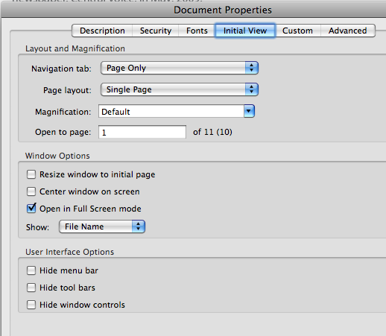

Under the SECURITY tab and select the following options:
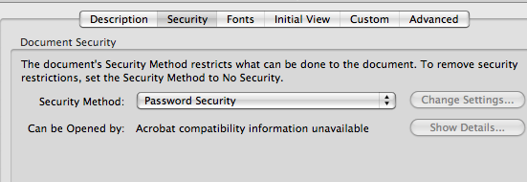

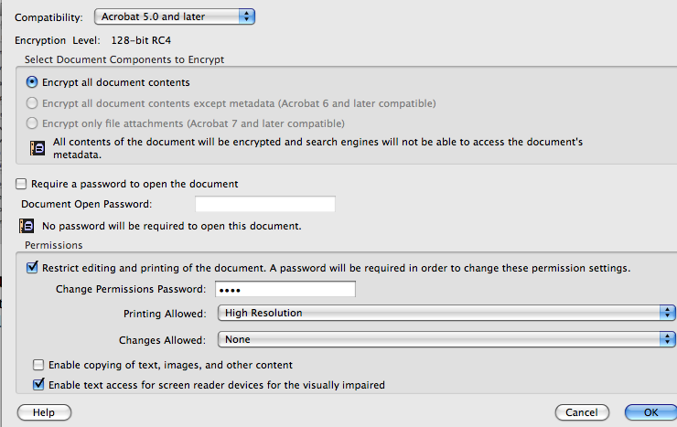

Useful Links
Log on to www.quia.com/pages/cecfund.html, scroll to the bottom of page and there you will find different links to websites for portfolio creation, cover letters and resume building.

