Name: ______________________________ Date: ____________

Branding Unit Test

True/False
Indicate whether the statement is true or false.

____ 1. A reverse and an overprint create the same effect.

____ 2. An ad that uses informal balance is said to have symmetry.

____ 3. Branding is the company’s name that goes on the company’s logo.

____ 4. In an advertisement a 4 point line can be considered a graphic.

____ 5. Branding can make or break the product.

____ 6. Formal balance is the hardest type of balance to create.

____ 7. When you are creating an advertisement, the three things you consider can be done in any order.

____ 8. An advertiser uses only one propaganda technique per ad.

Multiple Choice
Identify the choice that best completes the statement or answers the question.

____ 9. Before you begin creating an ad you consider three things. Which of the following is in the correct order?
a. | content, audience, form | c. | form, content, audience
b. | audience, form, content | d. | audience, content, form

____ 10. To communicate one must have a (an) __________ _____________.
a. | talker, listener | c. | idea, audience
b. | sender, receiver | d. | content, form

____ 11. Which of the following elements of design allow the ad to have state of salience?
a. | Balance | c. | Proportion
b. | Audience | d. | Rhythm

____ 12. Which of the following should one know about his/her audience?
a. | age | c. | Both A and B
b. | gender | d. | Neither A nor B

____ 13. Areas of the layout that are void of printed images is _____________.
a. | line art | c. | white space
b. | illustration | d. | Non of the above

____ 14. Information or lack of information given by an advertiser to sell a product is ________________.
a. | Propaganda | c. | Form
b. | Content | d. | Salience

____ 15. 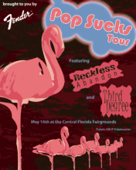
According to the elements of design, the ad above is using ____.
a. | Formal Balance | c. | Both A and B
b. | Informal Balance | d. | Neither A nor B

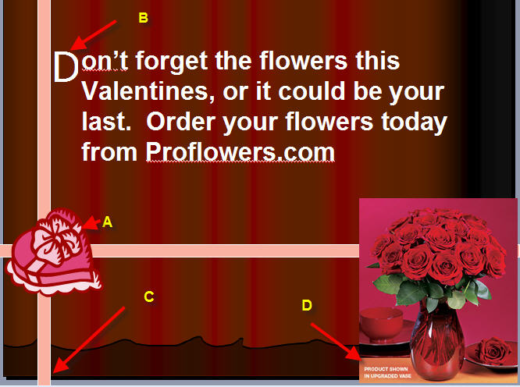
Figure 1
Use this information to answer the next four questions.

____ 16. Using the ad above, A would be ____
a. | Drop Cap | c. | Bleed
b. | Drop Out | d. | Reverse

____ 17. Using the ad above, B would be ____
a. | Drop Cap | c. | Drop Out
b. | Bleed | d. | Reverse

____ 18. Using the ad above, C would be ____
a. | Drop Cap | c. | Bleed
b. | Drop Out | d. | Reverse

____ 19. Using the ad above, C would be ____
a. | Drop Cap | c. | Bleed
b. | Reverse | d. | Drop Out

____ 20. The following is NOT a propaganda technique
a. | Using a famous person | c. | Giving false information about the product.
b. | Using people who have successfully used the product. | d. | Playing on the customers emotions

Answer Key

TRUE/FALSE

1. ANS: F PTS: 1

2. ANS: F PTS: 1

3. ANS: F PTS: 1

4. ANS: T PTS: 1

5. ANS: T PTS: 1

6. ANS: T PTS: 1

7. ANS: F PTS: 1

8. ANS: F PTS: 1

MULTIPLE CHOICE

9. ANS: D PTS: 1

10. ANS: B PTS: 1

11. ANS: C PTS: 1

12. ANS: C PTS: 1

13. ANS: C PTS: 1

14. ANS: A PTS: 1

15. ANS: B PTS: 1

16. ANS: B PTS: 1

17. ANS: A PTS: 1

18. ANS: C PTS: 1

19. ANS: B PTS: 1

20. ANS: C
.

PTS: 1

