Materials List
- Particle Board (could use thick balsa wood or thin pine)
- Fabric
- Duck tape (could use book binding tape)
- Hot Glue
- Cardstock
- Sticky Notes (two 3x3 packs)
Tool List
- Hand or Band Saw (something to cut the wood)
- Safety goggles
- Hot Glue Guns
- Scissors
- Ruler

- Cut out the following wood pieces:
2x 6.9 in. x 3.4 in. (Top & Bottom)
1x 6.8 in. x 1 in. (Full Sidewall)
1x 3.5 in. x 1 in. (Split Sidewall)
1x 2.6 in. x 1 in. (Split Sidewall)
2x 3.1 in. x 1 in. (Front & Back Walls)
1x 3.1 in. x .8 in. (Middle Divider)

- Cut out the following cardstock pieces:
2x 6.6 in. x 3 in. (Top & Bottom)
1x .7 in. x 3 in. (Back Wall)

- Using duct tape, bind one 3.1 in. x 1 in. piece in between the two 6.9 in. x 3.4 in. pieces on the shorter sides of the 6.9 in. x 3.4 in. pieces leaving about .5 in. between the pieces.

- On one 6.9 in. x 3.4 in. piece, glue the 6.8 in. x 1 in. piece on the left side leaving the extra space at the back.
  - Back is where other pieces are taped together.

- Then on the right, glue the 2.6 in. x 1 in. piece towards the back leaving the same amount of space as on the left.

- Next, glue the 2.6 in. x 1 in. piece on the right where it lines up at the front of the 6.9 in. x 3.4 in. piece you have been gluing to.

- On the other 6.9 in. x 3.4 in. piece glue the last 3.1 in. x 1 in. piece to the front leaving a little room on each side.
- Front is the side is where it’s not taped to other pieces.

- Cut out the following pieces of fabric:
1x 17 in. x 11 in.
1x 3.3 in. x 2.6 in.

- Wrap the 3.1 in. x .8 in. piece in fabric.

- Wrap your box in fabric leaving room wherever necessary for folding.

- On the right side where the gap is, cut a slit down the middle of the fabric and fold inwards, then glue the folds down.

- Place and glue the two 6.6 in. x 3 in. pieces of cardstock on the 6.9 in. x 3.4 in. pieces.

- Place and glue the .7 in. x 3 in. piece of cardstock on the piece between the two larger pieces.

- Place and glue the 3.1 in. x .8 in. piece standing on its edge just after the gap in the right side of the bottom piece.

- Lastly, bring up and glue the piece between the two larger pieces to the side piece.

- On a 3 in. x 3 in. sticky note pad divide it with lines into 5 pieces each 3 in. x .5 in.

- Cut the sticky note where you drew your lines.

- Place a full 3 in. x 3 in. sticky note pad in the top section of your box and the 5 pieces of sticky note in the bottom section. Pull off the back of the sticky notes so that they will stick down.

Photographs of Finished Project
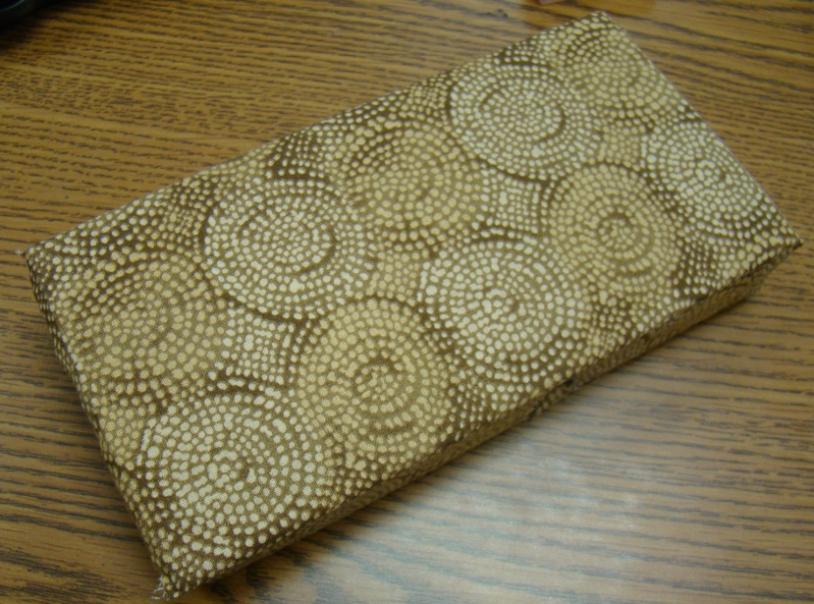
Finished Product (Outside View)

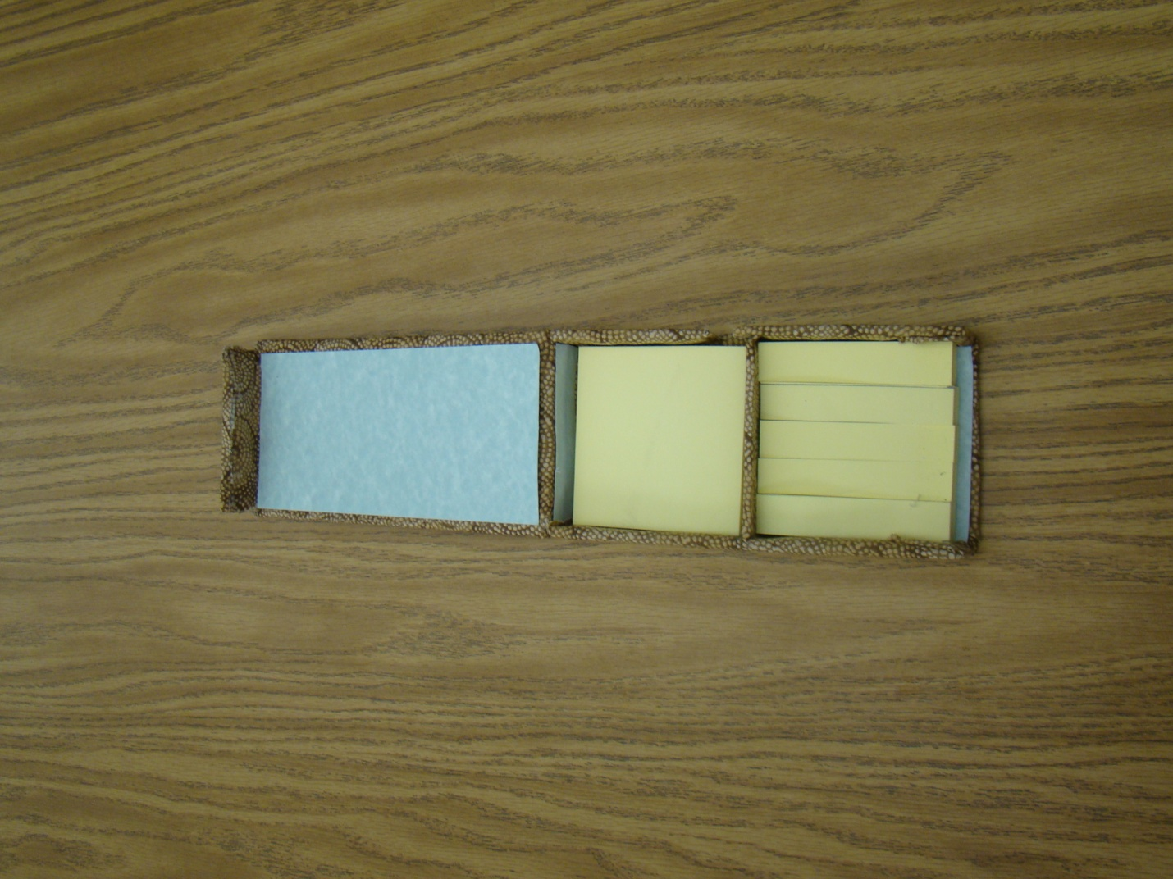
Finished Product (Side View)

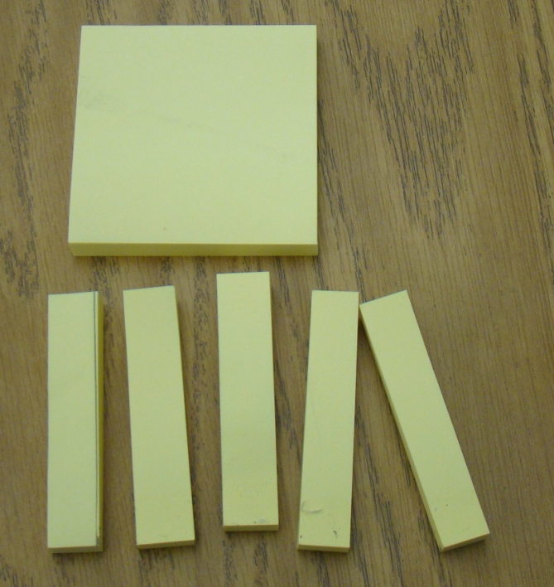
Cut & uncut sticky note pads

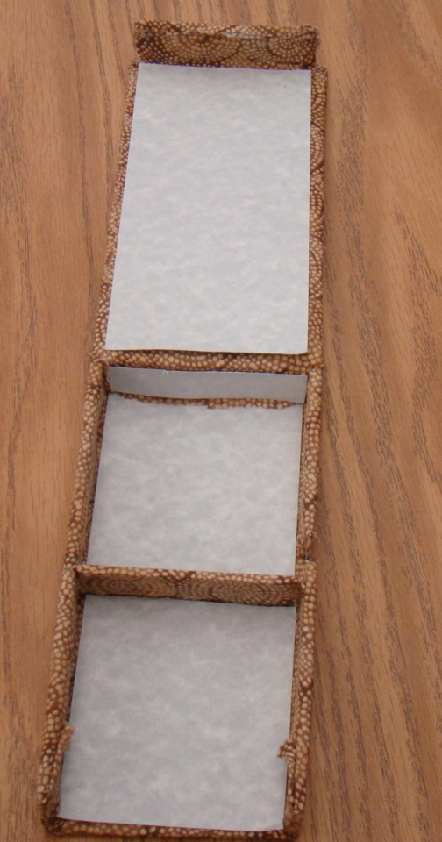
Inside finished without note pads

Sticky Notes Box

Student Name: ________________________________________

CATEGORY | 10 | 5 | 2 | 1
Aesthetics | The box looks professionally bound. |  | Looks good, but could use some work. | Looks as if it was just thrown together.
Cover | Lid closes securely and holds the sticky notes in place |  |  | Lid does not close properly and does not hold the sticky notes and they could fall out.
Waste | All parts of the project were created properly the 1st time and there was no waste or re-cuts. | No more than 2 pieces of the project had to be re-cut. |  | More than 2 pieces of the project had to be re-cut.

