Screen Printing Equipment

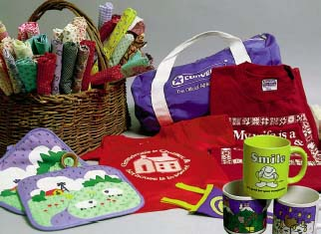
Many products in our free enterprise system are printed using the screen-printing process. Some of the various products that can be screen-printed are:

- Textiles
- Tee shirts
- Glass bottles
- Plastic bottles
- Bumper stickers
- Billboards
- Mugs
- Canvas bags
- Balloons
- Circuit boards and Instrument panels

Screen-printing is the most versatile process – it can be used print almost anything. This uniqueness sets it apart from the other major printing processes. Using the Internet, research some of the various printing machines for the different types of products. Explain how the inks for each will be different substrate.

  - Textiles including drapery, clothing, bedding, and a wide assortment of textiles. These products are often printed on rotary system printing presses.

List a manufacturer of this type of machine_________________________________

  - Tee shirts – are printed on automatic carousel screen-printing devices. Some machines can print upwards of 10-20 colors. Plastisol ink is the type of ink used for garment/tee shirt printing. Mesh counts range from 110-305 for high quality multi-color halftone printing. Most small labs will have a manual press with 4-6 color capability. Canvas bags and any flat fabric substrate can be printed on these types of machines.

List 5 manufacturers of these types of machine
_________________________________ _________________________________

_________________________________ _________________________________

_________________________________

  - Glass bottles, drinking glasses, mugs, plastic bottles (i.e. shampoo)

This machine is currently set up to print 3 bottles at a time. Bottles enter on left and deliver printed products on the right side. Along with glass bottles that utilize an epoxy-based ink, this type of machine can print numerous types of cylindrical products.

List a manufacturer of this type of machine_________________________________

d. Signs and Graphic printing is done on machines like the single color press below. Graphic printing generally uses UV inks to increase drying time and durability. Billboards, political signs, and printed products used outside are some examples of this type of screen-printing. These machines generally use screens that have higher mesh counts than textile printing machines. Mesh counts used are 305 and up to 405 mesh. This enables the final print to have greater detail and print line counts around 85 lpi. Most garment printers print halftone at around 45 – 55 lpi.

List 3 manufacturers of this type of machine _________________________________

_________________________________ _________________________________

  - Balloons are screen-printed on very specialized machines such as the ones below:

List 2 manufacturers of this type of equipment _________________________________

_________________________________
From the types of equipment and machinery you have researched, describe why screen-printing is an important printing process and how the markets it serves impacts our free enterprise system.

