Printing Processes
Name:

Date:

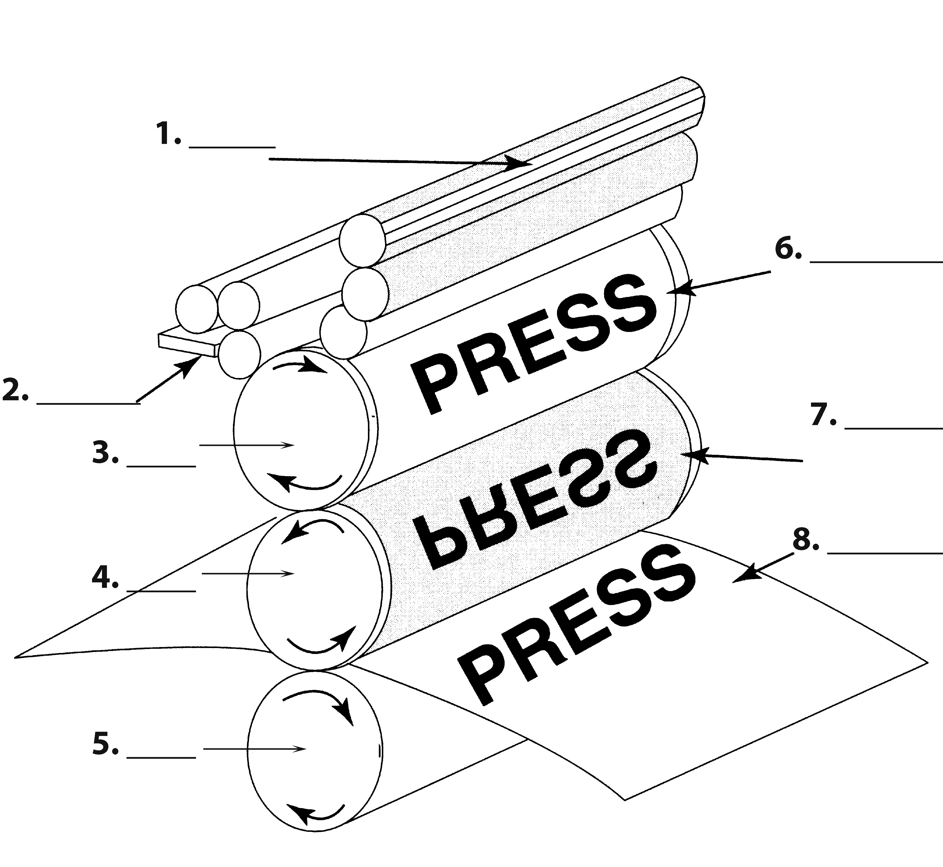
Label
- Rubber Blanket
- Plate Cylinder
- Doctor Blade
- Press Sheet
- Dampening System (Water Fountain)
- Printing Plate
- Ink Fountain
- Monitoring Gear
- Impression Cylinder
- Blanket Cylinder

Multiple Choice
- _____________________ is a printing method in which the image is transferred to the surface to be printed by means of ink squeezed by a squeegee through a stenciled fabric or metal wire screen stretched over a frame.

  - Offset Lithography
  - Flexography
  - Screen printing
  - Gravure

- A printing press that prints from a large roll of paper is called a _______________________.

  - Offset Lithography press
  - Web-fed press
  - Sheet-fed press
  - Gravure

True/False
T or F | - The image area of the plate surface is chemically treated to accept ink and reject water.
T or F | - The image on the rubber blanket is right-reading.
T or F | - During Offset printing, the plate receives ink first and then water.
T or F | - The printing plates of the Gravure press last longer than the Offset press.
T or F | - Offset lithography is the oldest and most used method of printing used today.
T or F | - During offset printing the ink transfers directly from the plate to the paper
T or F | - Maintaining the proper ink-water ratio on the offset press produces a clear, clean image.

Matching

____ | - Hydrophilic
____ | - Letter press/ Relief Printing
____ | - Gravure
____ | - Offset Printing
____ | - Prepress
____ | - Impression Cylinder
____ | - Type Blur
____ | - Rubber Blanket
____ | - Sheet-fed press

- A printing process in which the image is etched below the surface of the printing plate.
- All the steps necessary to get the printed product ready to ship
- Quality issue on the Gravure press where text can print poorly; text not as sharp as text printed on other presses.
- The cylinder which applies pressure for the image to transfer to the paper.
- Smooth rubber surface that transfers the image from the plate to the paper.
- A press that prints from a roll of paper.
- The process of printing from a raised surface that “stamps” the ink onto the substrate.
- All the steps necessary to get the press set up and ready to print.
- The cylinder which holds the rubber blanket.
- The image area of the printing plate.
- A press that prints pre-cut sheets of paper.
- The non-image area of the printing plate.
- A printing process based on the principle that oil and water does not mix.

Equipment Choices
Choose the press that will best print the following jobs or that fits the description given. You might use the choices more than once.

A: Letterpress B: Gravure Press C: Offset Lithography D: Digital E: Screen Printing

____ | - Magazines
____ | - Individual numbering
____ | - Short to Medium Runs
____ | - Press that takes a certain amount of skill to maintain water to ink ratio
____ | - 1,000 Envelopes
____ | - T-Shirts
____ | - Tickets
____ | - Large Runs
____ | - Glossy Newspapers
____ | - 1,000,000 Envelopes
____ | - Press that pictures are so expensive to reproduce that it can be cost prohibitive
____ | - Press known for doing pictures the best
____ | - Press that has the sharpest type
____ | - Press known for smooth, sharp print.

