24-hr Clock “Military Time” Worksheet

The 24-hour clock, or military time, has been used for decades in the medical field as a concise method of demonstrating time. This method begins at midnight, or 0000 hour, and runs consecutively until 2359, or 11:59 Greenwich time. This method uses a special two-digit system so a.m. and p.m. are not needed.
Military time is used to eliminate the confusion regarding time of day for medical records.

The following chart shows the comparison between regular, Greenwich, time and Military time.

Regular Time | Military Time | Regular Time | Military Time
Midnight | 0000 | Noon | 1200
1:00 a.m. | 0100 | 1:00 p.m. | 1300
2:00 a.m. | 0200 | 2:00 p.m. | 1400
3:00 a.m. | 0300 | 3:00 p.m. | 1500
4:00 a.m. | 0400 | 4:00 p.m. | 1600
5:00 a.m. | 0500 | 5:00 p.m. | 1700
6:00 a.m. | 0600 | 6:00 p.m. | 1800
7:00 a.m. | 0700 | 7:00 p.m. | 1900
8:00 a.m. | 0800 | 8:00 p.m. | 2000
9:00 a.m. | 0900 | 9:00 p.m. | 2100
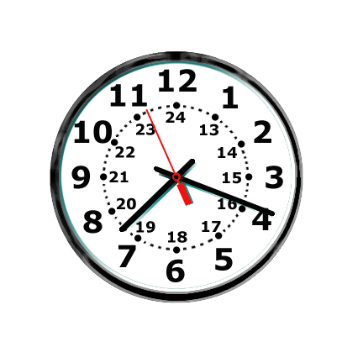10:00 a.m. | 1000 | 10:00 p.m. | 2200
11:00 a.m. | 1100 | 11:00 p.m. | 2300

24-Hour Clock Worksheet

Name: __________________________________________ Date: ________________

Convert the following times:
 | Greenwich | Military
1 | 1:15 am
2 | 2:35 pm
3 |  | 1210
4 | 2:45 am
5 |  | 0414
6 |  | 1800
7 | 8:25 am
8 | 11:30 pm
9 | 12:00 pm
10 |  | 0110
11 | 3:25 pm
12 | 9:15 pm
13 |  | 2125
14 |  | 1505
15 | 10:40 pm
16 |  | 2400
17 | 11:35 am
18 | 8:55 pm
19 |  | 2300
20 |  | 0845

