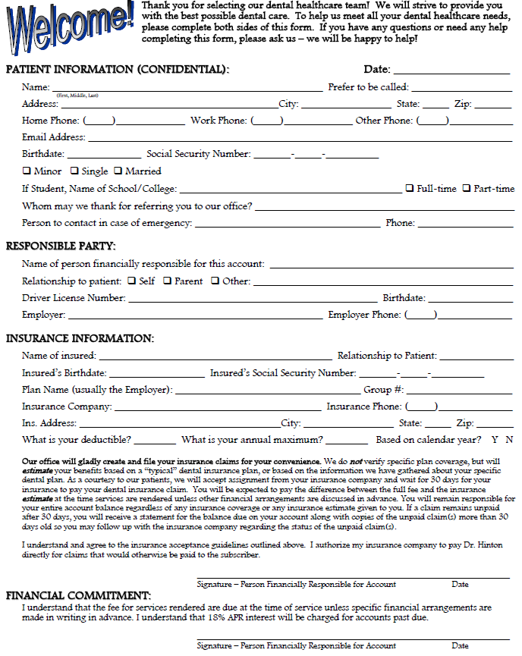

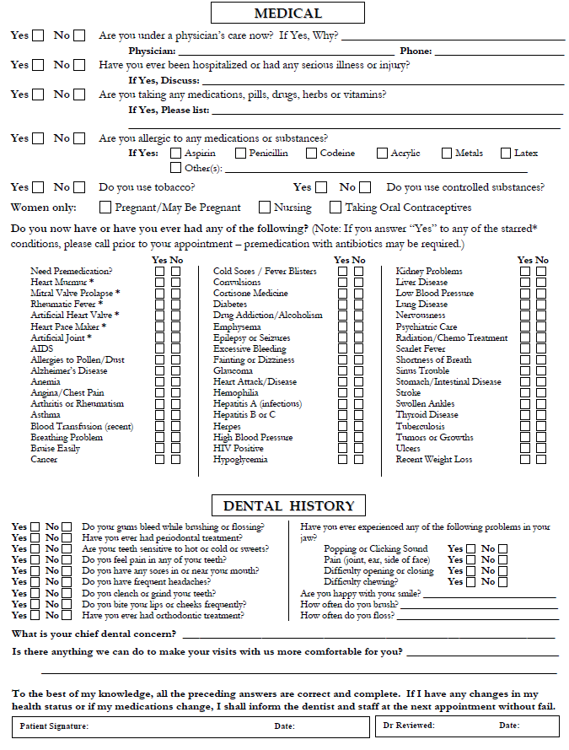
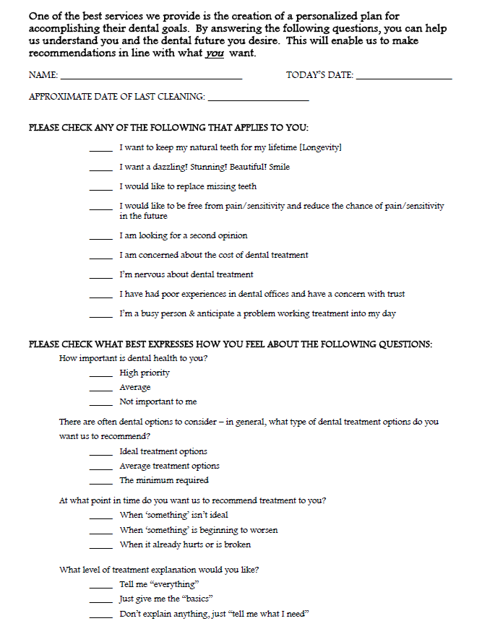
P.A. ACKNOWLEDGEMENT OF RECEIPT OF NOTICE OF PRIVACY PRACTICES

John G. Smith, DDS
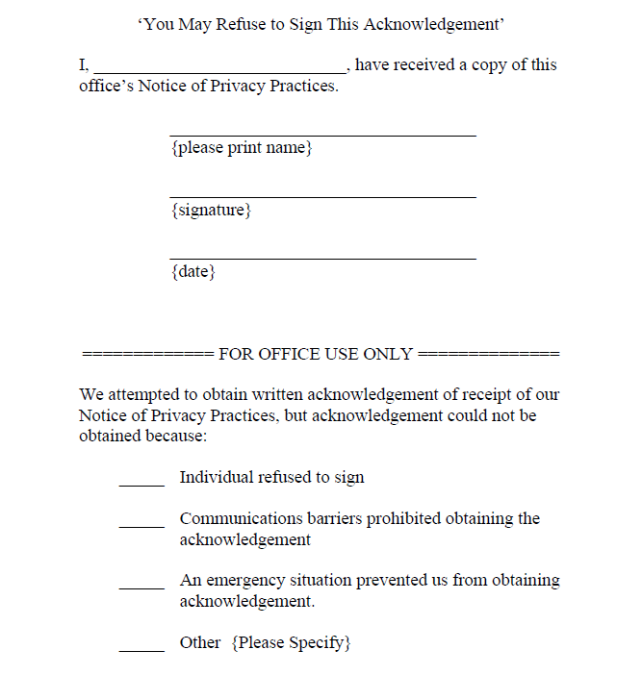
P.A. NOTICE OF PRIVACY PRACTICES
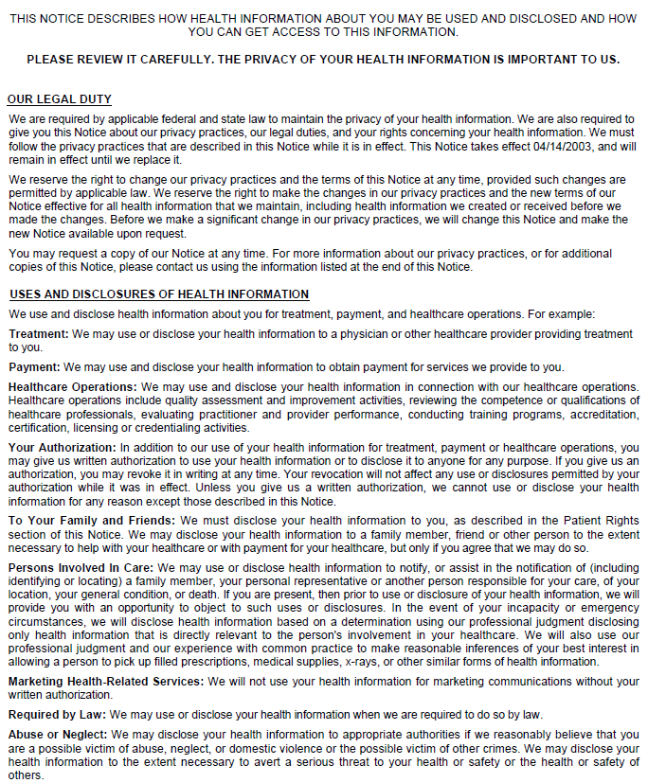
John G. Smith, D.D.S.

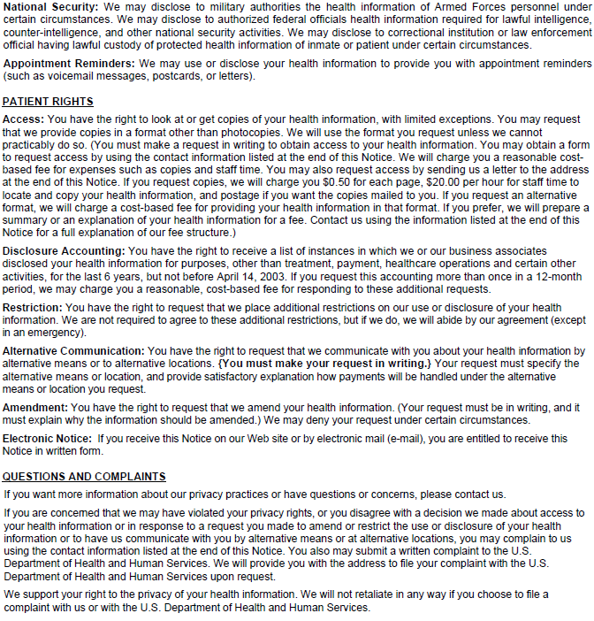

Contact officer: John G. Smith, D.D.S.
Telephone: (789) 456-3210
Fax: (789)321-0456
Email: johngsmithdental@dentists.com
Address: 4321 Smith Lane, Unit 456
Toothland, NJ 89745

