Name: ______________________

Anatomy and Physiology of the Reproductive System Note Taking Guide

Directions: Using the blank diagrams below, label the parts of the male and female reproductive systems.

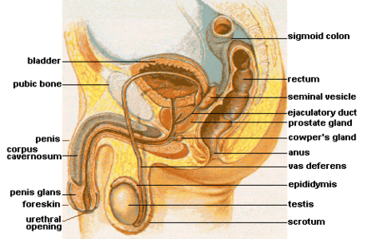
Male:

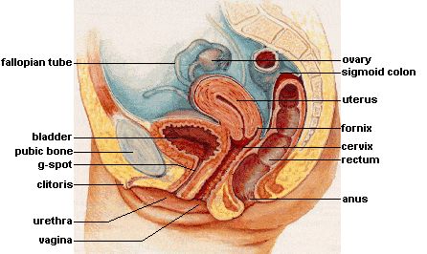
Female:

Male and Female Similarities:

- ______ pouches
*Testicles
*Ovaries

- Start out ___________ body
*Testicles “______________” before birth

- Fetus begins with “____________ ________” that could develop into either gender.

- Describe the process of how the fetus determines whether it will have male or female parts below:

- What are some of the main differences in how males and females function?
Males:
Females:

- Females:
-Ovaries:
*2 pouches
- Contain ______________
      - Born with _________of her eggs (~ 400,000)
      - Use up ~_________
      - Won’t run out!

- Ovulation:
*One egg released from ovary to ________________ (___________ tube)

- After ovulation:
* Egg pushed along by ___________
*Few days travel time to arrive in _____________
* ____________ – Opening between uterus & vagina
- Normally ___________
- At birth – muscles pull open (__________) cervix to allow baby to pass through = ___________

- Menstrual Cycle:
* Complex combination of 10-12 chemicals (_________________)
* Usually __________ egg ___________ a month
* All about timing!!!
- Uterus must be ready when egg gets there in case it was __________________.
- If no fertilization, tear down _____________ of uterus and rebuild for next month
* _______ Day Cycle:
- Three Stages
  - ___________ ___________
  - ________________
  - _____________ nutrients/blood for potential baby
-No Baby? Back to _______
* Chemicals (hormones)
- _____________ events in the body
- ________________
- ________________
- LH (______________ hormone)
- FSH (_______________ _____________ hormone)
- Many others
* Day ______:
- First menstrual ____________ & ____________
- No baby = breaks down _______________ of uterus
- _____________ days of blood/tissue exits body
* Day ______:
- Ovulation = ________ released
- _______________ spikes slightly
- Most ____________ in next few days!
- Able to get pregnant
- Egg gets fertilized while traveling through ________________.
* If fertilized…
- _____________ begins to divide as it travels through oviduct
- _____________ into lining of uterus
* If not fertilized…
- Egg travels through _______________ to _____________
- Exits body with blood and tissues during menstruation

- Birth Control Pills
* “Trick” body into thinking it’s _______________
- Extra ______________
- No _____________ occurs
- No ovulation = no egg = no fertilization = no baby!
- No hormones taken for 7 days = __________________

- Males:
- Testes
* Produce __________________ sperm every __________
* ______________ body – why?
- Sperm like temps _________° cooler than body temp

- ______ ____________
* ___________ sperm travel through

- Vasectomy
* _______/________ off tube – sperm can’t get out!

- Semen
* Contains:
- _________________ million sperm
- Sperm __________
- ______ buffers
* Allows sperm to survive for a couple of ________ inside female’s body (____________ environment)

- Sperm
* Contains several parts:
- ____________
- ______________ to dissolve egg goo
- Dad’s _______________ information (__________)
- Mitochondria
- ______________
- _____________
- swimming

- _____________ Gland
* Adds non-sperm stuff to _____________
- pH buffers
- __________________
* Cancer very common
- ____________-growing (usually)
- Surgery for ______________

- __________________ Gland
* Adds _______________ to aid travel of semen through the ___________

Describe the process of fertilization/conception below:

- After fertilization, ____________________ begins development
- Implants in ________________ lining
* __________________________ = outer lining of uterus
- becomes _________________
* uses mother’s ________________
* continues development

- Fetal Development
- ______________________
* _________________ surrounding baby
* contains amniotic _______________
* breaks just before birth = “_____________ ____________”

- _______________ Fluid
* the “______________”- surrounding baby
* buoyant cradle for baby
- _______________
- free _________________

- _______________ Cord
* ___________ ______________ from placenta to baby
* Mom’s & baby’s blood do _____________ circulate together!
- Can have 2 different ____________ types
- _________________

- Provide key notes on birth:

- Why is breastfeeding beneficial?
-

-

-

-

- What are the characteristics of each type of twins?
Identical:
Fraternal:
Conjoined:

- Using the chart on the last slide, determine the critical period of development for the:
- Central nervous system –

- Heart -

