Musculoskeletal System Bingo
CTAE Resource Network, Curriculum Office
March, 2009

Directions for the Instructor

1. Print the bingo cards. Twenty six different cards are included. Print additional cards at random if needed. Cut each sheet to separate the cards. Cards may be laminated for durability.

2. Give each student a bingo card and chips, markers, or scrap paper. If paper is to be used, ask students to tear or cut 25 pieces of paper about one-half inch square. If the cards have been laminated, students can mark their cards with erasable markers.

3. Explain to the students that you will read the definitions to the class and that they should mark the correct answer on their card. Note that all cards do not have all the answers.

4. Read the definitions only, at random, from the definitions list. Mark the definitions that have been used. The student should place a chip on the cell with the correct response.

5. When a student has placed chips on 5 spaces in a row (diagonally, vertically, or horizontally) the student should call “Bingo”. Ask the winning student to call out their answers. Check their answers to make sure those definitions have been used.

Optional Bingo Variations:

- T-Bingo: The card must be marked in the shape of a “T” to call Bingo.

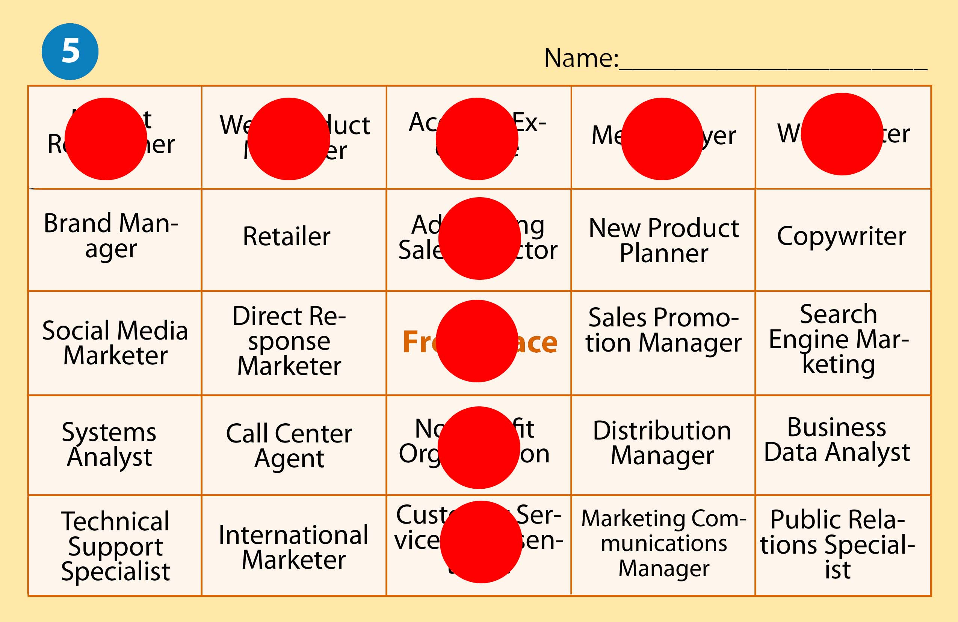

- Corners Bingo: The four outer corners of the card must be marked to get Bingo.

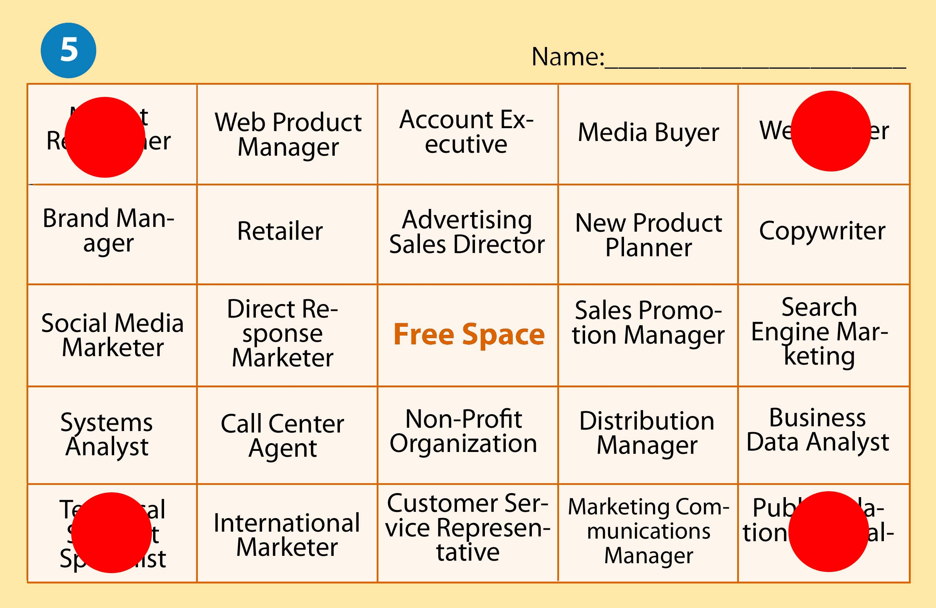

- U-Bingo: The card must be marked in the shape of a “U” to call Bingo.



Definition | Correct Response
Movement decreases the angle between two adjoining bones; bending of a limb | Flexion
Inability to coordinate the muscles in execution of voluntary movement | Ataxia
Helps physical therapists provide treatment that improves mobility, relieves pain, and prevents or lessens physical disabilities | Physical Therapy Assistant
Front or ventral surface of a body part faces downward | Pronation
Movement increases the angle between two adjoining bones | Extension
Therapy for minimum goal of restoring the individual to a level of self help | Activities of Daily Living (ADL)
Movement of an extreminity away from the midline of the body | Adduction
Rotation of a joint inward | Internal rotation
gentle stretching to increase strength, flexibility, and mobility | Range of Motion Exercises (ROM)
Sudden, violent, involuntary contraction of a muscle or group of muscles | Spasm
Treatment to prevent disability or restore function with exercise, heat, massage, etc. to improve circulation, flexibility, and strength | Physical Therapy (PT)
Study of factors affecting the design and operation of tools and the work environment | Ergonomics
Bending of the toes and foot downward | Plantar Flexion
Condition of abnormal muscle tone | Dystonia
Rotation of a joint outward | External Rotation
Movement increases the angle between two adjoining bones | Extension
Abnormal shortening of muscle tissues | Contracture
Assists occupational therapist improve ability of individuals to perform tasks in living and working environments | Occupational Therapist Assistants
Moving a body part beyond its normal resting extended position | Hyperextension
Abnormal shortening of muscle tissue | Contracture
Assists occupational therapist improve ability of individuals to perform tasks in living and working environments | Occupational therapist assistants (OTA)
Assists patients improve their ability to perform tasks in living and working environments | Occupational therapists
Turning of the body part toward the midline | Inversion
Turning of the body part away from the midline | Eversion
Front or ventral surface of a body part faces upward | Supination

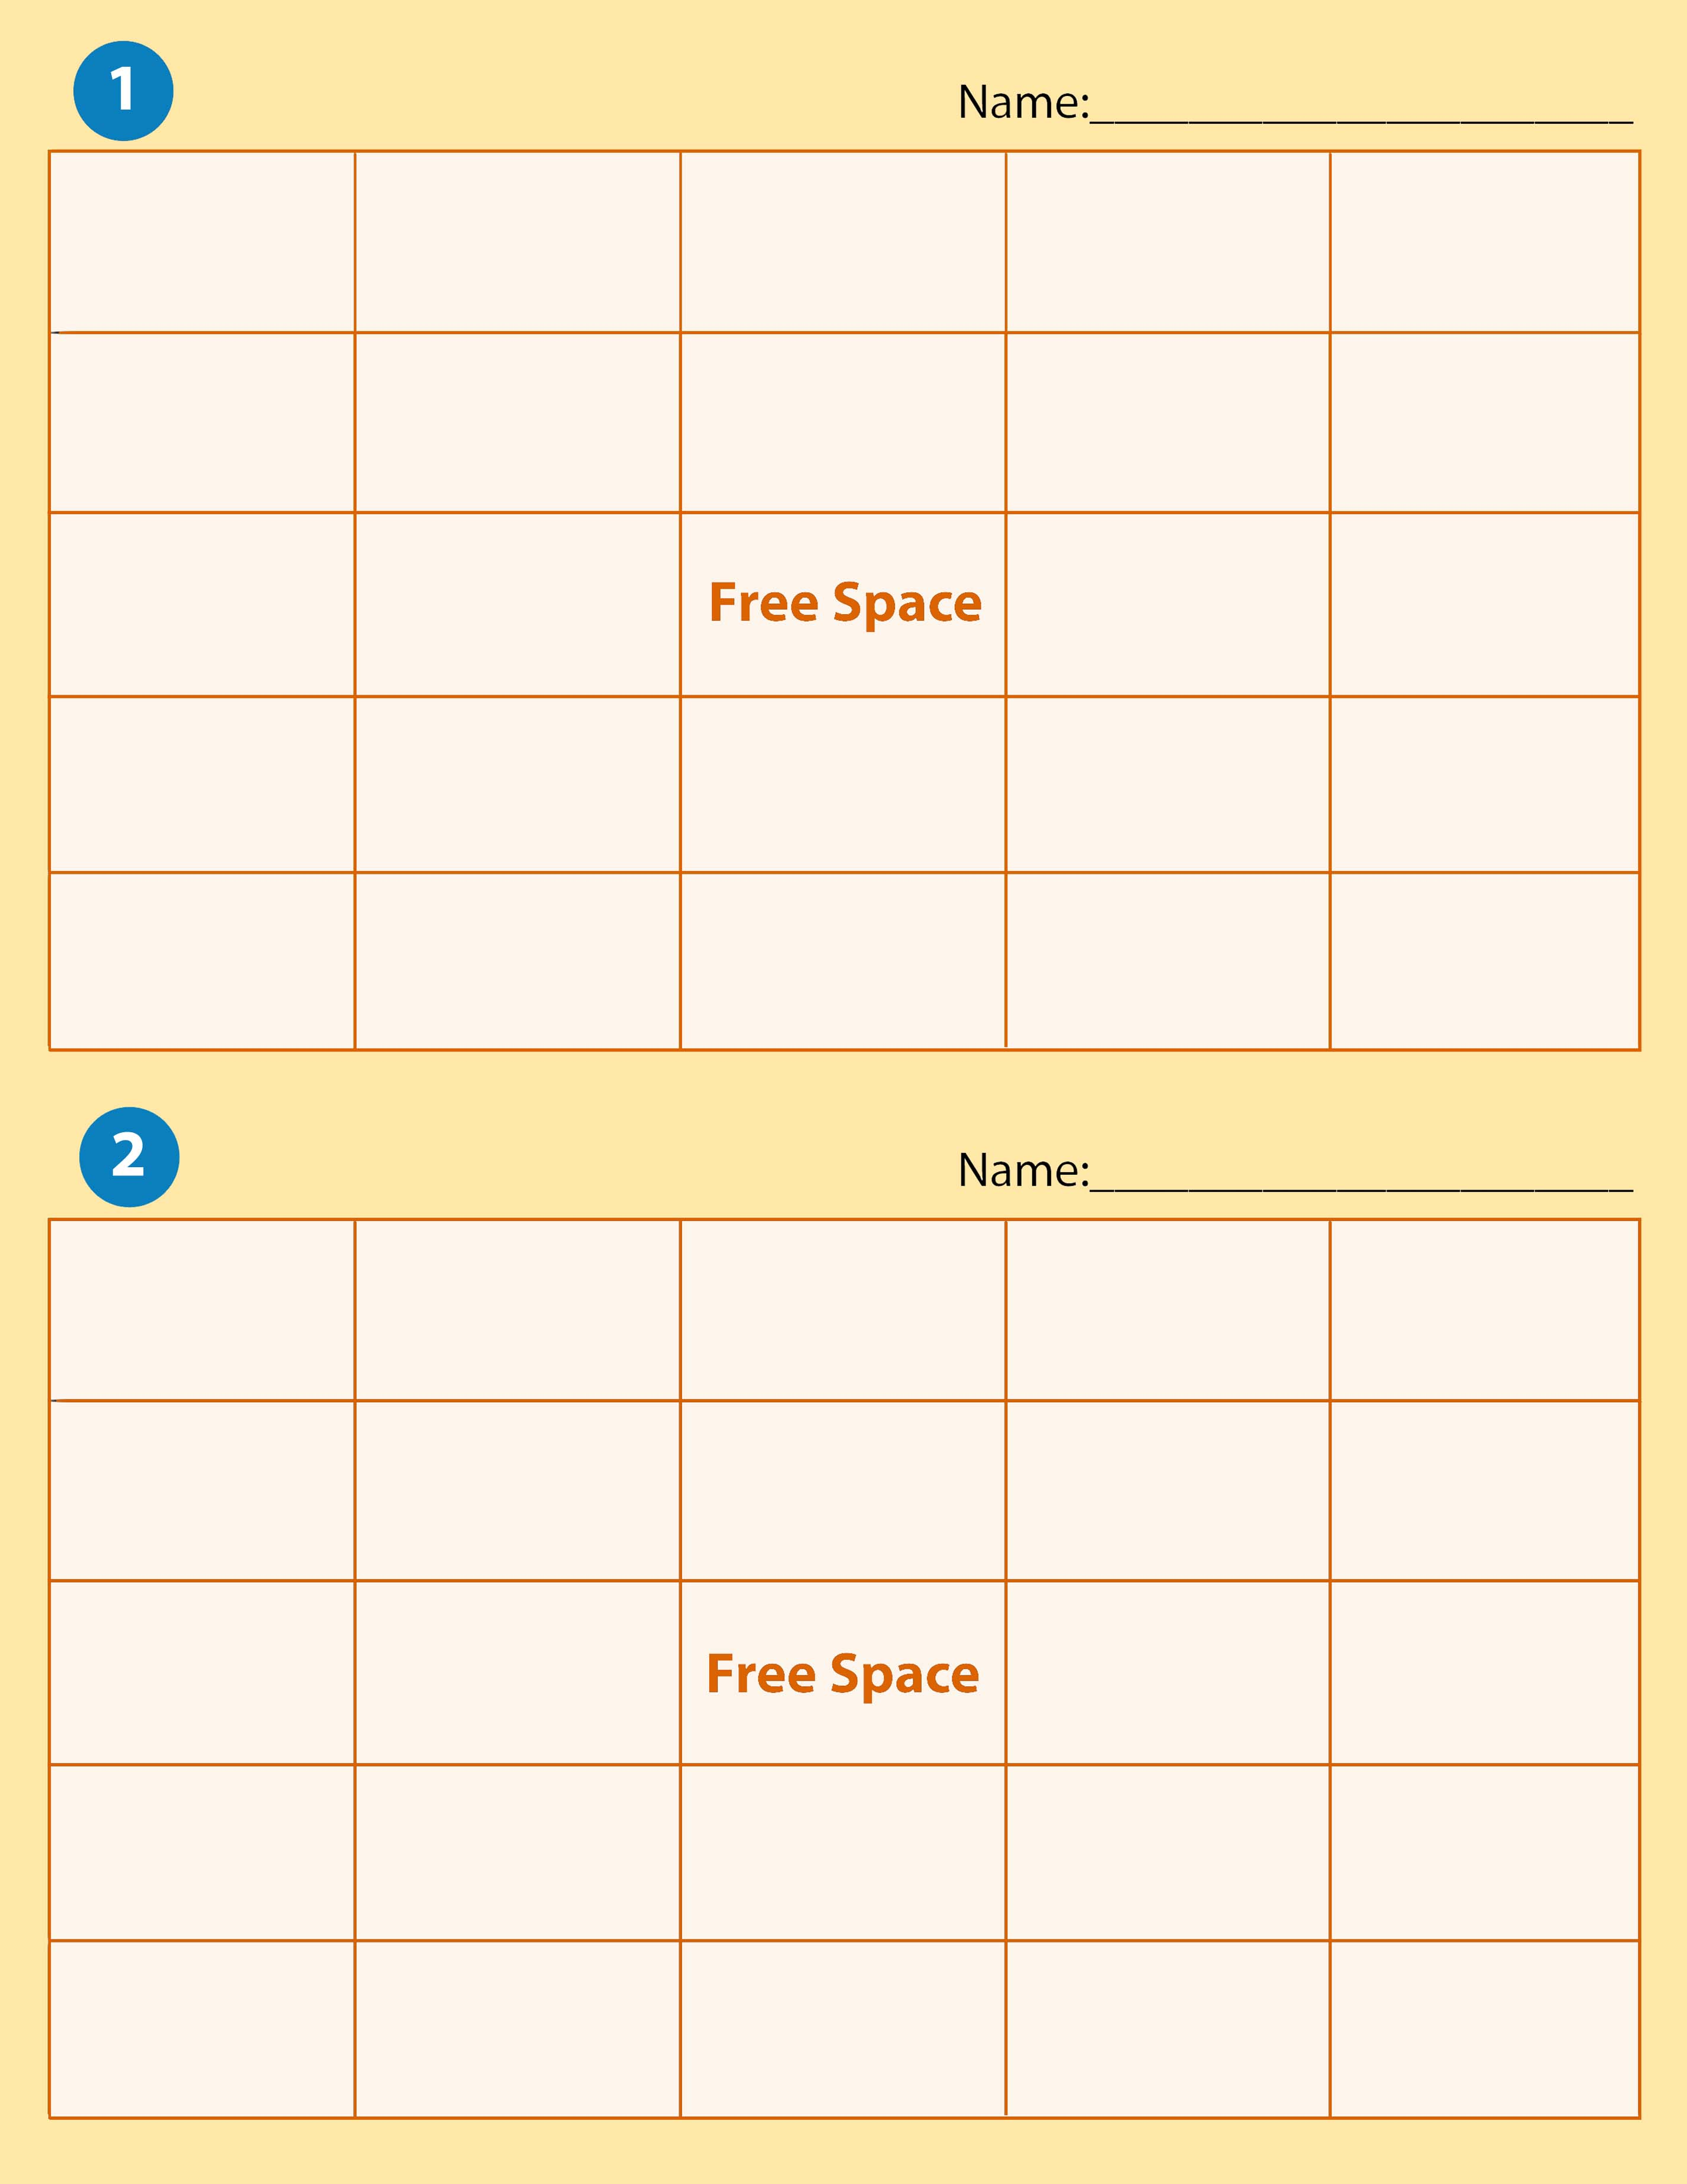

Flexion | Adduction | Inversion | Contracture | Occupational Therapist  Assistant
Pronation | Abduction | Dorsiflexion | Spasm | Ergonomics
Extension | Internal Rotation |  | Physical Therapy (PT) | Range of Motion exercises
Hyperextension | External  Rotation | Plantar Flexion | Physical Therapy Assistant | Open wound
Supination | Eversion | Ataxia | Occupational therapists (OT) | Activities of Daily Living

Extension | Hyperextension | Activities of Daily Living | Atonic | External Rotation
Supination | Physical Therapy | Ergonomics | Dystonia | Flexion
Adduction | Occupational Therapy |  | Plantar Flexion | Spasm
Abduction | Contracture | Physical Therapy Assistant | Dorsiflexion | Occupational Therapy Assistants
Eversion | Ataxia | Pronation | Inversion | Range of Motion

Flexion | Atonic | Internal Rotation | Dystonia | Eversion
Physical Therapy Assistant | Adduction | Hyperextension | Range of Motion Exercises | Activities of Daily Living
Inversion | Spasm |  | Extension | External Rotation
Occupational Therapists | Dorsiflexion | Supination | Occupational Therapist Assistants | Ataxia
Adduction | Physical Therapy | Abduction | Ergonomics | Contracture
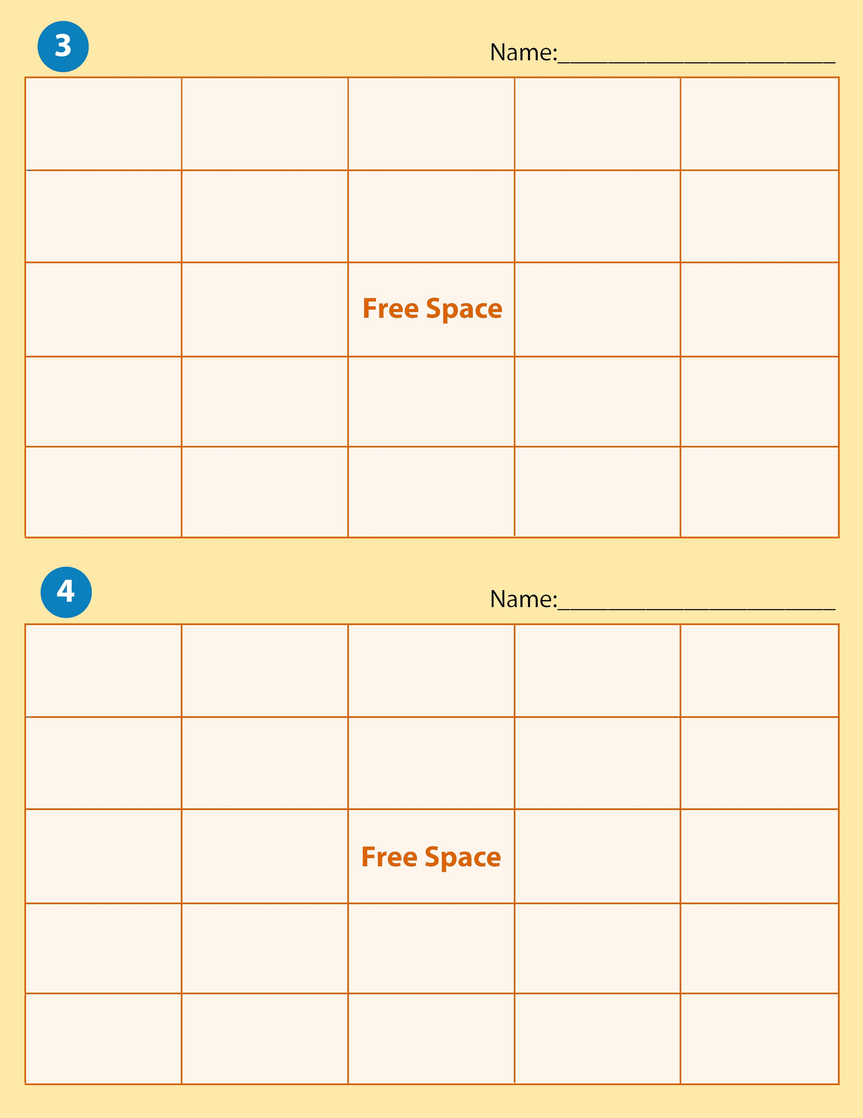

Activities of Daily Living | Pronation | Supination | Occupational Therapist Assistants | Abduction
Dystonia | Range of Motion Exercises | Dorsiflexion | Adduction | Internal Rotation
Occupational Therapists | Ataxia |  | Ergonomics | Spasm
Atonic | Physical therapy Assistant | Plantar Flexion | External  Rotation | Eversion
Inversion | Hyperextension | Extension | Physical Therapy | Contracture

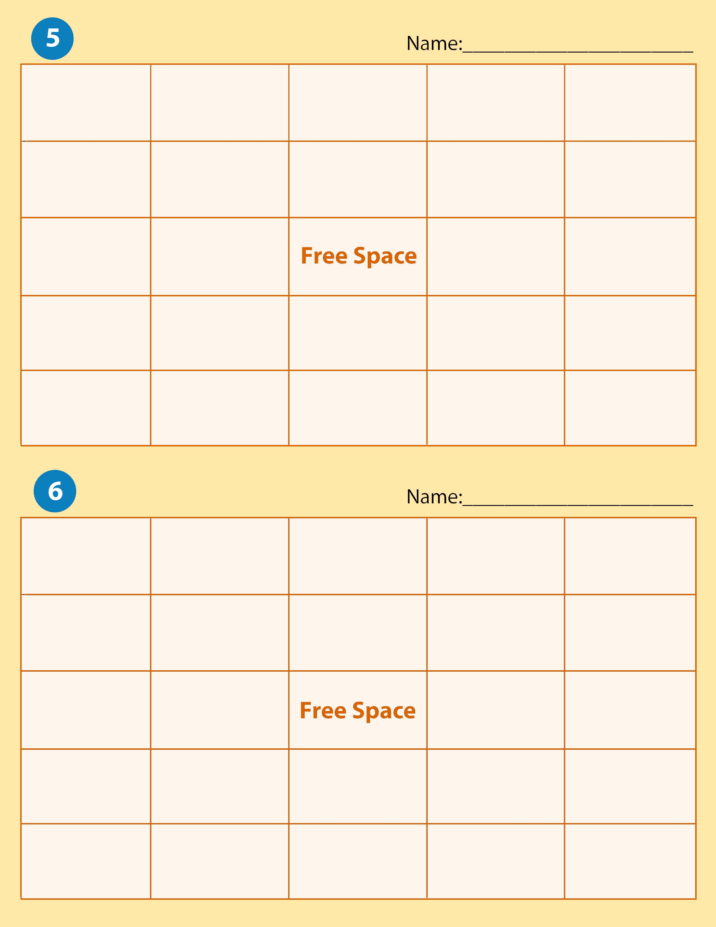

External Rotation | Plantar Flexion | Spasm | Hyperextension | Physical Therapy
Eversion | Occupational Therapist Assistants | Internal Rotation | Pronation | Ergonomics
Dorsiflexion | Flexion |  | Range of Motion Exercises | Physical Therapy Assistants
Inversion | Dystonia | Abduction | Extension | Occupational Therapists
Contracture | Ataxia | Adduction | Supination | Atonic

Eversion | Dorsiflexion | Inversion | Occupational Therapists | External Rotation
Atonic | Plantar Flexion | Dystonia | Hyperextension | Ataxia
Flexion | Adduction |  | Range of Motion exercises | Ergonomics
Spasm | Extension | Abduction | Ataxia | Activities of Daily Living
Physical Therapy | Supination | Physical Therapy Assistant | Contracture | Occupational Therapy Assistant

Activities of Daily Living | Flexion | Inversion | Dorsiflexion | Occupational Therapists
Range of Motion Exercises | Hyperextension | Eversion | Plantar Flexion | Physical Therapy Assistant
Ergonomics | Pronation |  | Atonic | Physical Therapy
Occupational Therapist Assistants | Supination | External Rotation | Dystonia | Spasm
Spasm | Internal Rotation | Abduction | Ataxia | Contracture
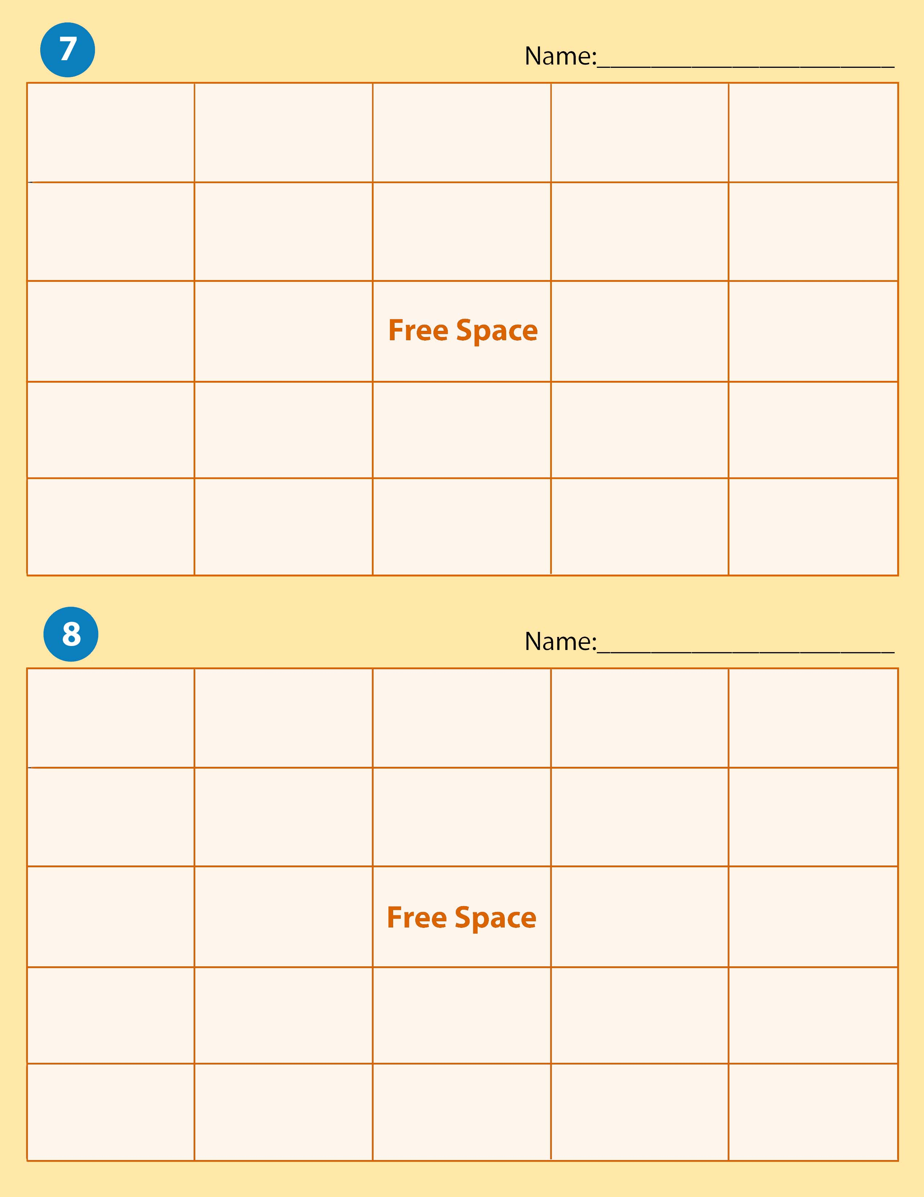

Pronation | Inversion | Physical Therapy | Activities of Daily Living | Extension
Dystonia | Plantar Flexion | Spasm | Occupational Therapist | Eversion
Supination | Atonic |  | Flexion | Ergonomics
Ataxia | Abduction | Hyperextension | Physical Therapy Assistant | Range of Motion Exercises
Contracture | Dorsiflexion | Internal Rotation | Occupational Therapist Assistants | External Rotation

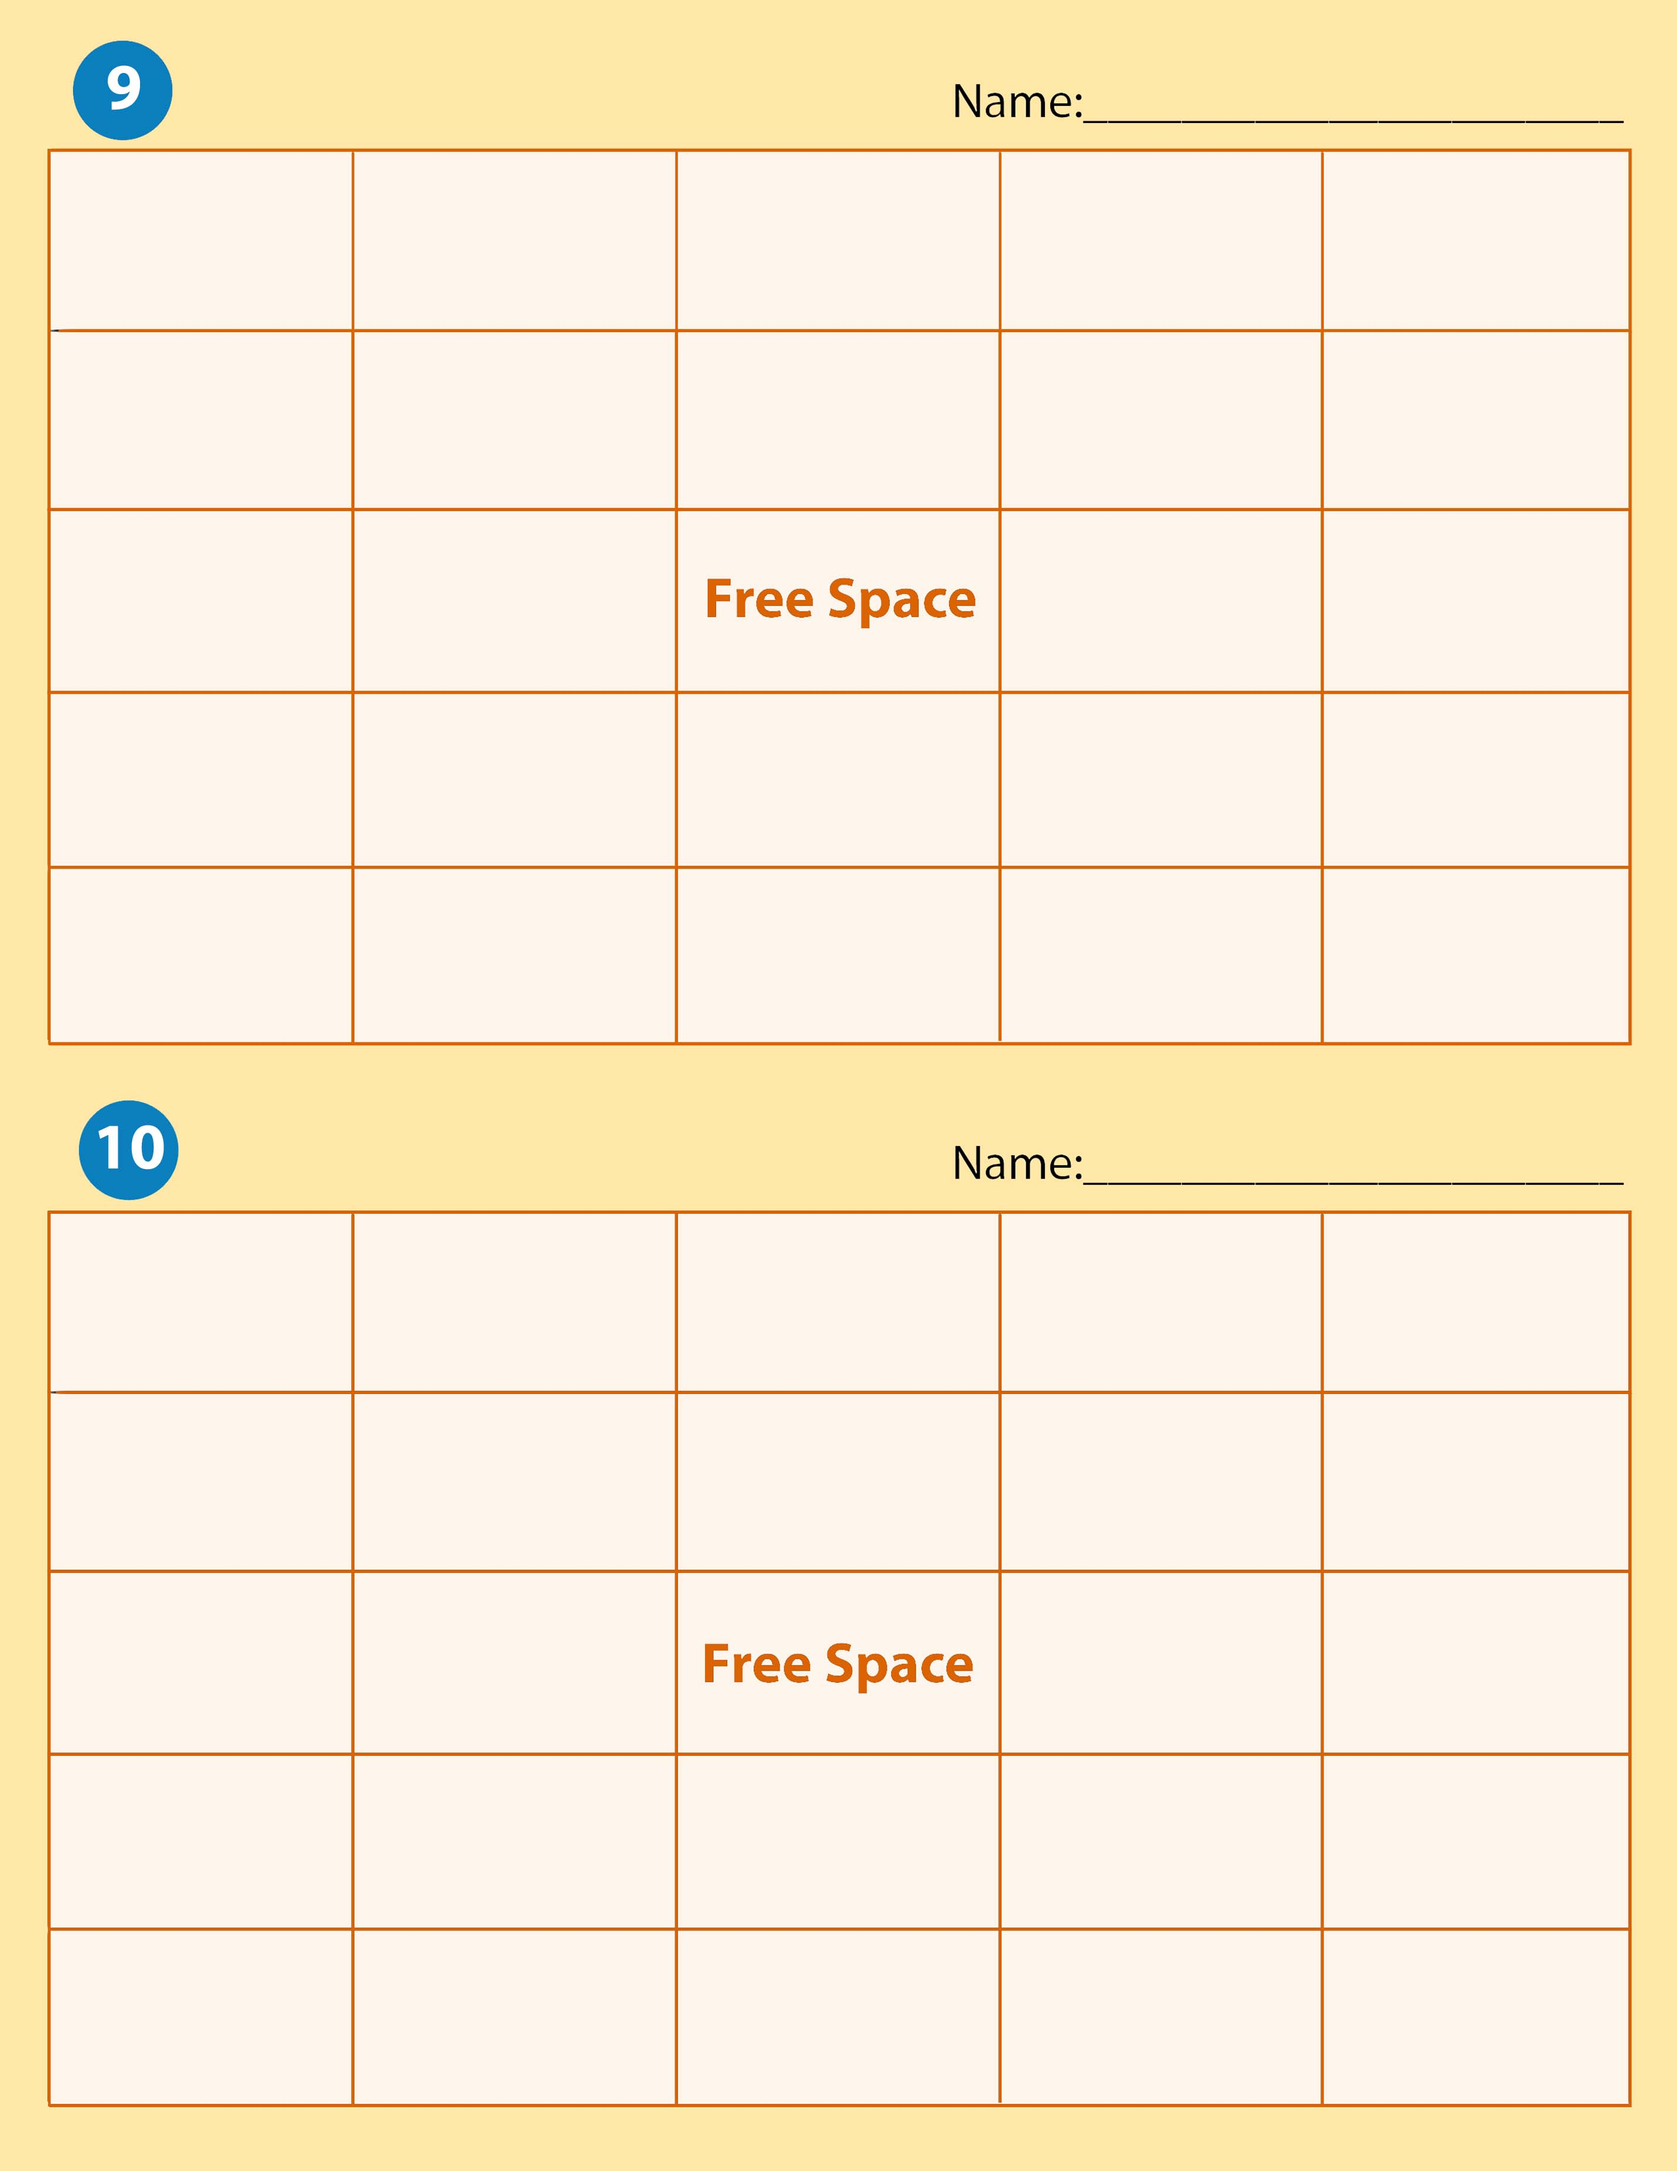
Flexion | Physical Therapy Assistant | Activities of Daily Living | Hyperextension | Ataxia
Physical Therapy | Abduction | Extension | External Rotation | Atonic
Contracture | Occupational Therapists |  | Eversion | Dytonia
Supination | Spasm | Internal Rotation | Pronation | Inversion
Ergonomics | Adduction | Range of Motion Exercises | Dorsiflexion | Plantar Flexion

External Rotation | Flexion | Occupational Therapists | Hyperextension | Occupational Therapist Assistants
Plantar Flexion | Ergonomics | Internal  Rotation | Range of Motion Exercises | Dorsiflexion
Pronation | Abduction |  | Hyperextension | Activities of Daily Living
Atonic | Ataxia | Extension | Spasm | Inversion
Supination | Eversion | Adduction | Contracture | Physical Therapy

Extension | Atonic | Activities of Daily Living | Inversion | Range of Motion Exercises
Physical Therapy Assistant | Flexion | Dorsiflexion | Hyperextension | Pronation
Physical Therapy | Dystonia |  | Ataxia | Ergonomics
Abduction | Plantar Flexion | Internal Rotation | External Rotation | Eversion
Occupational Therapist | Adduction | Contracture | Supination | Spasm
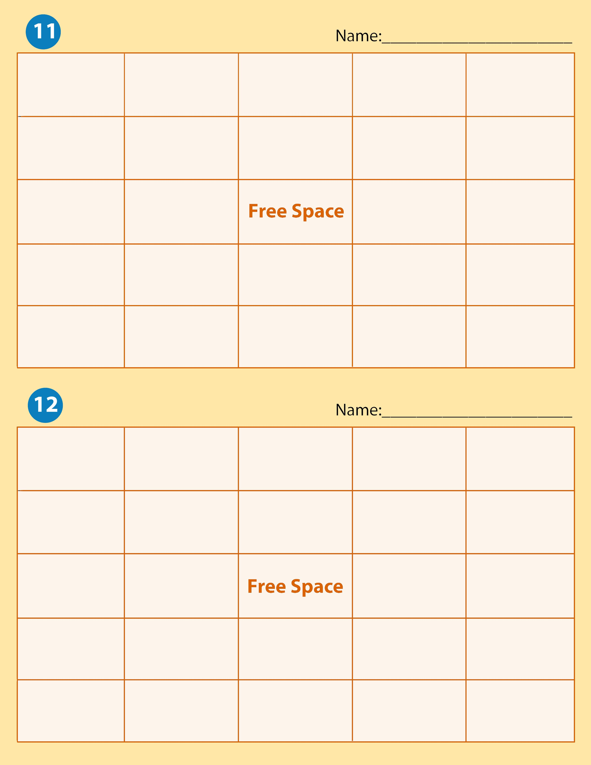

Flexion | Spasm | Physical Therapy | Activities of Daily Living | Internal Rotation
Ataxia | Contracture | External Rotation | Pronation | Abduction
Dystonia | Extension |  | Occupational Therapists | Adduction
Inversion | Atonic | Physical Therapy Assistant | Hyperextension | Ergonomics
Dorsiflexion | Plantar Flexion | Eversion | Occupational Therapists Assistants | Supination

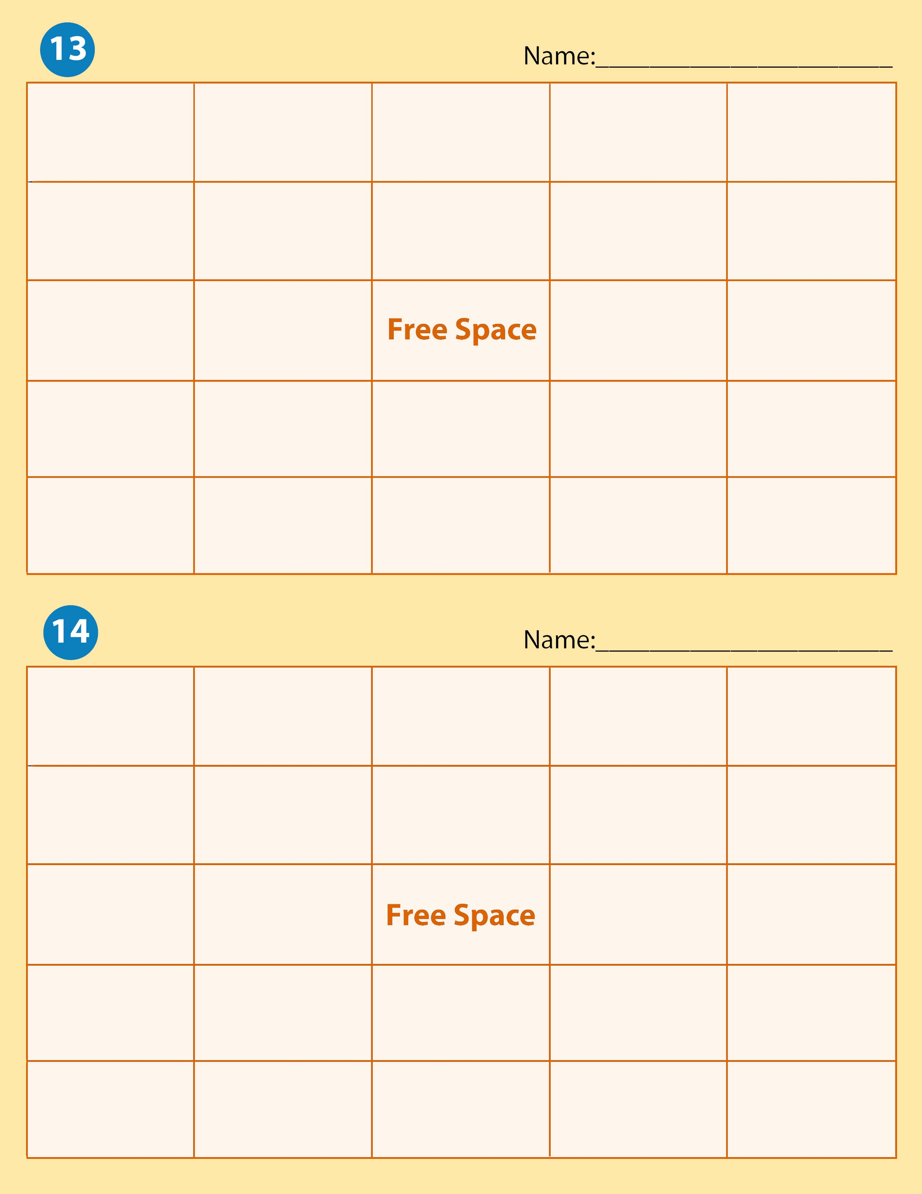

Inversion | Plantar Flexion | External Rotation | Occupational therapists | Occupational therapist assistants
Physical Therapy | Atonic | Eversion | Pronation | Ergonomics
Spasm | Flexion |  | Physical Therapy | Supination
Contracture | Dystonia | Inversion | Internal Rotation | Adduction
Ataxia | Extension | Dorsiflexion | Hyperextension | Abduction

Contracture | Inversion | External Rotation | Spasm | Physical Therapy
Plantar Flexion | Dorsiflexion | Hyperextension | Eversion | Activities of Daily Living
Supination | Pronation |  | Extension | Occupational Therapists
Dystonia | Atonic | Internal Rotation | Ergonomics | Range of Motion Exercises
Ataxia | Adduction | Abduction | Occupational Therapists | Flexion

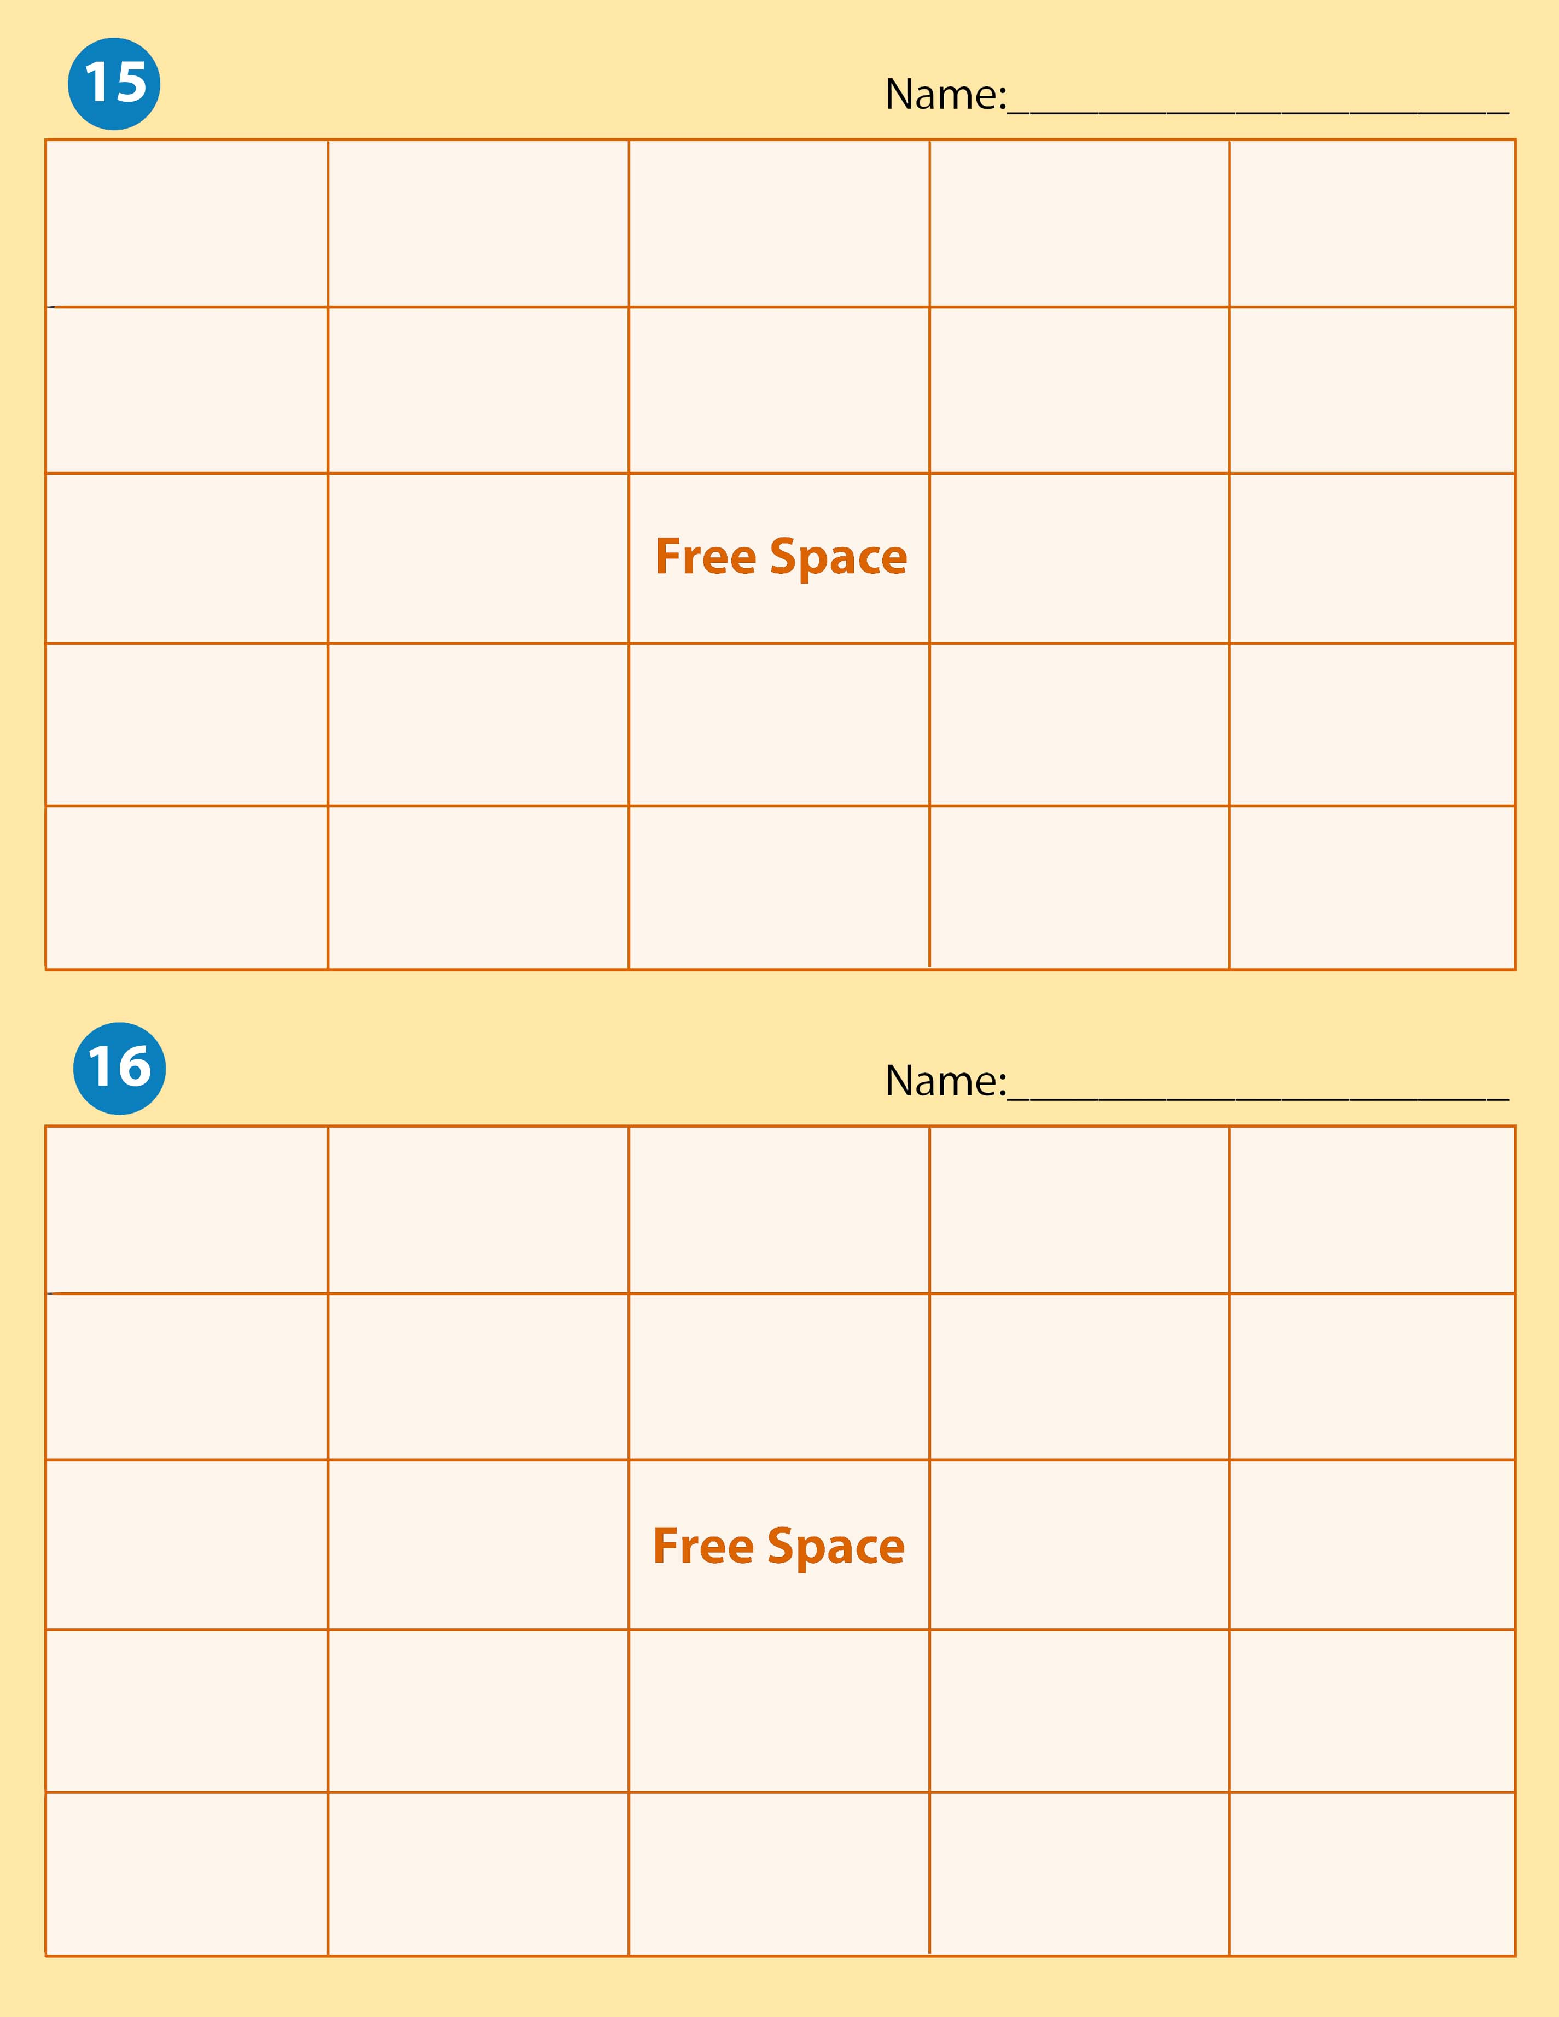

External  Rotation | Physical Therapy | Pronation | Spasm | Inversion
Dorsiflexion | Ergonomics | Internal Rotation | Physical Therapy Assistants | Hyperextension
Supination | Flexion |  | Plantar Flexion | Contracture
Abduction | Occupational Therapy | Ataxia | Extension | Occupational Therapist Assistants
Activities of Daily Living | Adduction | Atonic | Range of Motion exercises | Eversion

Flexion | External Rotation | Plantar Flexion | Contracture | Supination
Dystonia | Extension | Spasm | Adduction | Physical Therapy
Dorsiflexion | Ergonomics |  | Ataxia | Inversion
Physical Therapy Assistant | Abduction | Occupational Therapists | Hyperextension | Range of Motion Exercises
Internal Rotation | Activities of Daily Living | Eversion | Atonic | Pronation

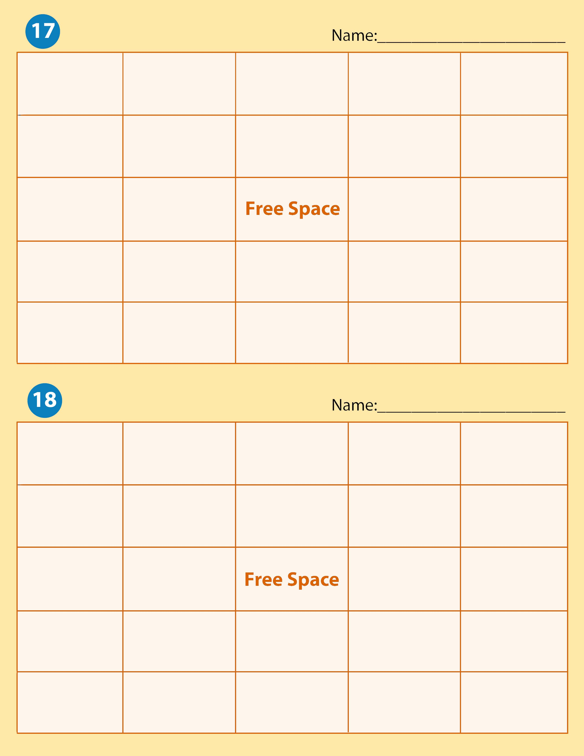

Flexion | Occupational Therapist | Hyperextension | Ataxia | Contracture
Activities of Daily Living | Dystonia | Abduction | Dystonia | Atonic
Spasm | Occupational Therapist Assistants |  | Extension | Plantar Flexion
Range of Motion | Pronation | Internal Rotation | Adduction | Dorsiflexion
Physical Therapy | Ergonomics | Supination | Eversion | Inversion

Flexion | External Rotation | Physical Therapy Assistant | Dystonia | Occupational Therapists
Inversion | Ataxia | Hyperextension | Atonic | Abduction
Pronation | Internal Rotation |  | Extension | Ergonomics
Contracture | Eversion | Range of Motion Exercises | Plantar Flexion | Adduction
Spasm | Supination | Dorsiflexion | Physical Therapy | Activities of Daily Living

Physical Therapy | Adduction | Inversion | Occupational Therapists | Internal Rotation
Plantar Flexion | Extension | Spasm | Supination | Occupational Therapist Assistants
External Rotation | Ataxia |  | Ergonomics | Dystonia
Range of Motion Exercises | Dorsiflexion | Contracture | Flexion | Physical Therapy Assistant
Atonic | Pronation | Activities of Daily Living | Abduction | Eversion
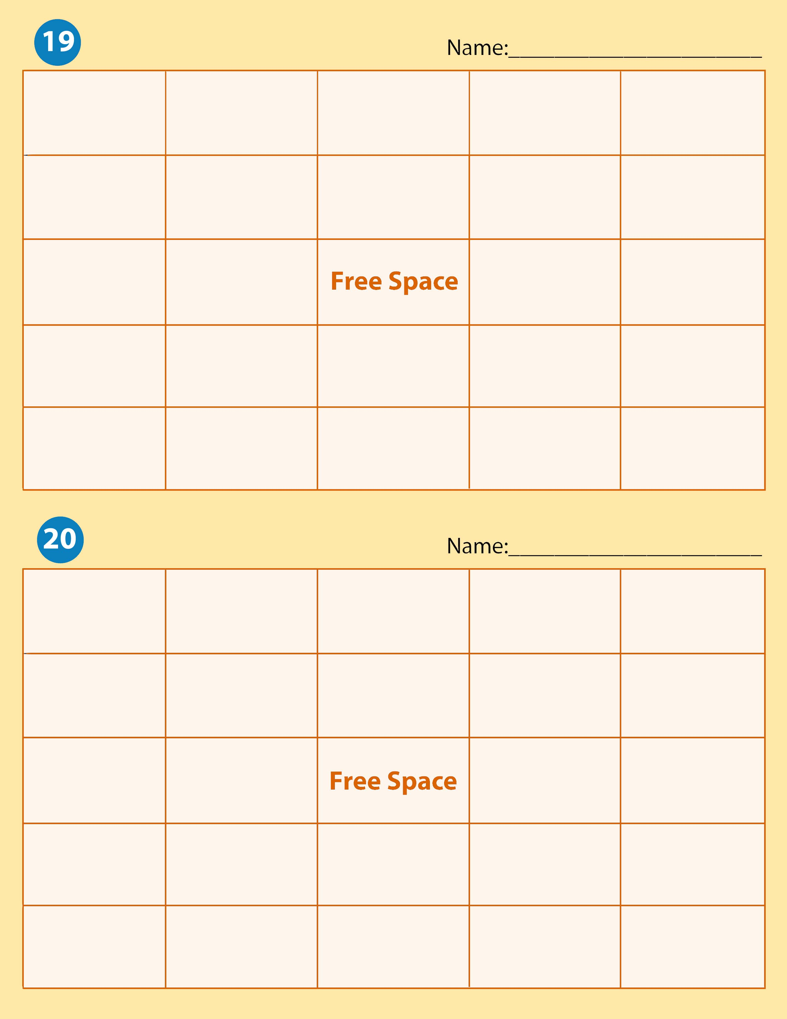

Atonic | Dystonia |  | Eversion | Physical Therapy | Pronation
Flexion |  | Ataxia | Occupational Therapist Assistants | Extension | Adduction
Plantar Flexion |  | External Rotation |  | Ergonomics | Activities of Daily Living
Atonic |  | Contracture | Range of Motion | Extension | Supination
Internal Rotation |  | Spasm | Inversion | Physical Therapy Assistant | Dorsiflexion

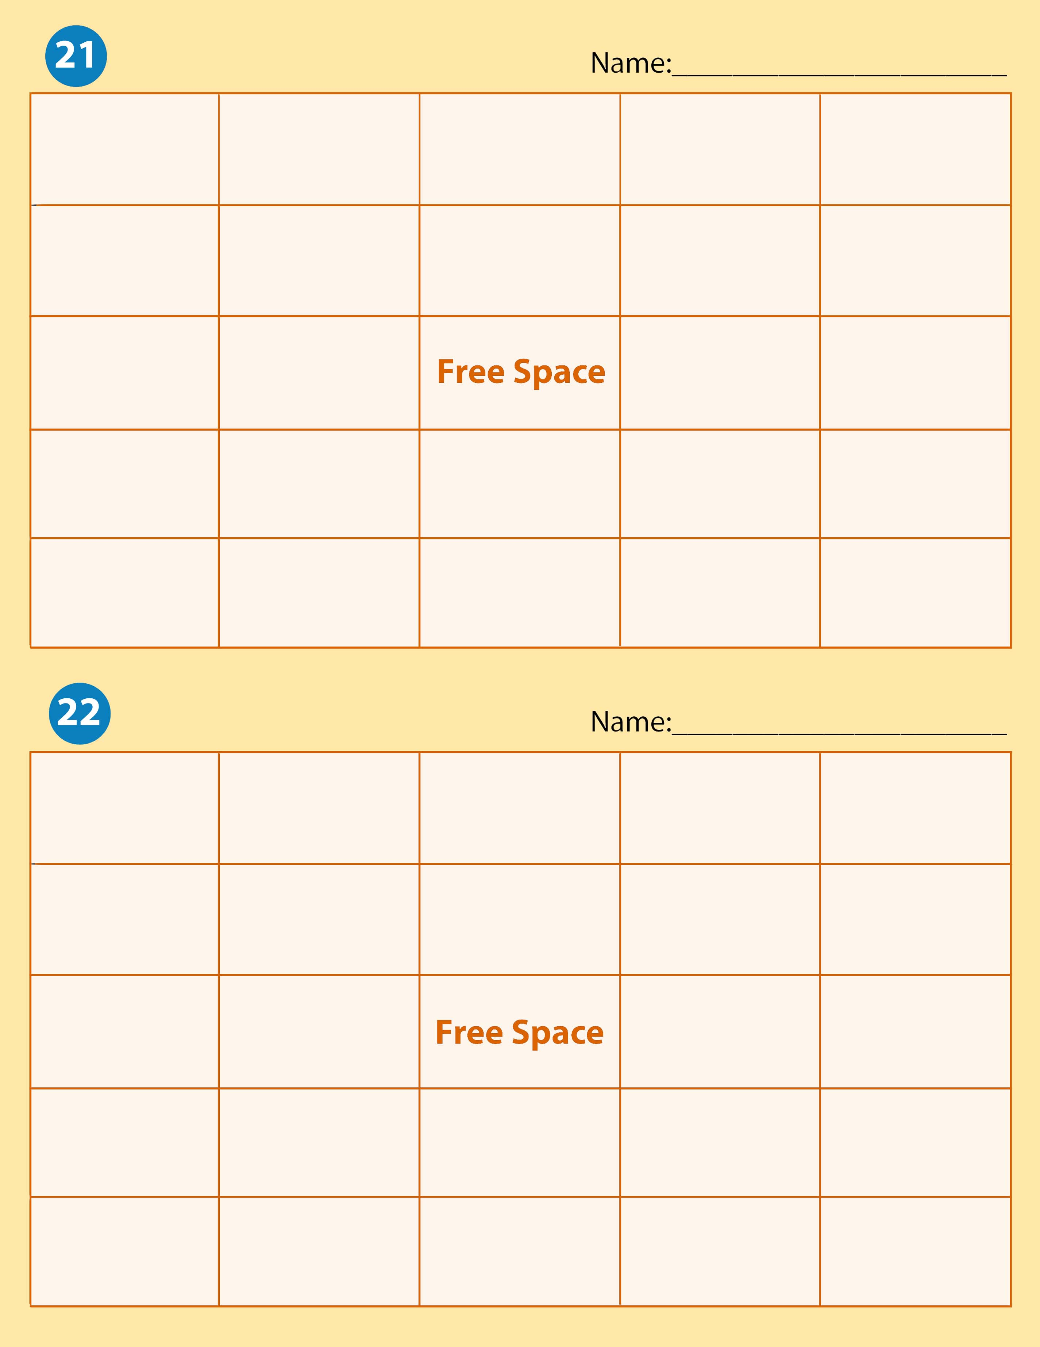
Ataxia | Physical Therapy | Occupational Therapists | Hyperextension | Range of Motion Exercises
Physical Therapy Assistant | External Rotation | External Rotation | Contracture | Spasm
Ergonomics | Internal Rotation |  | Extension | Dorsiflexion
Dystonia | Flexion | Atonic | Eversion | Pronation
Occupational Therapist Assistants | Adduction | Inversion | Supination | Plantar Flexion

Eversion | Contracture | Spasm | Extension | Occupational therapist assistant
Physical Therapy Assistant | Flexion | Inversion | Adduction | External Rotation
Plantar Flexion | Supination |  | Physical Therapy | Ergonomics
Pronation | Internal Rotation | Activities of Daily Living | Hyperextension | Dorsiflexion
Occupational Therapist | Atonic | Abduction | Dystonia | Ataxia

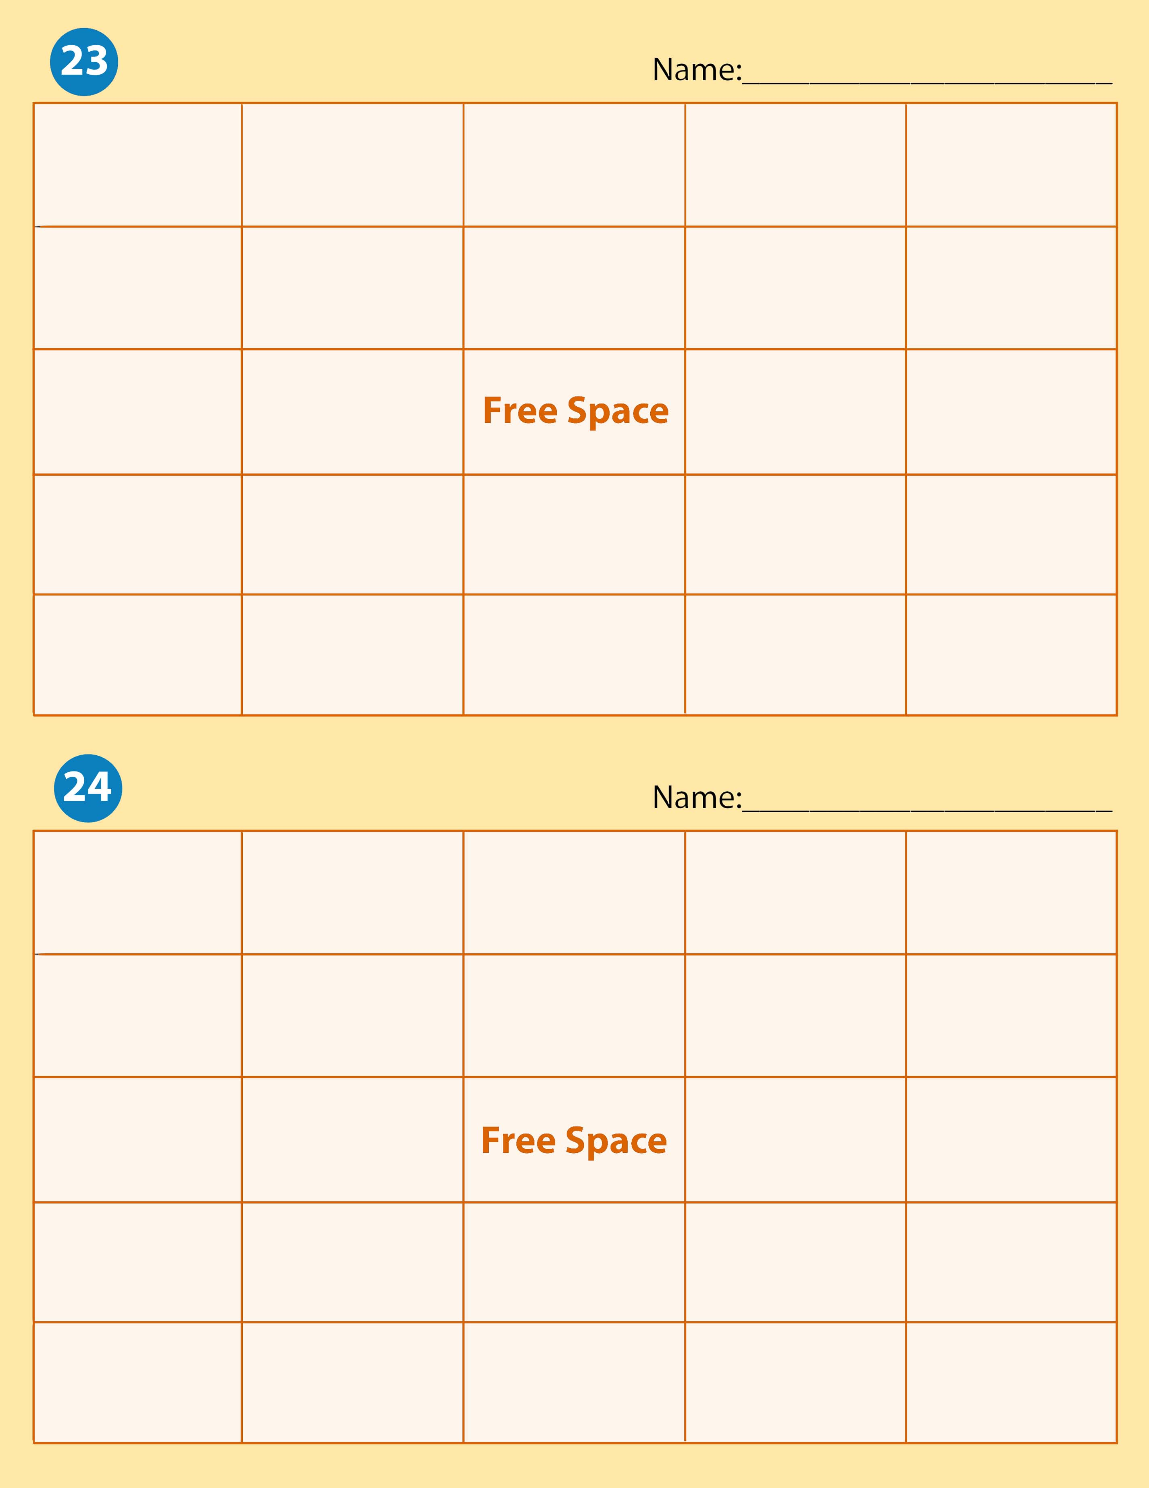
Occupational therapist | Hyperextension | Internal Rotation | Physical Therapy Assistant | Eversion
Plantar Flexion | Dorsiflexion | External Rotation | Extension | Inversion
Activities of Daily Living | Flexion |  | Physical Therapy | Adduction
Pronation | Occupational Therapist | Dystonia | Supination | Spasm
Range of Motion exercises | Atonic | Ergonomics | Ataxia | Contracture

Activities of  Daily Living | Pronation | Eversion | Occupational therapist assistants | Dystonia
Occupational therapists | Supination | Range of Motion Exercises | Dorsiflexion | Contracture
Hyperextension | Abduction |  | Ergonomics | Ataxia
Extension | Physical therapy assistant | Inversion | Plantar Flexion | Spasm
Flexion | Internal Rotation | External Rotation | Physical Therapy | Atonic

Flexion | Dorsiflexion | Activities of Daily Living | Pronation | Abduction
Spasm | Plantar flexion | Extension | Physical Therapy | Internal Rotation
Atonic | External Rotation |  | Range of Motion Exercises | Adduction
Dystonia | Eversion | Occupational Therapist Assistants | Supination | Physical Therapy Assistant
Contracture | Ataxia | Inversion | Ergonomics | Occupational therapists
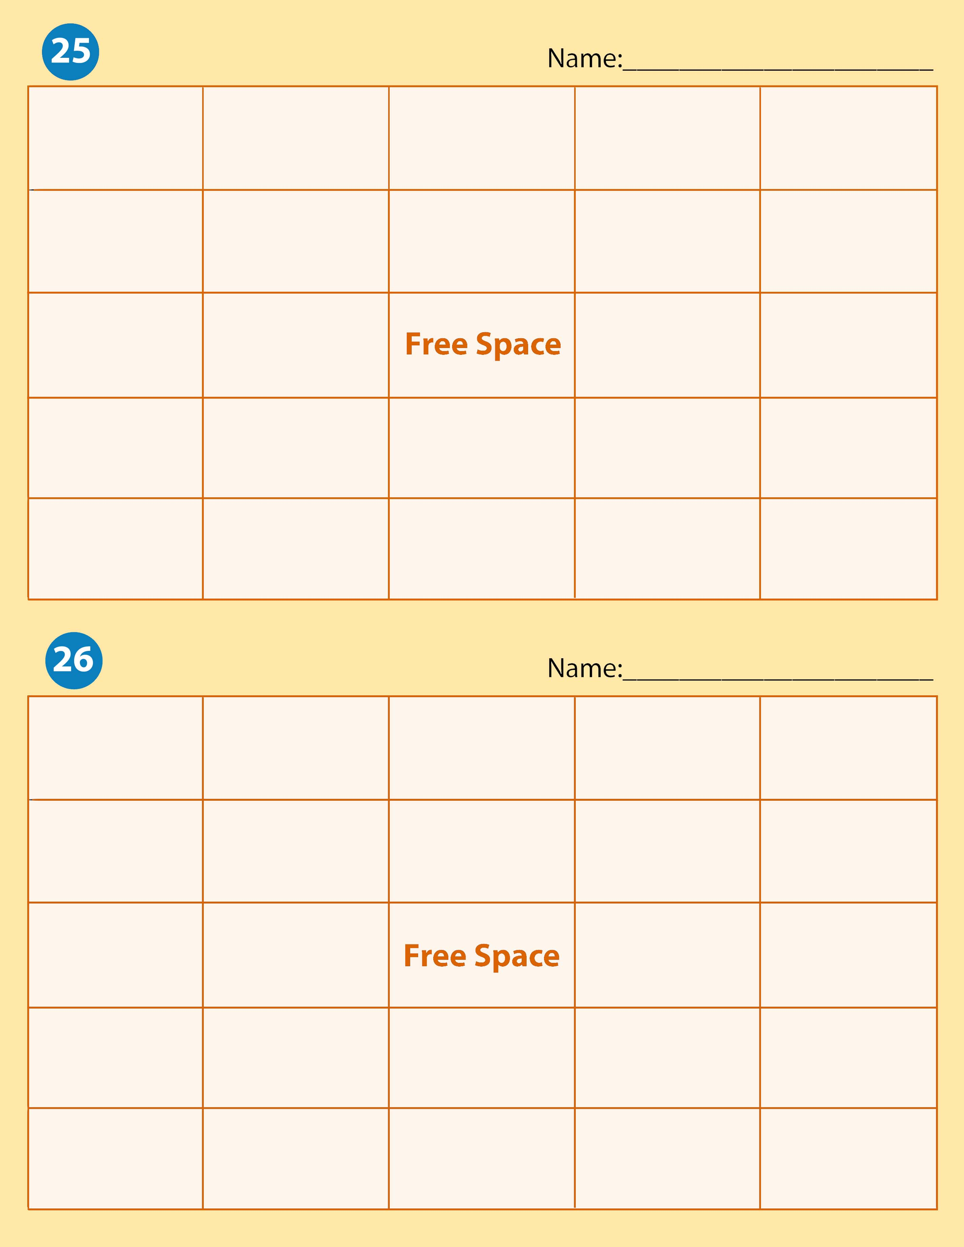

Dystonia | Hyperextension | Supination | Occupational Therapist Assistants | Activities of Daily Living
Contracture | External Rotation | Occupational Therapists | Internal Rotation | Extension
Atonic | Pronation |  | Flexion | Dorsiflexion
Physical Therapy | Inversion | Ergonomics | Adduction | Range of Motion exercises
Ataxia | Spasm | Eversion | Physical Therapy Assistant | Plantar Flexion

