Skeletal System Worksheet Name _____________________________________________________

    - Label the following diagram of the skeleton with the correct names for each of the bones.

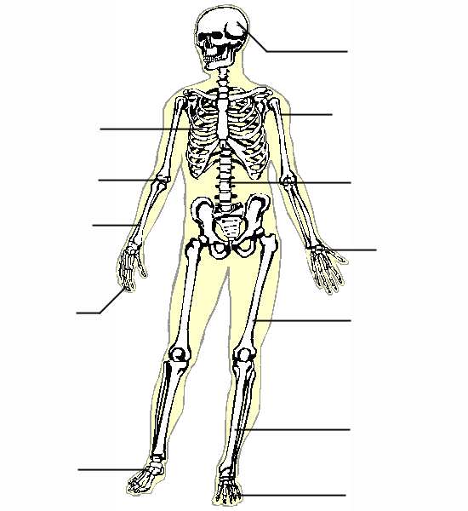
A
A
E
F
H
J
I
K
G
D
B
C
A. | ____________________
B. | ____________________
C. | ____________________
D. | ____________________
E. | ____________________
F. | ____________________
G. | ____________________
H. | ____________________
I. | ____________________
J. | ____________________
K. | ____________________
L. | ____________________
- List four functions of bones.

3. Name the 5 categories of bones.

4. What is another name for a bone cell?

5. Describe ossification.

6. Differentiate between closed reduction and open reduction of a fracture.

7. Name two treatments for osteoporosis.

8. What is a ruptured disk?

