Identify the Numbered Bones Name _________________________

Identify the bones that are numbered on the skeleton. Make sure you write down the correct bone by the corresponding number. Spelling counts!

1. ________________________________________
2 ________________________________________
3. ________________________________________
4. ________________________________________
5. ________________________________________
6. ________________________________________
7. ________________________________________
8. ________________________________________
9. ________________________________________
10. ________________________________________
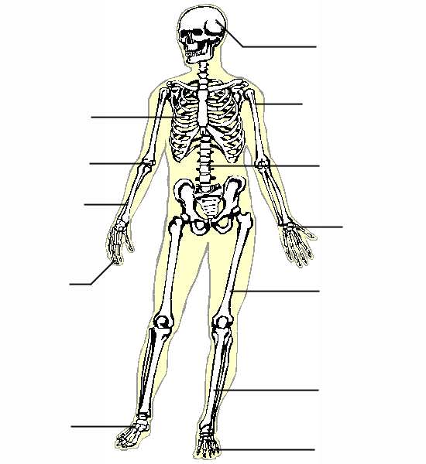
A
A
E
F
H
J
I
K
G
D
B
C

Identify the Bones: ANSWERS

A. skull
B. ribs
C. radial
D. humerus
E. vertebrae
F. carpals
G. phalanges
H. femur
I. metatarsals
J. tibia
K. phalanges

