Skeletal System Worksheet Name _________________

    - Label the following diagram of the skeleton with the correct names for each of the bones.

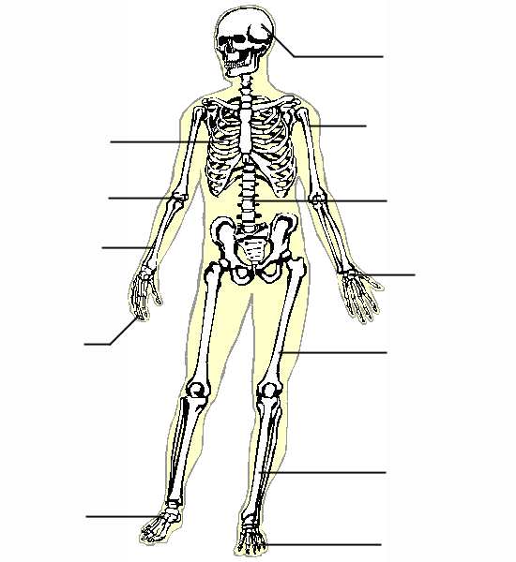
A
A
E
F
H
J
I
K
G
D
B
C

A. | ____________________
B. | ____________________
C. | ____________________
D. | ____________________
E. | ____________________
F. | ____________________
G. | ____________________
H. | ____________________
I. | ____________________
J. | ____________________
K. | ____________________
L. | ____________________

- List four functions of bones.

3. Name the 5 categories of bones.

4. What is another name for a bone cell?

5. Describe ossification.
6

6. Differentiate between closed reduction and open reduction of a fracture.

7. Name two treatments for osteoporosis.

8. What is a ruptured disk?
Skeletal System Answer

1. A. skull B. ribs C. radial D. humerus
E. vertebrae F. carpals G. phalanges H. femur
I. metatarsals J. tibia K. phalanges

2. Framework, protection, levers to provide movement, production of blood cells, storage

3. Long- form the arms and legs; has a shaft called diaphysis, oxygen and nutrients are brought form the bloodstream. Short bones- small cube-shaped of the writs, ankles and toes. Flat bones- large somewhat flat surface; shoulder blades, pelvis and skull. Irregular- Bones of the ears vertebrae and face. Sesamoid bones- are formed in the tendon near joints, The patella is an example.

4. Osteocytes are part of a dense network of connective tissue. The hardening and development process of the osteocytes is called ossification.

5. Closed reduction involves positioning the bone in correct alignment, usually with traction, and applying a cast or splint; open reduction involves surgical repair of the bone

6. Increased intake of calcium and vitamin D, medications to increase bone mass, exercise, estrogen replacement

7. An intervertebral disk that ruptures or protrudes out of place and causes pressure on the spinal nerve.

