Heart Circulation Outline

The Heart
A. The heart is made of muscle tissue the size of a closed fist. Located in the mediastinal cavity lies between the lungs and the sternum.
B. The heart is a pump and its action forces the blood to flow through the body
C. A pulse is the result of the heart and can be felt and the force of the body from the heart beats flows through arteries.
D. Main layers of the heart
1. Endocardium – a smooth layer of cells that line the inside of the heart is continuous with the inside of blood vessels. It allows for smooth flow of the blood
2. Myocardium – the muscular middle layer of the heart
3. Pericardium – is a double-layered membrane or sac that covers the inside of the heart.
4. Septum – is a muscular wall that separates the heart into left and right sides. It prevents blood from moving from the left and right sides
E. Chambers of the Heart
1. Divided into 4 parts
a. right atrium – receives blood as it returns from the body cells.
b. right ventricle – receives blood from the right atrium; pump the blood through the pulmonary valve to the pulmonary artery which carries the blood to the lungs for oxygen. The only time in the body that an artery carries “deoxygenated blood.
d. left atrium – receives blood from the lungs through the pulmonary veins. The only time in the body that a vein carries “oxygenated blood.
F. Valves of the Heart
1. Purpose – keeps blood flow going in the correct direction
a. Tricuspid – located between the right atrium and right ventricle.
b. Pulmonary (semilunar) valve - located between the right ventricle and the pulmonary artery
c. Bicuspid Valve (Mitral) – located between the left atrium and left ventricle
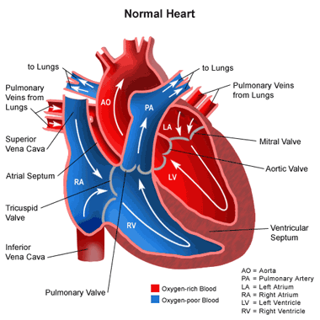
d. Aortic (semilunar) Valve – located between the left ventricle and the aorta – largest artery in the body
Picture can be moved to a page of its own

