Heart Circulation Flow Handout
BODY

Superior Vena Cava
Aorta

Inferior Vena Cava

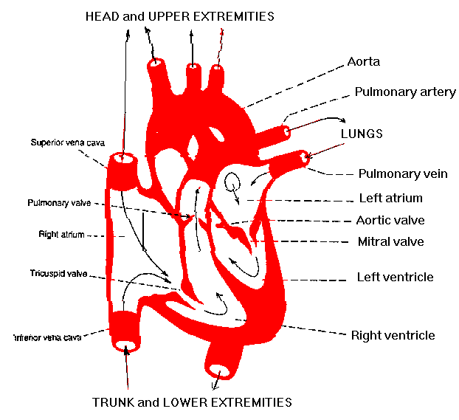
Aortic Semilunar
Valve
Right Atrium
Tricuspid Valve
Right Ventricle
Pulmonary Semilunar Valve
LUNGS
Lt & Rt
Pulmonary Veins
Left Atrium
Bicuspid (Mitral)
Valve
Left Ventricle
Lt & Rt
Pulmonary Arteries
Pat Rutherford©2008
Heart Microsoft Clip online

