LESSON PLAN FOR FILLING OUT A JOB APPLICATION

Preview: Have students complete a Personal Data Sheet three days before the Job Application Lesson.

Essential Question: How do you fill out a job application correctly?

Time Needed: 2 hours

Activating Strategy: To determine prior knowledge of filling out a job application correctly.

Materials needed:
- A completed sample incorrect job application for each student.
- Highlighter pens, one for each group
- Pencil for each student
- Blank Job Application

Hand out a sample incorrect job application to each student. Give a highlighter pen to each group. Each student will need a pencil.

Ask the students, "Would you hire this person? How many errors do you think the sample application contains?" Give the groups approximately 2 minutes to estimate the number of errors and write the number on the board by the group number. They may use the highlighter pen to mark the errors. The group that finds the correct number of errors will win a prize after the acquisition lesson.

Briefly discuss students' prior history in filling out a job application.

Next:
- Have the students divide into small groups.
- Instruct the group to look over the incorrect job application and identify and circle all errors on the application.
- Count the number of errors that the students found
- Teacher will walk around and listen to groups and guide them as necessary.
- Teacher will ask for a report for the student’s number of errors. Goal: see which group discovered the most errors. (Prizes may be given)

Acquisition Lesson: Students will learn how to fill out a job application correctly.

Materials and equipment needed:
- Overhead Projector and a transparency of a job application and a different color overhead pen for each group or an Elmo with paper copies of a job application for each group and a black ink pen.
- Transparency and or multimedia replication of the incorrect application to demonstrate to the class all of the errors with explanations.
- One copy of "How to Fill Out a Job Application" for each student.
- Two blank copies of a Job Application for each student to fill out. One application will be filled out in class to correct the sample application given out for the activating strategy; one application to be filled out with the student's information to be turned in the next day.
Procedure:
- Distribute each student the "How to Fill Out a Job Application" handout and briefly discuss. Students will refer to the handout while completing the assignment. Discuss the grading scale on the back of the handout.
- Each student will correct the sample incorrect application on a blank application as the teacher demonstrates using the transparency or multimedia replication

Summarizing the Lesson: Allow approximately 5 minutes.
Ask students for answers to the Essential Question.
Assignment: Students are to fill out a job application with their information to be turned in the next day.

Ticket out the Door: Allow 2 minutes. Have students write on a sheet of paper three characteristics of a job application that they learned in the lesson that they did not know before today and collect as they leave.

Assessment: The teacher will mark the student's errors on his/her application, and the student will fill out another application for the final grade.

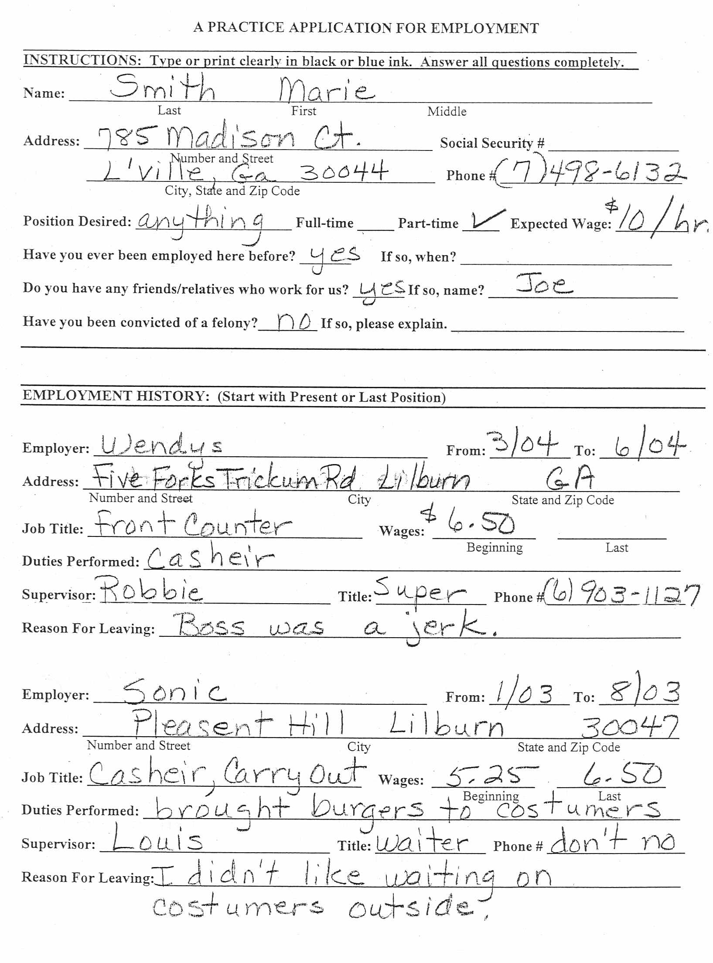
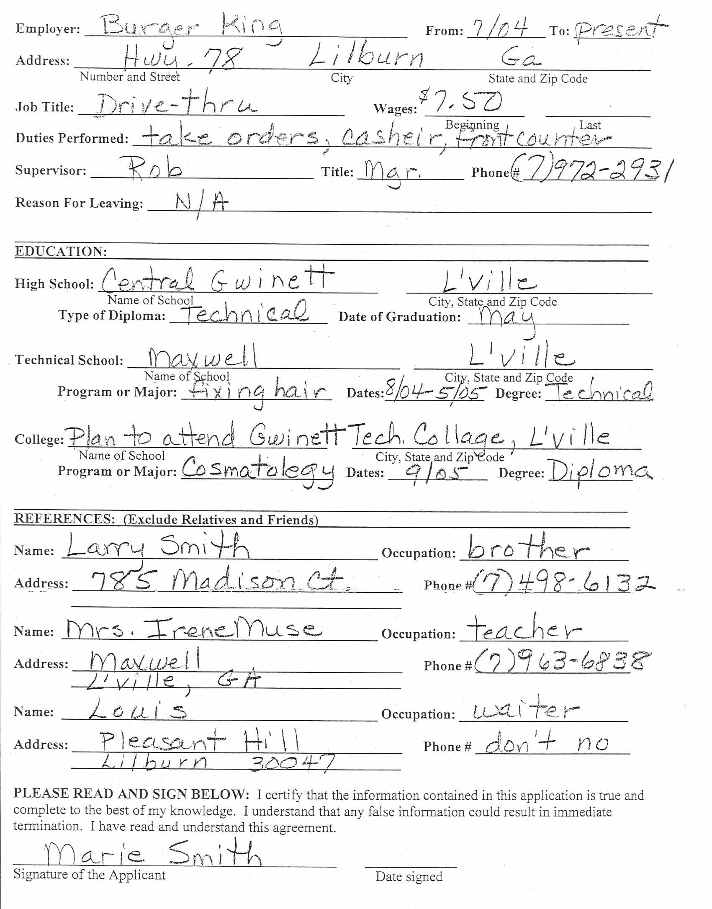
How to Fill Out a Job Application

Picking it up: When you pick up or drop off an application, be prepared for an interview. You never know if they will have a few minutes and are in a hurry to hire someone. Also, dress appropriately because even though you may not get an interview that day, the secretary or person who takes the application may be asked by the interviewer what they thought of you. First impressions are important; you only get one time to make it.

Read carefully: Read the entire form carefully. Know what is being asked before filling out the form. Employers may use the application form to judge how well you follow instructions and how careful you may be as an employee.

Fill in the blanks: Answer all questions. Fill in the blanks completely, accurately, and truthfully. When something doesn’t apply to you, write N/A for non-applicable. Check your answers for correct spelling, grammar, punctuation, completeness, and accuracy.

Ink/Type: Use blue or black ink or type the application. Print clearly. No funky colors.

Position: Avoid the word “anything.” Put a specific job down to show you’re not desperate and that you have a goal in mind.

Salary expected: Employers may use this question to screen out applicants. It is best to give a salary range or to respond with “negotiable.” Use one of these responses even if you know the wage. This leaves you room to negotiate a higher wage.

Personal information: If you don’t have a phone, give a number where messages can be left for you.

Education and training: List academic, vocational, and professional education and schools attended. Be prepared to attach copies of certificates or other documents. If you are planning to attend college, write “Plan to attend XYZ College” and when.

Work experience: Always list the most recent employer first. Give complete and accurate names, dates, addresses, phone numbers, job titles, dates of employment, etc. Use your resume as a guide. Make sure the information presented in the application agrees with the information in your resume. Explain gaps in your work history.

Special job-related skills: Use action verbs to list your special job-related skills, training, licenses, and accomplishments. List the types of equipment/tools that you can use. This will make you stand out from other applicants. The job description can provide clues about important skills.

Reason for leaving: Be careful when giving your reason for leaving a previous job. Even if your previous boss was a jerk, you should never be negative. Acceptable answers include: “school conflict,” “conflicting hours,” “better opportunities for advancement,” “lack of work,” “seasonal employment.”

References: Most employers will call references, but they also may request a written evaluation by mail. Many employers can only tell dates worked and if they would re-hire you. Therefore, you may want to use teachers, counselors, principals, coaches, ministers, etc. as references. (Do not use relatives.) Be sure to ask for their permission and verify where they can be reached. Provide complete and accurate information about 3 (or more) people who can speak highly of you.

Last details: Sign (Don’t print) your name and include the current date. Check carefully that you have completed the application. Once you fill out an application, it is a binding document; any misinformation could be grounds for termination. If you are asked when you can begin work, be sure to allow enough time to give at least two weeks’ notice to your current employer.

JOB APPLICATIONS
GRADING SCALE

0 errors = 100 | 6 errors = 78
1 error = 96 | 7 errors = 76
2 errors = 92 | 8 errors = 74
3 errors = 88 | 9 errors = 72
4 errors = 84 | 10 errors = 70
5 errors = 80 | minus 2 points for each error over 10

Minus 10 points for not using Blue or Black ink, for not printing (except for signature), and for incorrect job order.

Minus 1 error for each misspelled word, stray marks, white out, smudges, scratch outs, folded or wrinkled application, leaving areas blank when not appropriate, not filling out information as instructed on “On How to Fill Out a Job Application" handout, and not following instructions on "A Practice Application for Employment."

Applications must be turned in within 1 school day when present for lesson, or the student will receive a zero. If a student is absent, he/she must make arrangements with a teacher within 2 days.

WEB SITES

http://411.com (addresses)
http://USPS.com (zip codes)
http://yellowpages.com (business addresses)
http://bellsouth.com (residential and business addresses)

A PRACTICE APPLICATION FOR EMPLOYMENT
\
INSTRUCTIONS: Type or print clearly in black or blue ink. Answer all questions completely.

Name: ___________________________________________________________________________
Last First Middle

Social Security # ___________________
Phone # _________________________

Address: __________________________________________________________________
Number and Street

___________________________________________________________________________
City, State and Zip Code

Position Desired: _____________________ Full-time _____ Part-time _____
Expected Wage: ________

Have you ever been employed here before? _______ If so, when? __________________

Do you have any friends/relatives who work for us? _______ If so, name? ____________

Have you been convicted of a felony?________ If so, please explain. ____________________________________________________________________________________________________________________________________________________________________________________________________________________________________________________________________________________________________________

EMPLOYMENT HISTORY: (Start with Present or Last Position)

Employer: __________________________ From: ___________ To: ________

Address: ___________________________________________________________________________
Number and Street City State and Zip Code

Job Title: ____________________________ Wages: ______________ ______________
Beginning Last
Duties Performed: _________________________________________________________________________
Supervisor: ____________________ Title: _______________ Phone # ______________
Reason for Leaving: _______________________________________________________________________

Employer: __________________________ From: ___________ To: ________

Address: ___________________________________________________________________________
Number and Street City State and Zip Code

Job Title: ____________________________ Wages: ______________ ______________
Beginning Last
Duties Performed: _________________________________________________________________________
Supervisor: ____________________ Title: _______________ Phone # ______________
Reason for Leaving: _______________________________________________________________________

Employer: __________________________ From: ___________ To: ________

Address: ___________________________________________________________________________
Number and Street City State and Zip Code

Job Title: ____________________________ Wages: ______________ ______________
Beginning Last
Duties Performed: _________________________________________________________________________
Supervisor: ____________________ Title: _______________ Phone # ______________
Reason for Leaving: _______________________________________________________________________

EDUCATION: ___________________________________________________________

High School: ______________________________________________________________
Name of School

_________________________________________________________________________________
City, State and Zip Code

Type of Diploma: _______________ Date of Graduation: _________________________

Technical School: ________________________________________________________
Name of School
________________________________________________________________________________
City, State and Zip Code
Program or Major: _______________ Dates:__________ Degree: _______________

College: ___________________________________________________________________
Name of School

_________________________________________________________________________________
City, State and Zip Code

Program or Major: ______________ Dates: _________ Degree: ____________

REFERENCES: (Exclude Relatives and Friends)______________________

Name: ____________________________Occupation: _____________________

Address: __________________________________________ Phone # ___________

Name: __________________________Occupation: ______________________

Address: __________________________________________ Phone # ___________

Name: _____________________________________Occupation: ___________________

Address: __________________________________________ Phone # __________

PLEASE READ AND SIGN BELOW: I certify that the information contained in this application is true and complete to the best of my knowledge. I understand that any false information could result in immediate termination. I have read and understand this agreement.

_____________________________________________ _____________
Signature of the Applicant Date signed

Job Application Test Name _________________________________

Fill in the blank with the correct information.

1. When you pick up or drop off an application, be prepared for an ___________________.
2. When picking up an application, you should dress appropriately because first ___________________________________________.
3. Read the entire form ___________________. Know what is being asked _____________ filling out the form.
4. Answer ______________ questions on the application form.
5. When something doesn’t apply to you, write _______________________________
6. Use __________________ ink or type the application.
7. What word should you avoid putting on the application when asked about a desired position? __________________________
8. Always list the most recent employer _________________________.
9. Identify one acceptable reason for the question, “why did you leave your previous job?”
___________________________________________________________________________

10. Once you fill out an application, it is a binding document; any misinformation could be grounds for ___________________________.

Job Application Test KEY Name _________________________________

Fill in the blank with the correct information.

1. When you pick up or drop off an application, be prepared for an interview.
2. When picking up an application, you should dress appropriately because first impressions are important.
3. Read the entire form carefully. Know what is being asked before filling out the form.
4. Answer all questions on the application form.
5. When something doesn’t apply to you, write N/A for non-applicable.
6. Use blue or black ink or type the application.
7. What word should you avoid putting on the application when asked about a desired position? Anything
8. Always list the most recent employer first.
9. Identify one acceptable reason for the question, “why did you leave your previous job?”
Acceptable answers include “school conflict,” “conflicting hours,” “better opportunities for advancement,” “lack of work,” “seasonal employment.”

10. Once you fill out an application, it is a binding document; any misinformation could be grounds for termination.

Career Essay Guidelines

Objectives:
This lesson is to connect to a health career.
- Students will be able to explore and expand on writing skills by developing an essay of a health career they are interested in pursing.
- Students will accumulate information by interviewing a health care professional in the chosen health career.
- Students will research a health career by using the Internet or other methods approved by the instructor.
- Students will relate how to go from school to work and develop a plan to do so.
- Students will write an essay using complete sentences.
- Students will be able to communicate thought ideas and information in writing.

Procedure
The purpose of this essay is for the student to connect school to the work world. Students will develop a plan to achieve a health career after secondary education has been completed. The student will research educational requirements, post-secondary schools with location and financial arrangements that may be needed. Students will develop a timeline that will depict how long it may take to complete the educational requirements as well as to include the financial arrangements that may be involved.

1. By using various methods, research information on your chosen career. This can be from an interview, Internet or some of the books in the classroom.
2. Include job descriptions, personal characteristics, job outlook, salary ranges, educational requirements, and identify post-secondary institutions.
3. List the reason(s) why you choose this career.
5. After getting the above information together, begin to type your essay. The requirements for the essay are as follows:
- Introduction should contain at least 5 complete sentences.
- The body of the report should have a minimum of 3 different paragraphs with at least 5 sentences each.
- Five events from your mentor experiences should be related in the essay.
- Conclusion should contain at least 5 complete sentences
- Spelling counts
- Bibliography Page
Websites that the student can obtain career information can be found in the following sites:
www.marblehead.com/guidance/jrles.htm
www.bls.gov/oco/
www.sowega-ahec.org/career_guide/
http://www.pbs.org/als/career/health.htm
http://guidance.wwwcomm.com/career.html
www.okcareertech.org/cimc/free-hoe.htm

Develop a timeline of information from your essay. Information should include the steps it will take to achieve the health career. The timeline is a tool that will enable the student to begin to see the big picture and give them a direction to begin when attempting their educational experience toward a health career.

Rubric for Career Essay

Name ______________________ Date Due ____________ Class ____________

Title ____________________________________________________

Scoring Criteria | Excellent 5 |  |  | Good  4 | Some Improvement 3 | Much Improvement  2 | Not Acceptable  0 |  | Score Earned
Report | Very neat & well organized |  |  | Neat & organized | Somewhat neat & organized | An attempt to demonstrate organization skills | No attempt to demonstrate  Organization
Introduction | Contains at least 5 complete sentences |  |  | Contains 4 complete sentences | Contains 3 complete sentences | Contains 2 complete sentences | Intro included but uses fragmented sentences
Body of Report | Contains at least 3 paragraphs with 5 sentences each |  |  | Contains 3 paragraphs with 4 sentences each | Contains 2 paragraphs with 4 sentences | Contains 2 paragraphs with 2 sentences | One paragraph
Address required info Job Descriptions, personal characteristics, job outlook, salary ranges, educational requirements, and identify post-secondary institutions | Includes all 8 portions of required information in the body of the essay |  |  | Includes 6 portions of required information in the body of the essay | Includes 4 portions of required information in the body of the essay | Includes 2 portions of required information in the body of the essay | Includes 1 portions of required information in the body of the essay
Develops a timeline |  | Includes 5 events |  | Includes 4 events | Includes 3 events | Includes 2 events |  | Includes 1 event
Conclusion |  | Contains at least 5 complete sentences |  | Contains at least 4 complete sentences | Contains at least 3 complete sentences | Contains at least 2 complete sentences |  | Contains at least 1 complete sentence
Spelling |  | No misspelled words |  | 2 misspelled words | 4 misspelled words | 6 misspelled words |  | 7 or more
Total Score |  |  | ________ A  30-35 | _______ B  29-24 | _______ C  23-18 | Needs Improvement  17-12 |  | Unacceptable  Repeat Project below 12
One letter grade will be deducted for turning in late.

Comments

Guidelines for Interviews for Health Career
Name of the person you interviewed ________________________
Date of interview _______________

- What is your health career?
- How did you decide on the career?

- What school did you attend and why?

- What type education is required for your job?

- Of all the things you did to prepare for this job, what helped you the most?

- What are two or three skills helped you the most in performing your duties?

- What courses did you take in college?

- What do you like most about your job?

- What do you least like about your job?

- What is the hardest part of your job?

- Can you give me a brief description of a typical day?

- If you had a chance, would you choose the same career, why?

- What is the future employment outlook for your career?

- Is there any advice you could give me?

- Is there a question you think I should have asked to better understand your career?

Do not forget to thank the person you interviewed.

This interview was prepared by _____________________________.
Date Due __________ Date turned in _______________________

