Place two arrows on the correct lines for the blood pressure reading at each BP gauge.
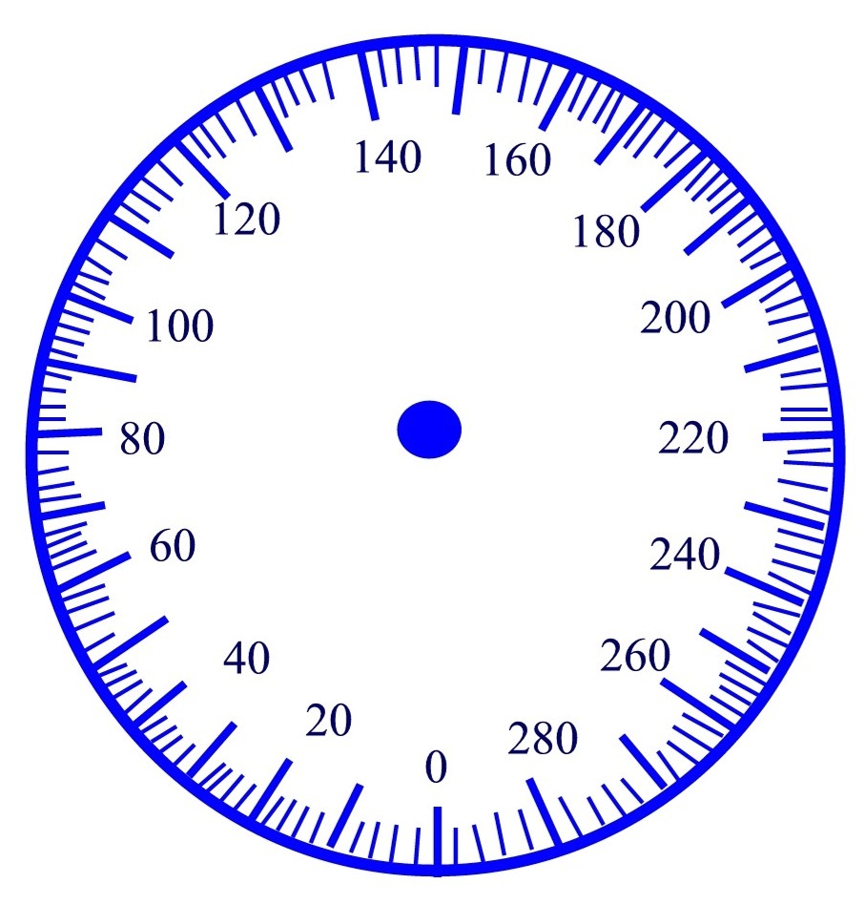
124/74 162/94

172/102 118/62

